Photo Upload, Phase 1
There are two relevant states for registered RentSocial users when it comes to Photo Upload, Phase 1:
- State 1: User owns a keeper or has accepted an invitation to join another registered RentSocial user’s keeper.
- State 2: User does not own a keeper and has not accepted any invitation to join another registered RentSocial user’s keeper.
There are two pages from which a registered RentSocial user could potentially upload a photo:
- Their home-page.
- A keeper page for a keeper they either own or have accepted an invitation to join.
Therefore, user flow will be described for three separate combinations of these states and screens:
- 1A
- 1B
- 2A
(2B is non-existent)

1A: User with access to keeper uploads photo from his/her home-page

Step 1 of 9
Click in field
No change from current
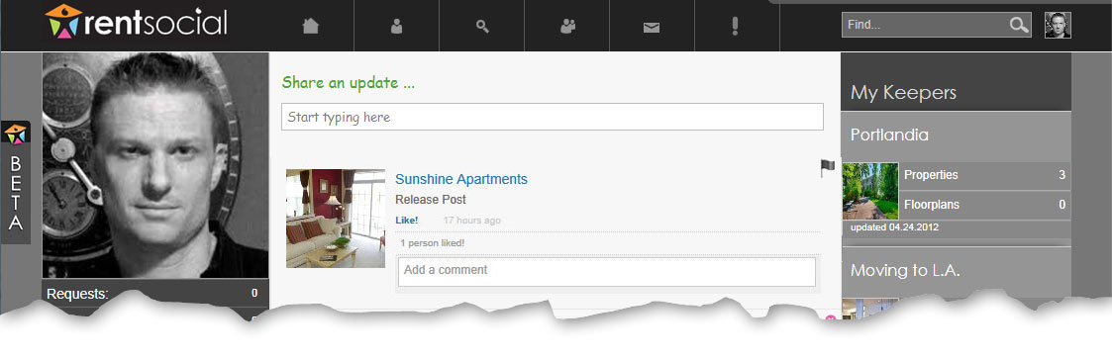

Step 2 of 9
5 new icons (in order L to R):
- Upload photo
- Upload video
- Tag Property
- Tag Keeper
- Tag Neighborhood
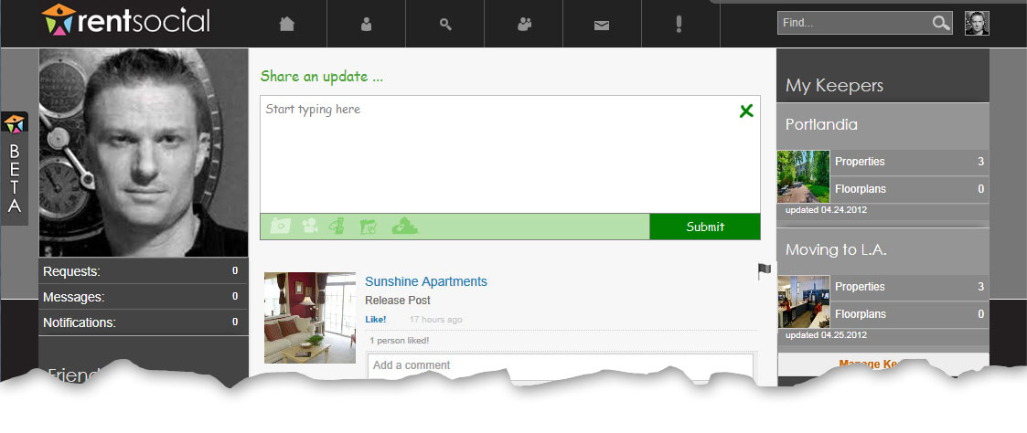
Upload photo
We can either show all five and pop “coming soon” messages for those not yet wired, or hide unwired icons till they’re wired up.

Step 3 of 9

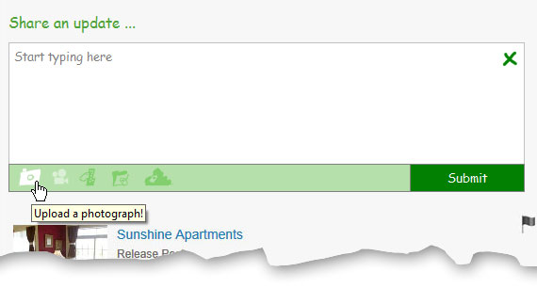
Mouse-over and tooltip

Step 4 of 9

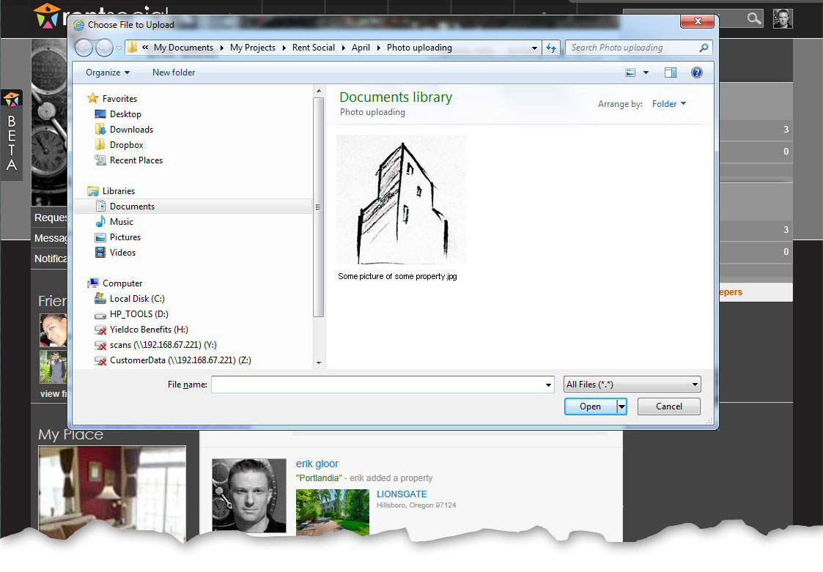
Select image
No ‘browse’ button; straight in to download. Browsing is implied – why waste a step?

Step 5 of 9
Back to step 4 of 9
Back to step 3 of 9
Back to step 1 of 9
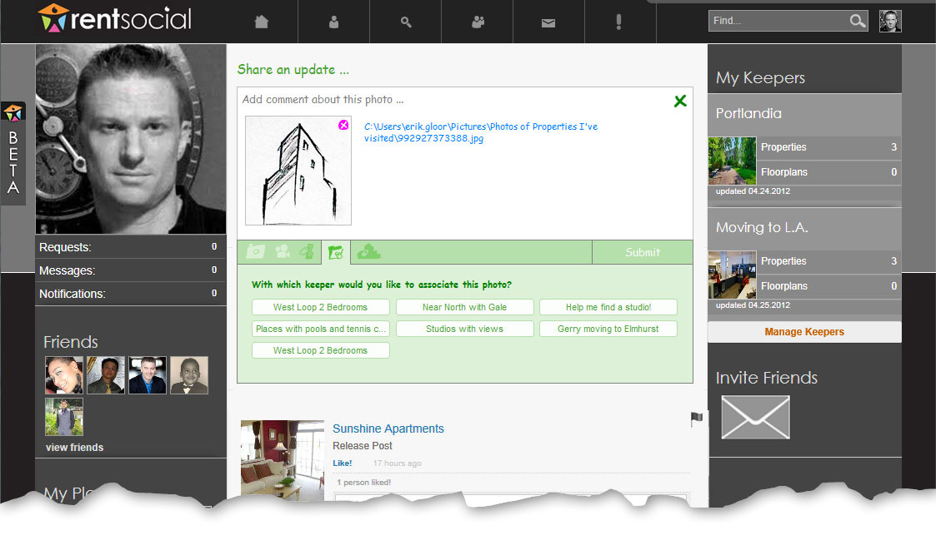
Multi-select

Step 6 of 9

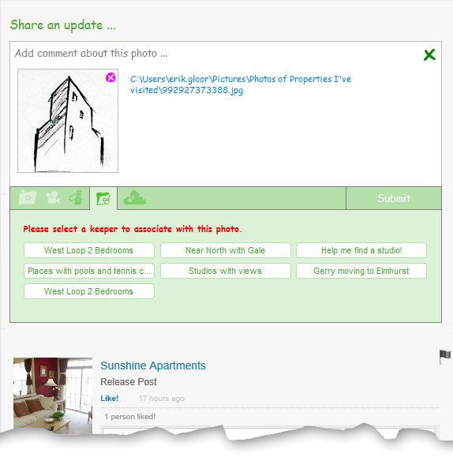
Grayed till any selection is made.

Step 7 of 9

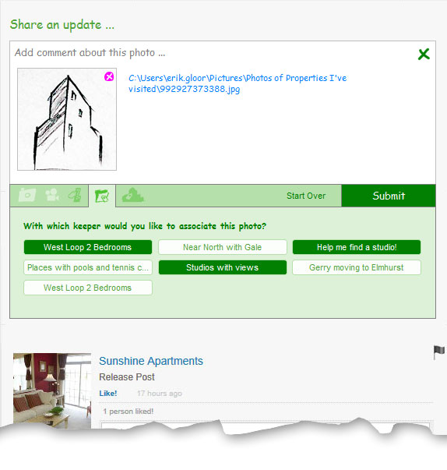
Occurs after any selection is made: Clears all keeper selections
Click to select
Click to de-select
Proceed

Step 8 of 9
Click to view

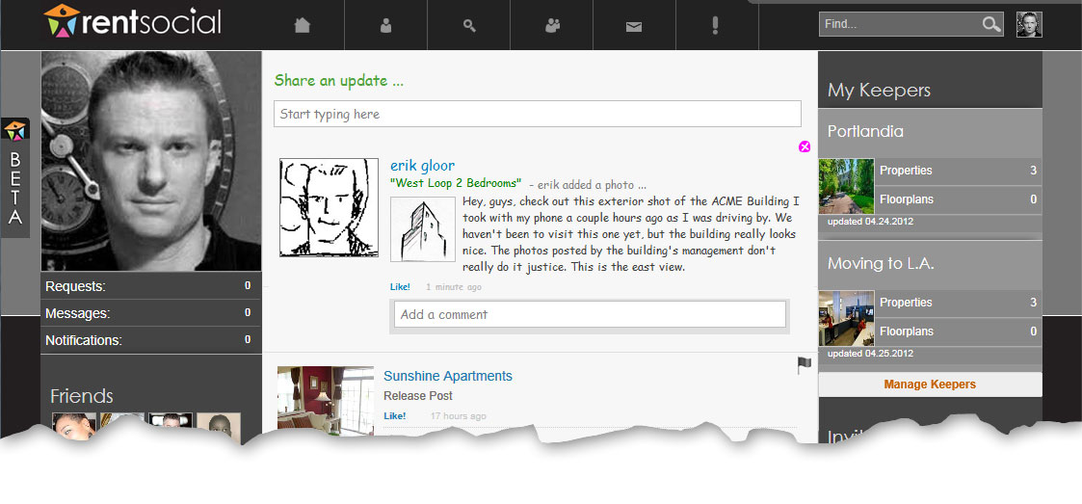

Step 9 of 9
Click to close

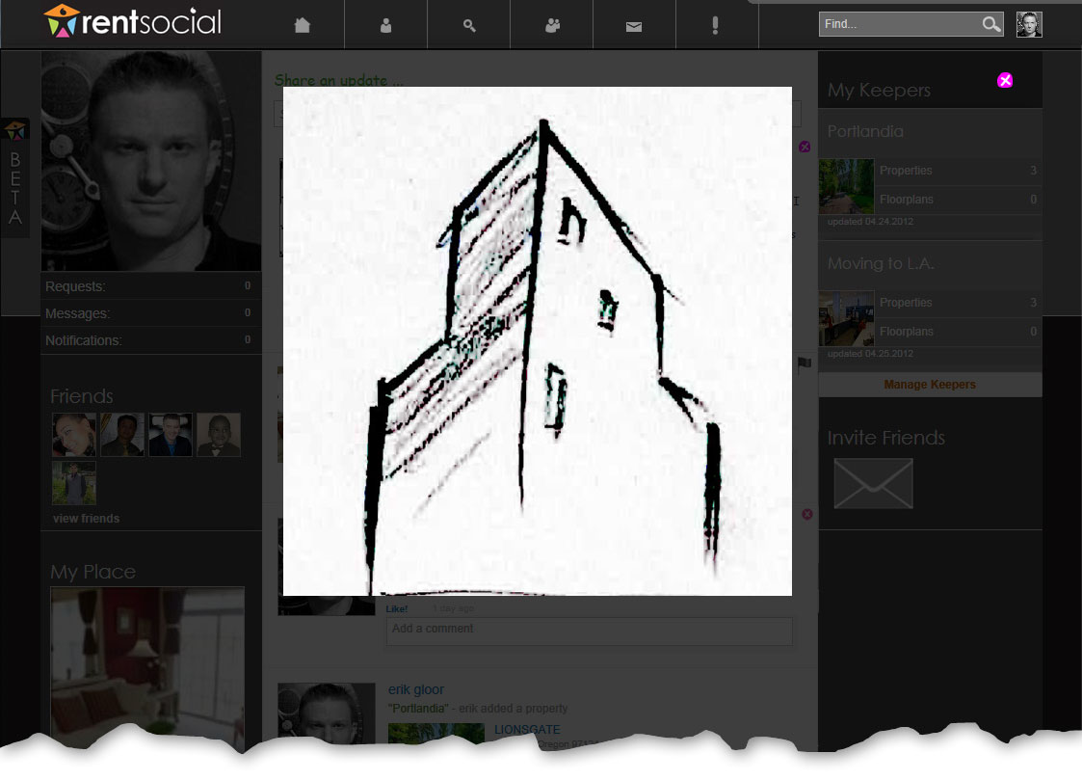
No thumbnails
No albums this phase
Commenting occurs in feed

1B User with access to keeper uploads photo from a given keeper page

Step 1 of 7
No change from current
Click in field
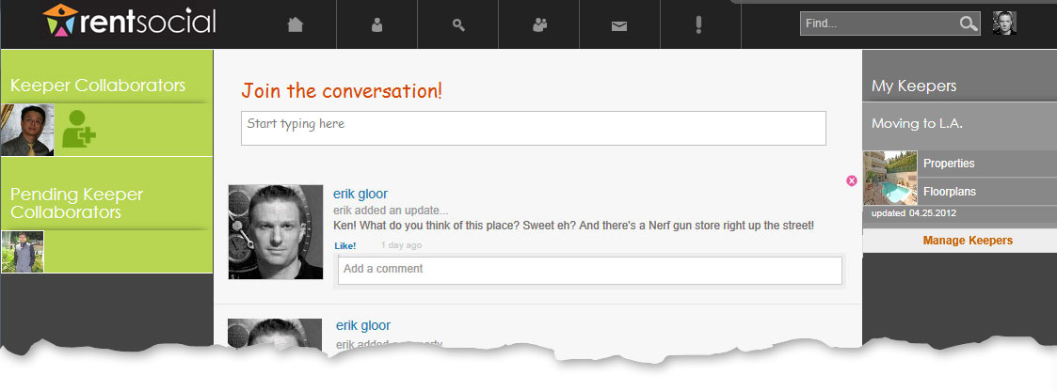

Step 2 of 7

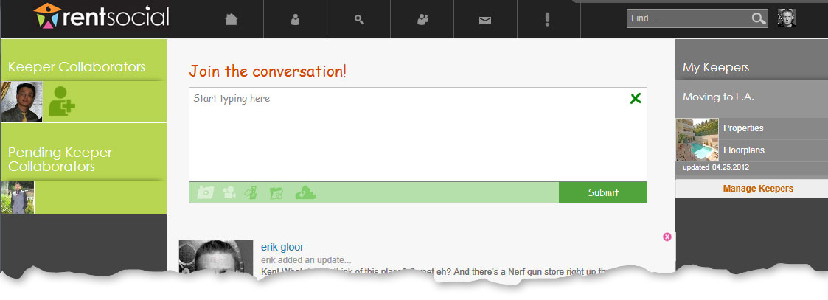
Upload photo

Step 3 of 7

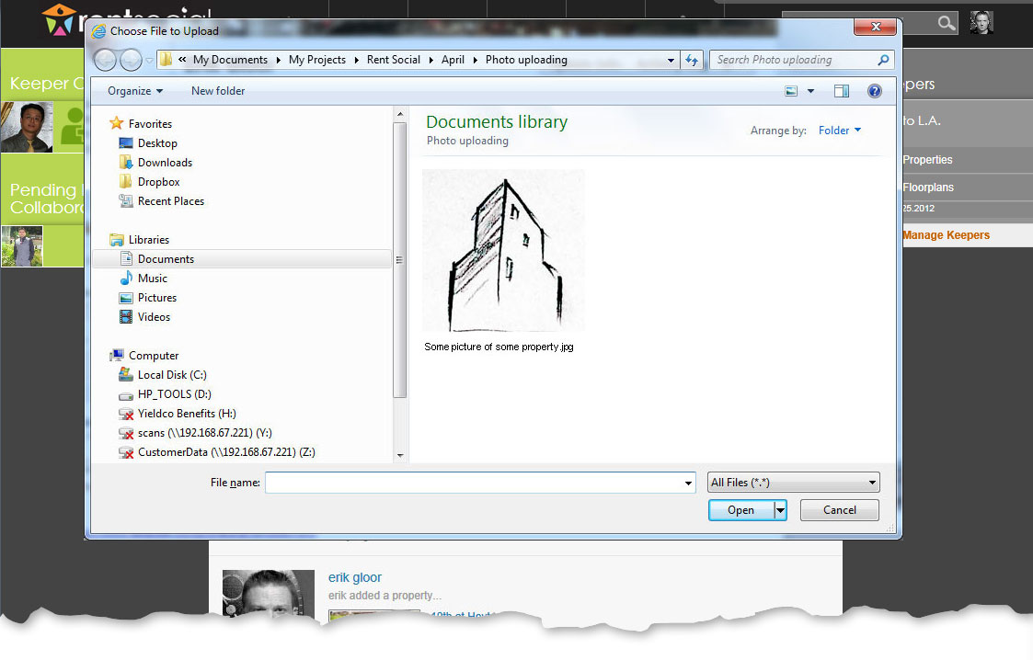
Select image

Step 4 of 7
It is presumed the user wishes to associate the photograph with the current keeper, so associating it with other keepers is provided as an option the user must specify.

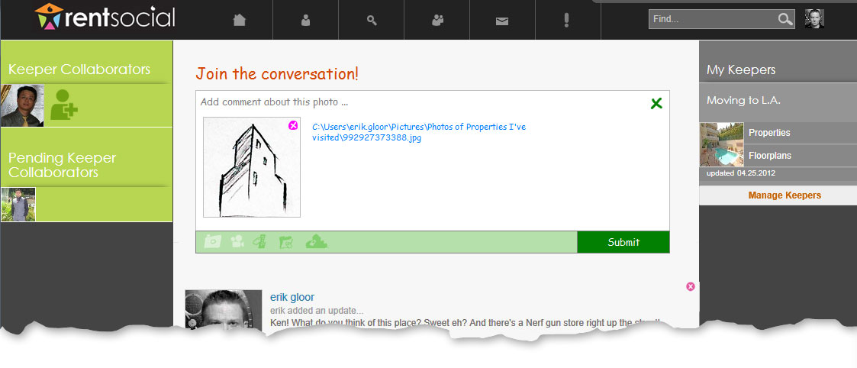
Tag to additional keepers

Step 5 of 7

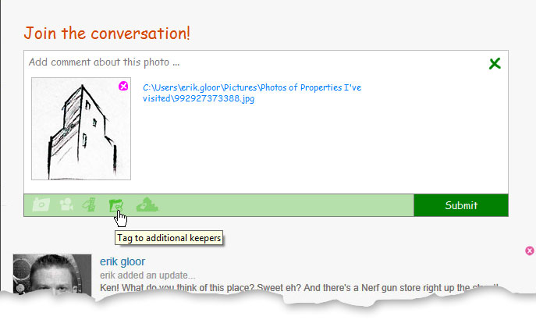
Mouse-over and tool-tip

Step 6 of 7

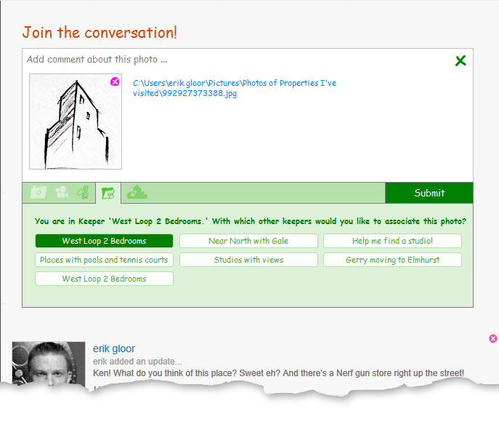
Multi-select
Current keeper is pre-selected and cannot be unselected

Step 7 of 7

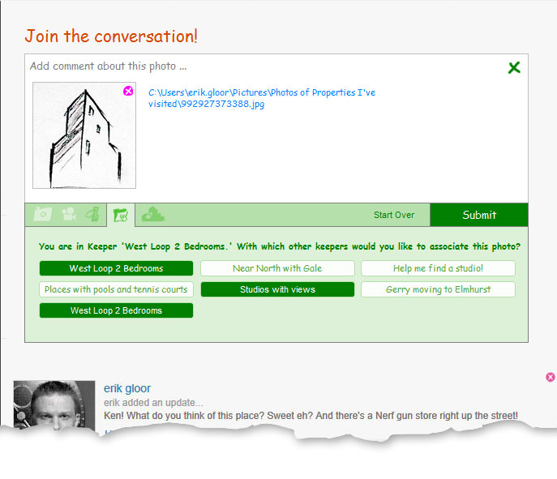
Proceed
The rest mirrors 1A

2A: User without access to any keeper, attempts to upload photo from home-page

Step 1 of 3
Click in field
No change from current
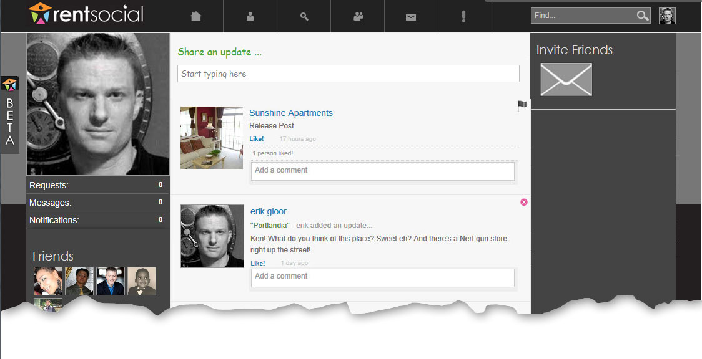

Step 2 of 3
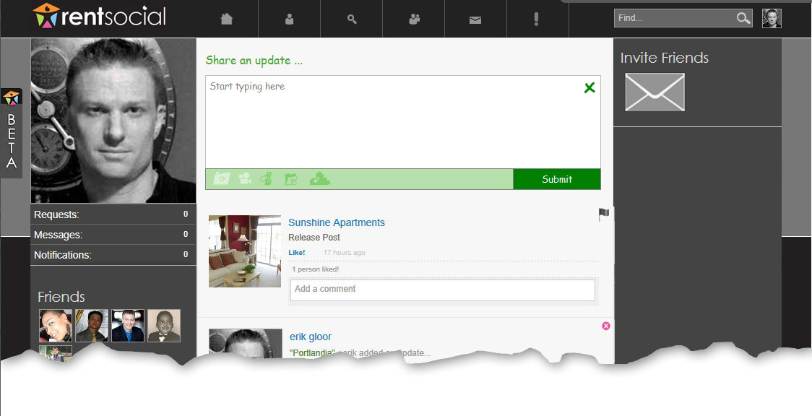
Click to upload photo

Step 3 of 3

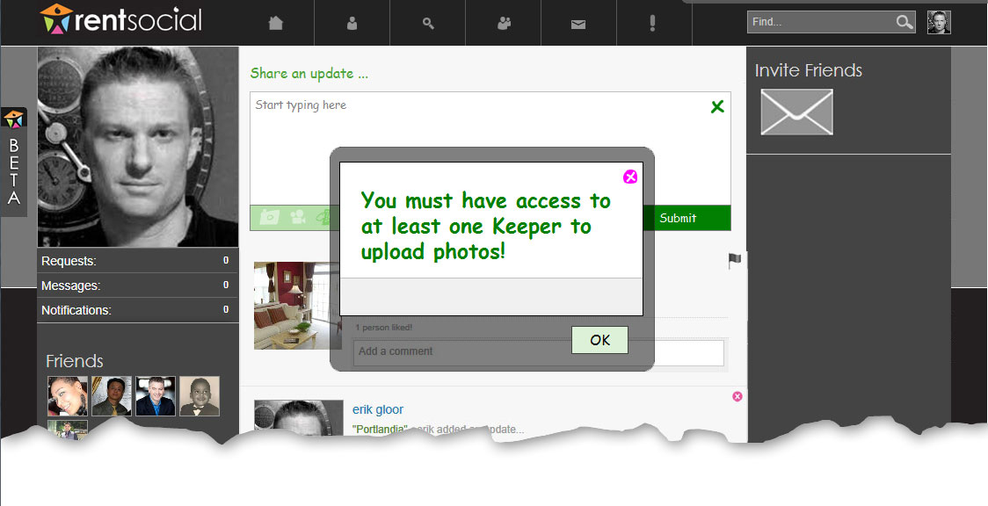
Proceed

