User Listings 2013 – Broker Subscription version 4.1
Table of Contents
User Listings 4
Broker Subscription 5
MVP Phase 6
Broker Listings 7
Broker Subscription – Core Flow 8
Broker Subscription User Story Synopsis 8
Special Considerations 9
Broker Users vs. Regular Users 9
The “Supplemental Global Nav” 10
Shrinkage 10
Should be “Scroll-Proof” 11
Links in the Supplemental Global Nav for Broker Subscription 12
Key Questions about the Supplemental Global Nav 12
The “Advertising On Area” 13
The Sideways Listing Pin 14
The Two Forms Taken by the Sideways Listing Pin 14
Always truncate, never wrap 14
States of the Sideways Listing Pin 15
My Listings 16
My Listings: Three Main Functions 16
My Listings: Three Distinct Views 16
Summary View 17
Data Grid View 18
The De-Select View 19
Select Listings to Advertise On 22
“Dead Stick Mode” - When selection exceeds subscription 23
How Dead Stick Mode is triggered 23
How Dead Stick Mode is made manifest 23
How Dead Stick Mode ceases 26
Contingencies 27
The Exceeded Limit Modal 27
The Listing Filter Control 28
Here’s how it is intended to work, step-by-step: 28
The “Second Chance Modal” 39
What happens when a User attempts to filter unselected listings they have clicked on 39
Manage My Ads for Broker Subscription 40
The two contexts under which a User will encounter the Manage My Ads screen 40
Context 1: choosing listings to advertise on 41
Context 2: all other contexts 41
One-User-One-Ad 42
Overview 43
The Current Ad 44
Confirm 45
Create New / Edit 46
Flow for Create New 46
Flow for Edit 49
Rollover functionality on Inactive Ads 50
Promoting an Inactive Ad to the Current Ad 51
Editing an Inactive Ad 52
Deleting Ads 53
The Default Ad 54
The two states of the Manage My Ads screen when no ad has been created 54
Nicknames and Dates Created 57
Nickname 57
Date Created 57
Showing Nicknames and Dates Created 57
Appendix I – Questions still outstanding as of version 1.0 of this document 59
The Supplemental Global Nav 59
Can brokers advertise on only ListHub listings? 59
How would the One-User-One-Ad schema tie in to subscriptions? 59
Appendix II – Assumptions 60
Broker Users must first be regular Users 60
Appendix III – Special Instructions 60
Viewing multiple comps in one Photoshop file 60

User Listings
“User Listings” is an overarching term intended to encompass the facility of user interaction with the listings that appear on RentSocial. This interaction will come in two forms: creating listings and advertising on ListHub listings. Any user will be able to create their own listing. But advertising on ListHub listings will be the province of a distinct new type of user, a “Broker User.” Both forms of interaction will require payment, which will also come in two forms: pay-as-you-go and subscription. Obviously, all these new considerations introduce several new layers of complexity to the information architecture of RentSocial:
All new
Login

User type?
Broker User
Existing

Payment type?
Subscription

Pay-as-you-go

Create Listing

Interact with existing RentSocial content
Select Listing(s) to advertise on
Create Listing(s)
Card on file?
No

Yes

Pay online
Select Listing(s) to advertise on
Create Listing(s)
Create Listing(s)
Select Listing(s) to advertise on

Logout

Broker Subscription
The document you are reading describes just a small segment of the new architecture suggested by User Listings. This small segment will comprise the entirety of the very first release of User Listings and shall hereafter be referred to as “Broker Subscription.”
Broker Subscription – the subject of this wireframe
Login

User type?
Broker User
Existing

Payment type?
Subscription

Pay-as-you-go

Create Listing

Interact with existing RentSocial content
Select Listing(s) to advertise on
Create Listing(s)
Card on file?
No

Yes

Pay online
Select Listing(s) to advertise on
Create Listing(s)
Create Listing(s)
Select Listing(s) to advertise on

Logout

Some of the remaining portions of this architecture are described in other, similar documents that, as of this document, were at various stages of completion. See below:
MVP Phase. The most recent version of the wireframe for this portion lives here >> https://www.dropbox.com/s/utc8xr21btr7wm2/User%20Listings%202013%20-%20MVP%20v1.0.1.docx

MVP Phase
This portion of User Listings will be re-named in future wireframes.
Login

User type?
Broker User
Existing

Payment type?
Subscription

Pay-as-you-go

Create Listing

Interact with existing RentSocial content
Select Listing(s) to advertise on
Create Listing(s)
Card on file?
No

Yes

Pay online
Select Listing(s) to advertise on
Create Listing(s)
Create Listing(s)
Select Listing(s) to advertise on

Logout

Broker Listings
Broker Listings. The most recent version of the wireframe for this portion lives here >> https://www.dropbox.com/sh/wktzjc8mcdpphzp/hU2966vniy
Broker Listings comprises the first portion of User Listings that includes online payment.
Login

User type?
Broker User
Existing

Payment type?
Subscription

Pay-as-you-go

Create Listing

Interact with existing RentSocial content
Select Listing(s) to advertise on
Create Listing(s)
Card on file?
No

Yes

Pay online
Select Listing(s) to advertise on
Create Listing(s)
Create Listing(s)
Select Listing(s) to advertise on

Logout

Broker Subscription – Core Flow
This is the core flow for this build-out:
Manage My Ads / Create New Ad
Select Listings to Advertise On
My Listings

Broker Subscription User Story Synopsis
User selects a number of listings to advertise on, up to a pre-arranged limit defined by a monthly subscription price. The User’s ad stays on the listing until it is either removed by ListHub or de-selected by the User. The User can create their own ad or use a default ad generated by the system. Using the My Listings screen, the User can periodically check on the performance of their listings and see if ListHub has removed any. The User can also use the My Listings screen to de-select Listings they had previously selected so that they can then select different ones.

Special Considerations

Broker Users vs. Regular Users
Ultimately, User Listings is intended to serve two distinct groups of users:
- Existing RentSocial members
- Existing RentSocial members who are Brokers – Broker Users.
The Broker Subscription build will serve only the latter – Broker Users. And because the functionality could be viewed as confusing or distracting by non-broker members, it will be hidden from that user group. Only brokers will see the screens that facilitate this new functionality.
Existing RentSocial member | Broker User
 | 
Which means there must be a solution that creates a means of making a distinction between these two user groups on login.
As of this document, the specifics of such a solution were still TBD. The most recent discussion of this solution is comprised by an e-mail from Kevin Koperski on February 12, 2013:
We’ll probably need them to request that their account be designated a broker account. At that point, we’ll flip a broker flag or something in the user record. It will definitely be a manual request at first.

The “Supplemental Global Nav”
A crucial UI component common to all user listings screens for Broker Subscriptions (and all future iterations) is what shall be referred to in this document as the Supplemental Global Nav (SGN). It will occur in the same place on every User Listing page and facilitate navigation to every User Listing screen named in it.
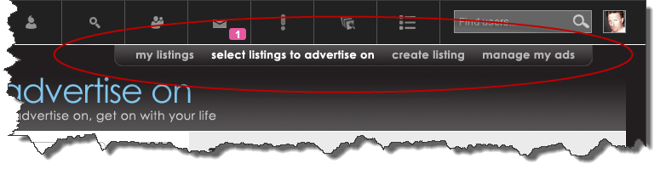

Shrinkage
The above screenshot shows all the links the Supplemental Global Nav will ultimately display (to a Broker User) when the User Listings build-out is fully-implemented in a later iteration.
In several contexts, however, the Supplemental Global Nav will include fewer of the links shown in the above screenshot. For example, even when User Listings is fully-implemented, non-broker users will only see the ‘My Listings’ and ‘Create Listing’ links – see screenshot below.
Whenever fewer of the links shown in the above example are requisite, the shape encompassing the links will shrink horizontally to avoid displaying empty space. When it does this, it will do so flush right. That is, the left edge will move right, but the right edge will stay put.
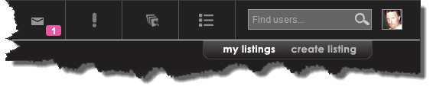

Should be “Scroll-Proof”
However many links it contains, the Supplemental Global Nav should join the rest of the global nav as a scroll-proof overlay:
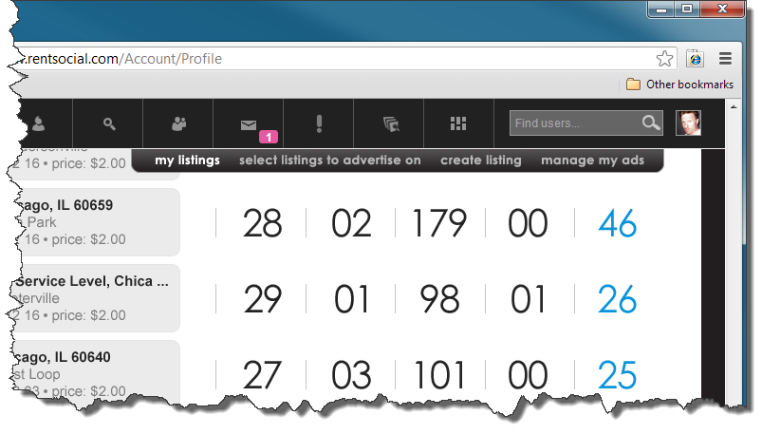
Scrolled down
Joins the rest of the global nav as a scroll-proof overlay

Links in the Supplemental Global Nav for Broker Subscription
For the Broker Subscription build of User Listings, the SGN will include the following links only. Please disregard any conflicts in this respect described by any of the screenshots shown throughout this document.
- My Listings
- Select Listings to Advertise On
- Manage My Ads

Key Questions about the Supplemental Global Nav
Some questions that touch on the SGN were outstanding as of this document and these questions are captured in Appendix I.

The “Advertising On Area”
The Advertising On Area (AOA) is a two-part expression of the number of listings a User is currently advertising on out of the number they have subscribed to advertise on. The AOA occurs on two of the three main screen types in the Broker Subscription build: My Listings and Select Listings to Advertise On. However, as described below, it is the locus of special functionality under certain circumstances.

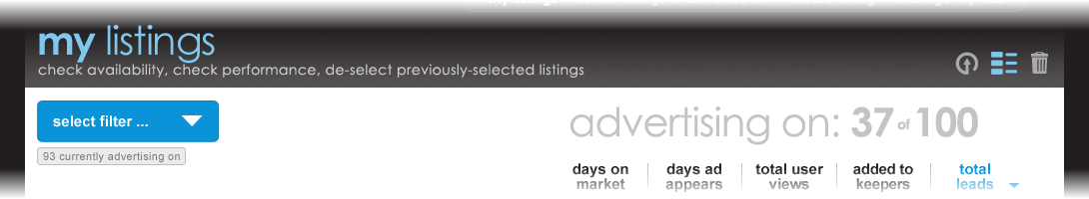
The number of listings the User is currently advertising on.
The Advertising On Area
The number of listings the User has subscribed to advertise on.

When the AOA occurs on either the Select Listings to Advertise On screen or the De-Select View of the My Listings screen, it will do so in parentheses whenever the number of listings is greater than zero. In the below example, the Select Listings to Advertise On screen is shown as it appears initially, and then after a selection has been made.
No selection … | … no parentheses | One or more selected … | … parentheses
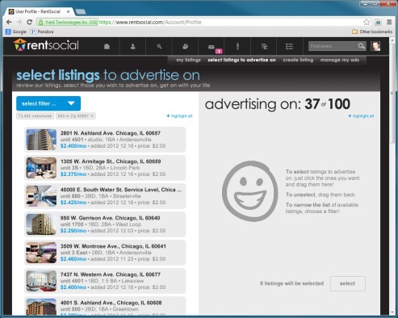 |  | 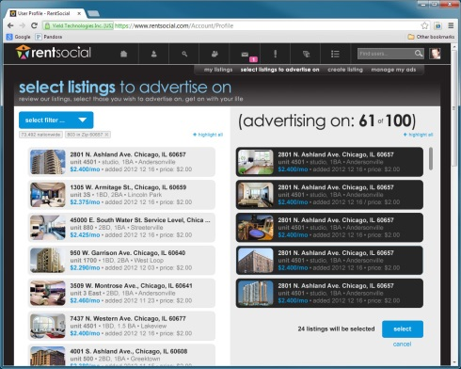 | 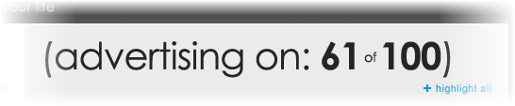  parentheses

The Sideways Listing Pin
Any listing occurring in the Broker Subscription build of User Listings is presented in what shall be referred to as a “Sideways Listing Pin” (SLP). The SLP is not complex and takes only two basic forms that vary only slightly in the data presented. Each of these forms has four User-driven states that vary by background color, border color and font color. These states are described in a later section of this document. Please note! The SLP as shown here may differ slightly from depictions occurring elsewhere in this document, especially with regard to the date and differentiation between Selected and Unselected forms. Please regard the depictions here as definitive and refer to them in all cases of discrepancy.

The Two Forms Taken by the Sideways Listing Pin
The Sideways Listing Pin occurs in either of exactly two forms, Unselected or Selected.
Unselected | Selected
This is the form a listing will take when the User is not advertising on it. | This is the form a listing will take when the User is advertising on it.
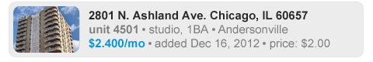 | 

The only difference

Always truncate, never wrap
The Sideways Listing Pins were designed to accommodate three long strings of data, but it is conceivable that in rare instances there may not be enough horizontal space to display one to all of them. In these rare instances, each of these strings should truncate and end with an ellipsis (the three dots …). They should never wrap.
In this example, String 1 is shown truncated because it is especially long.

String 1
String 2
String 3

States of the Sideways Listing Pin
In the Broker Subscription build of User Listings, the system presents the Sideways Listing Pin (SLP) in the following two contexts and four screens:
- Those listings that the User is not currently advertising on. This context exists on:
  - the “Select Listings to Advertise On” screen
- Those listings that the User is currently advertising on. This context exists on:
  - the “Summary View” of the “My Listings” screen
  - the “Data Grid View” of the My Listings screen
  - the “De-Select View” of the My Listings screen
Here is a breakdown of the four states in which the Sideways Listing Pin can occur in these contexts and screens along with what each state means.
State name | State appearance | Meaning in Context 1 | Meaning in Context 2
State name | State appearance | Meaning in Context 1 | Summary | Data Grid | De-Select
Unselected | 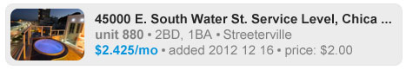 | A listing that the User is not currently advertising on | A listing that the User is currently advertising on | A listing that the User is currently advertising on | A listing that the User is currently advertising on
Moused Over | 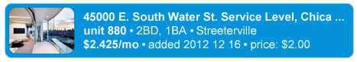 | Same as above plus moused over | Same as above plus moused over | Same as above plus moused over | Same as above plus moused over
Highlighted |  | A listing that the User is not currently advertising on and has clicked | (Does not occur on this screen) | (Does not occur on this screen) | A listing that the User is currently advertising on and has clicked
Pre-Selected | 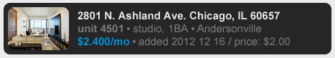 | A listing that the User is not currently advertising on and has dragged from the left side of the screen to the right | (Does not occur on this screen) | (Does not occur on this screen) | A listing that the User is currently advertising on and has dragged from the left side of the screen to the right

My Listings
My Listings will ultimately display all the listings a user has either created or elected to advertise on. For the Broker Subscription build, it will only show the latter group -- those listings the user has elected to advertise on.
Like the Select Listings to Advertise On screen, the My Listings screen will provide a means of filtering the listings it displays. Unlike the Select Listings to Advertise On screen, the My Listings screen will additionally include a means of sorting them by clickable header.

My Listings: Three Main Functions
The Broker Subscription version of the My Listings screen provides the User with the following three capabilities:
- To check on the performance in terms of views, leads, etcetera, of the Listings they are currently advertising on.
- To check the User’s current “Ad Balance.” Ad Balance refers to the gap between the number of listings a user can be advertising on at any given time and the number upon which they are actually advertising. For example, if a user has a subscription to advertise on 100 listings but is only advertising on 86, they will be said to have an Ad Balance of 14.
- To de-select listings they no longer wish to advertise on. De-selecting any one listing increases a User’s Ad Balance by one. De-selecting five, increases their Ad Balance by five. And so on.

My Listings: Three Distinct Views
Though not entirely correlated with the three main functions described above, the My Listings screen describes its data and functionality in three distinct views: “Summary,” “Data Grid” and “De-Select.”
All three views share the same heading in common. They vary only by whichever navigation icon associated with these three views is highlighted in the “My Listings Subnav.” See below.
My Listings Subnav. These function like radio buttons. One must always be selected.
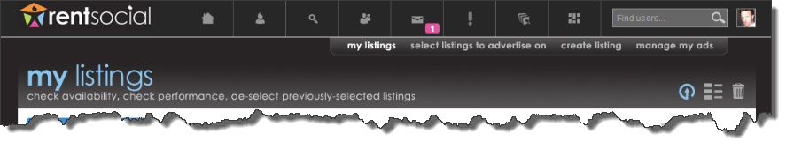
De-Select. Enables the user to change which listings get ads.
Summary View. This is the default view for My Listings.
Data Grid View. Shows performance data by listing.

Summary View
The Summary View is the default view for My Listings. This means that the first time a User clicks the ‘My Listings’ link in the Supplemental Global Nav for that login, they see the Summary View. After that, whatever view the User had up last is the one that persists whenever they navigate away from it. When the User logs out or otherwise ends his/her session, the Summary View again becomes the view the User sees when they next log in, regardless of whichever view was the last displayed when they last logged out. In short, its default status is session-based.
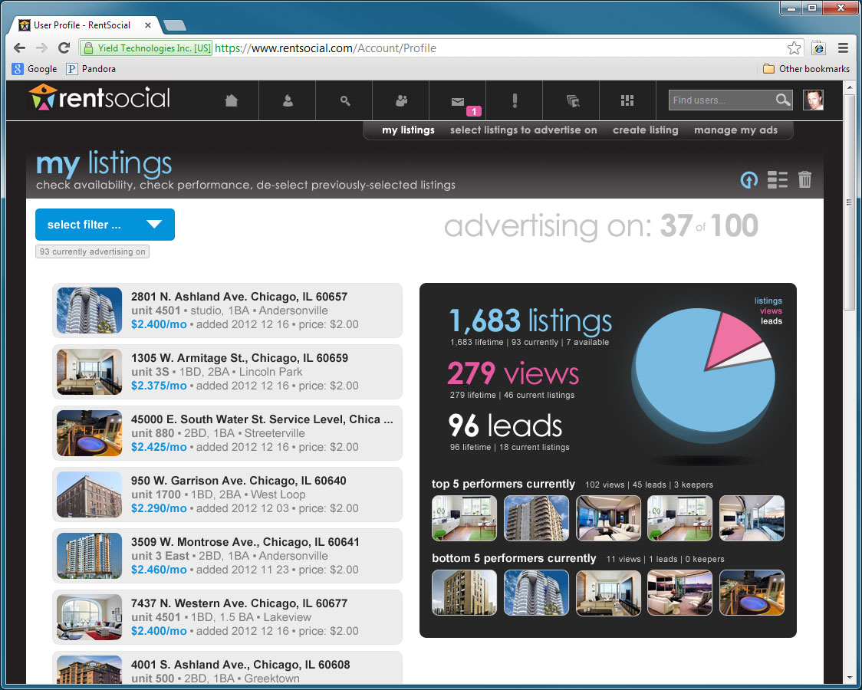
Listing Filter Control. This functionality is described in a section on the subject later in this document.

The ‘Advertising On Area’ describes the number of listings a User is advertising on as of this screen’s instantiation vs. the number they could be advertising on. The Advertising On Area appears on all three views of the My Listings screen.

These are all the listings the User is advertising on as of this screen’s instantiation. These lazy-load when their number exceeds a number TBD. Clicking any of these pins loads the individual listing page for that listing in a separate window.

“Breakdown Box.” This area is mostly self-explanatory. However, it is intended to react with the listings on the left and change as they are filtered and unfiltered. A more detailed explanation will follow in future versions of this document.

A Photoshop comp of this screen or screen element lives here >> https://www.dropbox.com/s/lprhvmrybv2y6ym/ML-Summary-02.psd

Data Grid View
Clicking any of these pins loads the individual listing page for that listing in a separate window.
The primary purpose of the Data Grid View is to provide performance data per listing.
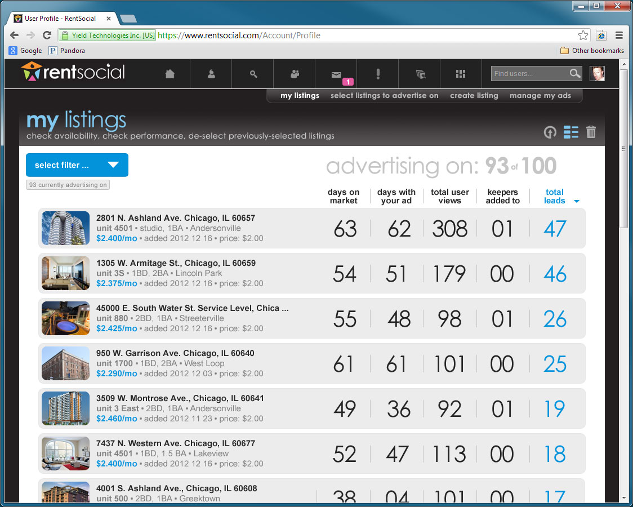
A user may sort the data by whatever criteria occurs in any given heading by clicking that heading.
When a sort is in effect:
- The heading is highlighted in blue and accompanied by a blue arrow.
- All numerals in the respective column are highlighted in blue.
The arrow occurs in two states:
- Descending, in which case the arrow points downward. In this state, the greatest value occurs at the top of the column and lowest, at the bottom.
- Ascending, in which case the arrow points up and the column order reverses with the lowest value at the top of the column and the greatest at the bottom.
The default sort for any given column is descending. Clicking the heading again toggles the sort between descending and ascending.
The default sort for the screen is Total Leads.
A sort must always be in effect.

A Photoshop comp of this screen or screen element lives here >> https://www.dropbox.com/s/2bbghm0wfjk02rg/ML-DataGrid-02.psd

The De-Select View
The De-Select View is the My Listings screen that enables the User to remove their ad from one or more of the listings they are currently advertising on. It behaves very much like the Select Listings to Advertise On screen, described later in this document. But where that screen enables the User to select listings, this screen enables them to do the opposite – to de-select them. Once they have de-selected one or all of the listings they are currently advertising on, they need not do anything further. But they will probably want to replace the listings they de-selected by proceeding to the aforementioned Select Listings to Advertise On screen.
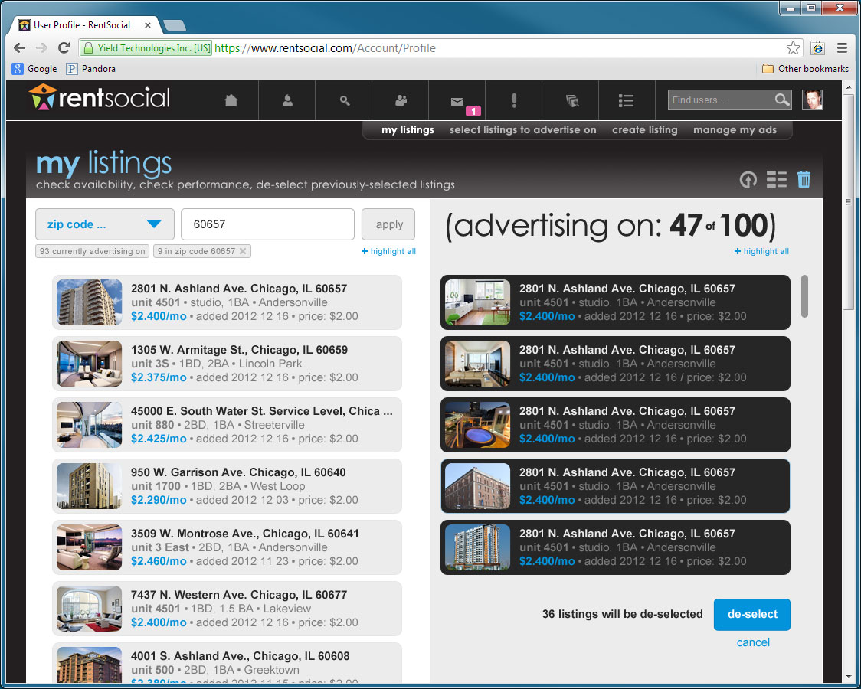
On the Select Listings to Advertise On screen, the User sees light-colored ListHub listings on the left side of the screen and must drag them to the right side, where they become pre-selected and turn black. Pre-selected listings will receive the User’s ad once the user “pulls the trigger.” The trigger in this case being a blue button in the bottom right-hand corner of the screen.
In the De-Select View, shown here, the mechanism is the same but the data flow is reversed. Now the User is de-selecting listings. The light-colored listings on the left are listings the User is already advertising on and the ones they drag to the right are listings they wish to advertise on no longer.
The Advertising On Area shown in this example is in parentheses because it is only a potential number until the user clicks the De-Select button. If the user clicks ‘Cancel,’ the black listings on the right will return to the group of current listings on the left and the availability number will shed its parentheses and remain unchanged.

A more detailed explanation will follow in future versions of this document.
A Photoshop comp of this screen or screen element lives here >> https://www.dropbox.com/s/y9zljliquurzxh4/ML-Deselect-02.psd

De-select flow
The flow for de-selecting listings mirrors the flow for selecting them in virtually every respect. The following are a few instances in which they differ:

When the User has yet to pre-select any of their listings for de-selection:
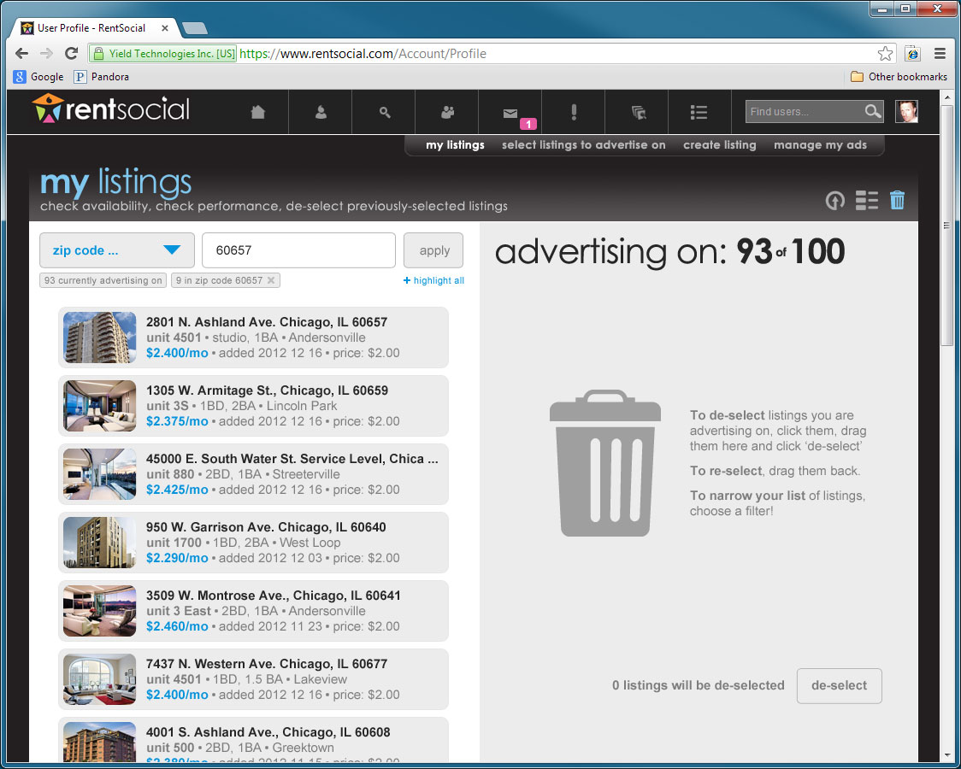

In this example, the User has decided to de-select all of the listings they’re advertising on in a certain Zip code and has so filtered.

Obviously, different iconography and verbiage for the start of the de-selection process.

A Photoshop comp for this incarnation of the De-Select View of the My Listings page, lives here >> https://www.dropbox.com/s/n5lcigip3t0su5s/ML-Deselect-06-NoPre.psd

When the User has no listings selected to start with:
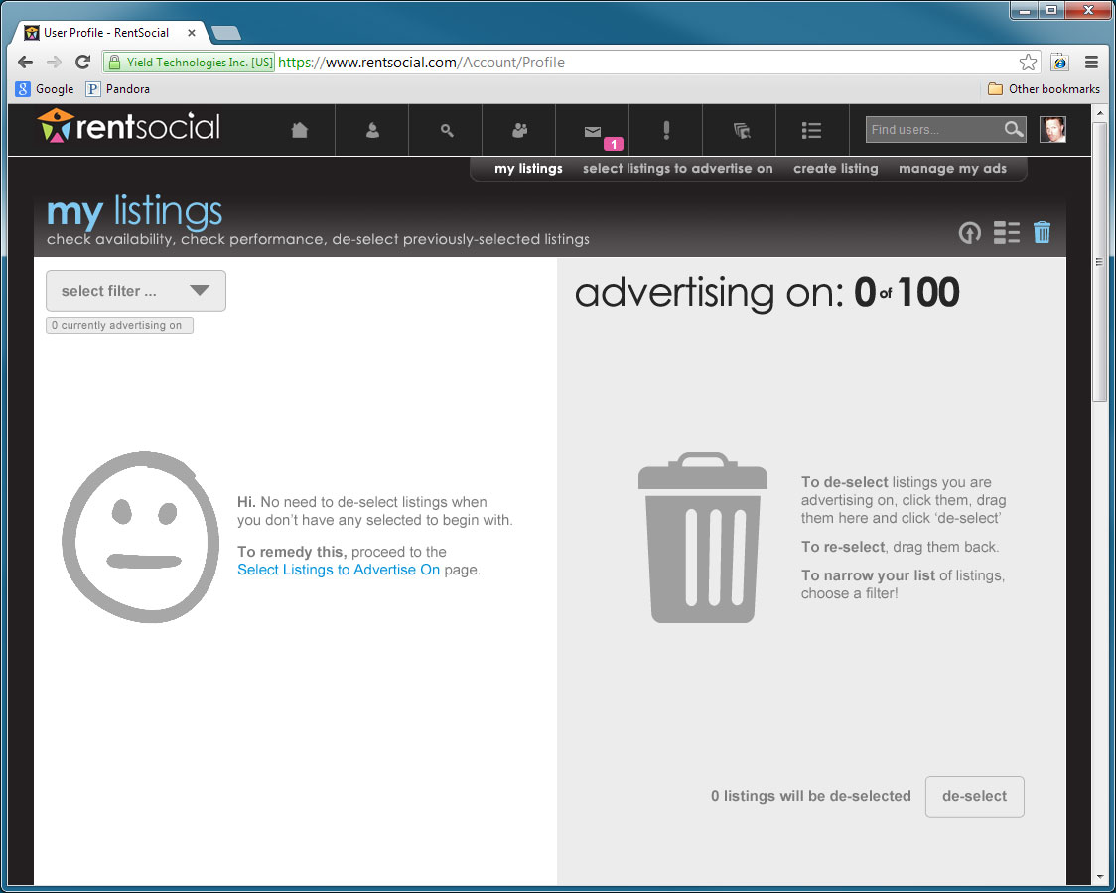
Obviously, if the User doesn’t currently have any listings selected, then they can’t de-select any of them. Better to go ahead and provide access to this screen anyway, just to promote familiarity.
A Photoshop comp for this incarnation of the De-Select View of the My Listings page, lives here >> https://www.dropbox.com/s/32euoh2jqlolch0/ML-Deselect-06-NoPre-NoSel.psd

Takes User to the Select Listings to Advertise On screen.

Select Listings to Advertise On
The Select Listings to Advertise On screen will provide the Broker User with access to all the ListHub listings currently appearing on RentSocial. Using the filter functionality on this screen, the Broker User will first narrow this list to a specific region and can then filter based on more specific criteria such as rent range. Once the list is adequately narrowed, the Broker User can pre-select one or more listings by clicking and then dragging them to the other side of the screen. The listings are selected and receive the User’s ad when the ‘Select’ button is clicked. Users can select up to as many listings as they have subscribed to advertise on.
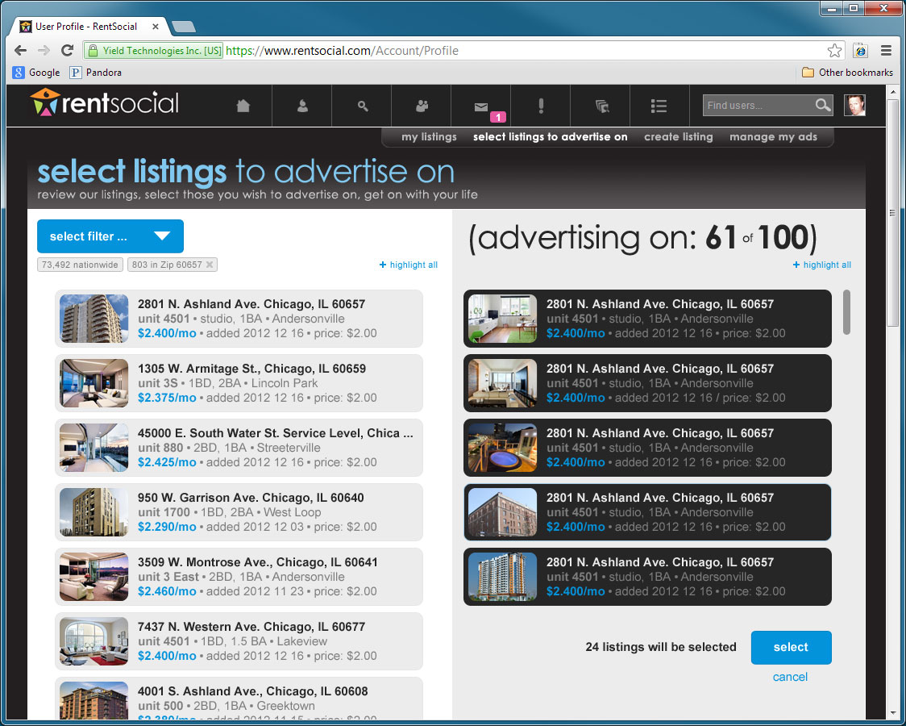
This and more functionality is described in a PowerPoint presentation that lives here >> https://www.dropbox.com/s/hy3iyraxjhkro5u/Select%20Listings%20to%20Advertise%20On%2020130131%201634.pptx. Three special notes on this!
- That PowerPoint presentation shows a design for this screen that was intended for use in a pay-as-you-go model of Broker Listings build. Please note all differences between that design and this one.
- The filtering mechanism shown in that PowerPoint presentation has been deprecated. Please refer to the section in this document that describes the “Listing Filter Control” (LFC) for details on how this mechanism ought to function.
- That PowerPoint presentation shows a design for this screen that describes ‘Select All’ links instead of ‘Highlight All.’ With the goal of emphasizing the distinction between highlighting a listing (by clicking on it and turning it orange) and pre-selecting it (by dragging it from one side of the screen to the other), the language ‘Select All’ has been deprecated in all instances of this screen and the De-Select View of the My Listings screen. Please use ‘Highlight All’ or ‘Unhighlight All’ wherever ‘Select All’ or ‘De-Select All’ were described in the abovementioned PowerPoint file.
A Photoshop comp of this screen lives here >> https://www.dropbox.com/s/ka6qi2ffyo7qkys/SLTAO-01.psd

“Dead Stick Mode” - When selection exceeds subscription
In future builds of User Listings, the Broker User will have the option of advertising on as many listings as he or she desires. For the Broker Subscription build, obviously, there is a limit by definition. So when the User reaches the limit of Listings they have subscribed to advertise on, the Select Listings to Advertise On screen will go into what shall be referred to as “Dead Stick Mode.”

How Dead Stick Mode is triggered
Dead Stick Mode is triggered when either one of the following two criteria have been met:
- The number of listings a User is advertising on = the number of listings they have subscribed to advertise on.
- The number of listings a User is advertising on + the number of listings they have preselected on the Select Listings to Advertise On screen = the number of listings they have subscribed to advertise on.

How Dead Stick Mode is made manifest
Dead Stick Mode is only manifest on the Select Listings to Advertise On screen.
Dead Stick Mode manifests itself in the following three main ways:
- Greying of the Advertise On Area
- Reduced functionality
- The User can no longer highlight listings

1. Greying of the AOA
Dead Stick Mode’s most immediate manifestation is the greying of the Advertising On Area (AOA). See below. So if, for example, the User’s subscription entitles them to advertise on 100 listings, the AOA on their Select Listings to Advertise On screen will look like it does on the left for 99 listings (or fewer). But will look like it does on the right for 100 listings.
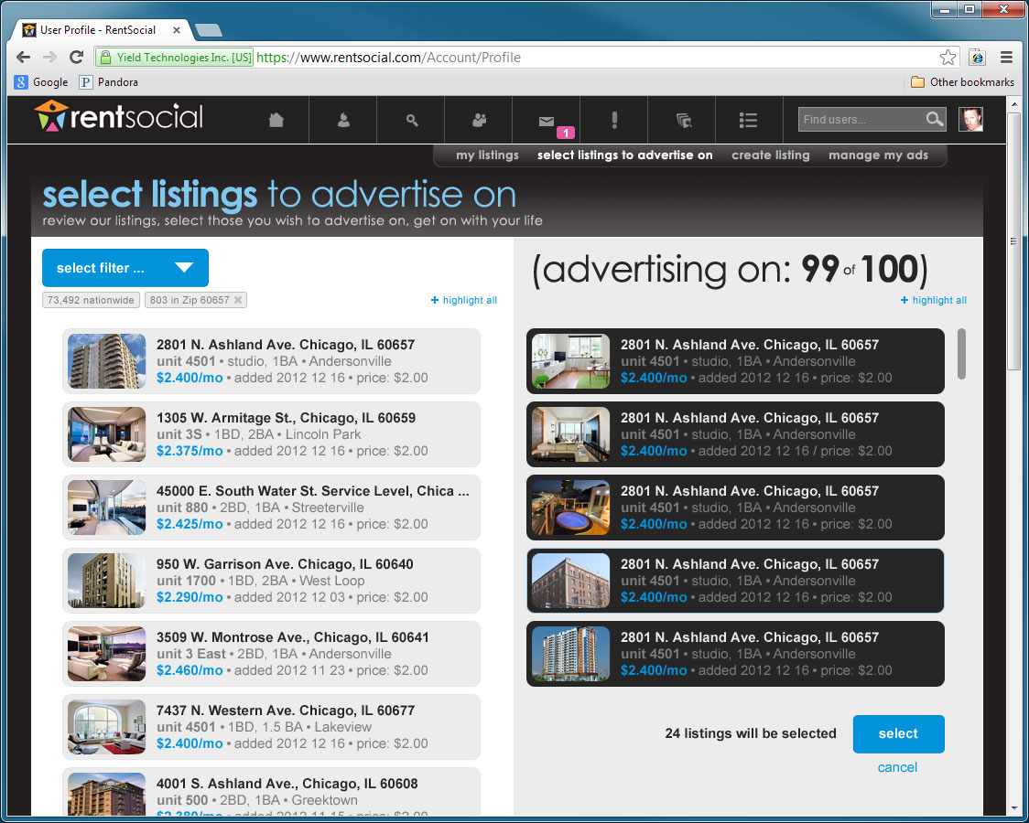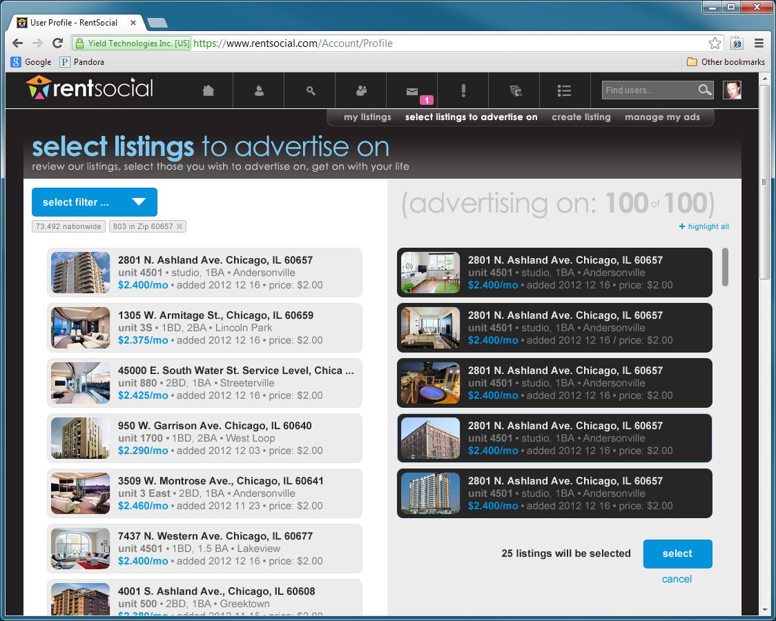
Note, ‘Highlight All’ link disappears in Dead Stick Mode
A Photoshop comp of the Dead Stick Mode lives here >> https://www.dropbox.com/s/kdeilglq0zh7w8o/FTC%2011%20--%20Dead%20Stick%2001.psd
AOA in Dead Stick Mode

2. Reduced Functionality
In Dead Stick Mode, the User cannot:
- Highlight the ListHub listings on the left side of the screen.
- Drag those listings to the right side of the screen.
- Observe the ‘Highlight All’ link.
In Dead Stick Mode, the User can:
- Access the full functionality of the Listing Filter Control as described in the section on that subject, except where that functionality involves highlighting unselected listings.
- Complete the selection process using the ‘Select’ button bottom right.
- Highlight the pre-selected black listings on the right side of the screen.
- Drag the pre-selected black listings from the right side of the screen back to the left – this would obviously take the screen out of Dead Stick Mode.
- Cancel the selection process by clicking the ‘Cancel’ link just under the ‘Select’ button – this would obviously take the screen out of Dead Stick Mode.

3. The User can no longer highlight listings
The third manifestation of Dead Stick Mode is the User’s inability to highlight any further unselected listings. Ordinarily, when a User clicks an unselected ListHub listing on either the Select Listings to Advertise On screen or the De-Select View of the My Listings screen, that listing becomes highlighted in orange. This means it is ready to be dragged to the right side of the screen (thereby pre-selecting it). Clicking it again, un-highlights it.
Unselected listing | Unselected listing onMouseover | Unselected listing onClick
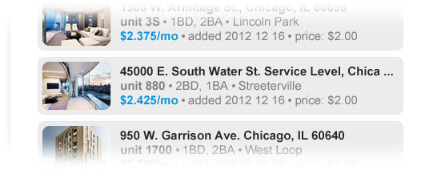 | 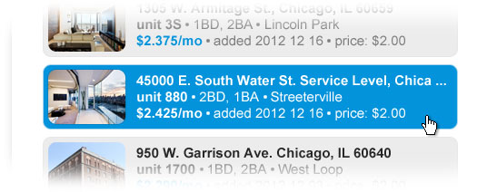 | 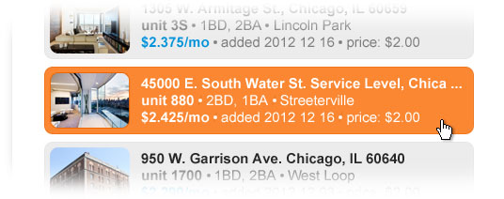

But in Dead Stick Mode, no more unselected listings can be highlighted. They can’t even be moused over:
Unselected listing | Unselected listing onMouseover | Unselected listing onClick
 | 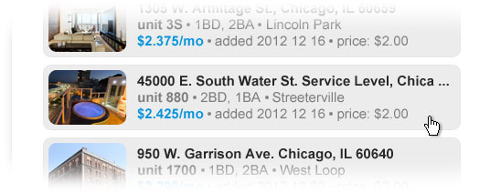

How Dead Stick Mode ceases
Dead Stick Mode (DSM) ceases and the Select Listings to Advertise On screen returns to normal whenever either of the criteria that triggered it is reversed. For example, if a User has triggered DSM by pre-selecting as many listings as he/she has subscribed for, moving one or more of these pre-selected listings back to the unselected column instantly ceases DSM and restores the Select Listings to Advertise On page to normal operating parameters.

Contingencies
The purpose of Dead Stick Mode is to provide a subtle and unobtrusive means of signaling to the User that they have reached their subscription limit. Inevitably, however, a number of scenarios will arise that will require the kind of clarity only a modal can provide. In the following instances, we must invoke what shall be referred to henceforth as the “Exceeded Limit Modal.”

“Multi-highlight exceeds limit”
Dead Stick Mode, as we’ve seen, kills the User’s ability to highlight unselected listings on the left side of the screen. But what if a User who has subscribed to advertise on 100 listings, and has 98 listings pre-selected, attempts to multi-highlight three unselected listings? We will not be expecting the system to track selected, pre-selected AND highlighted listings. Too unwieldy. So in this instance, the User is allowed to highlight all three. But when they attempt to drag these three highlighted listings to the pre-selected side of the page, the Exceeded Limit Modal is invoked and the operation fails. The listings stay highlighted, but cannot be dragged over together. In this example, the User must un-highlight one or more of these three and drag them over one at a time or in a group of two.

“Highlight All exceeds limit”
Highlight All exceeds limit behaves exactly like Multi-highlight exceeds limit, described above. If the User with a 100-listing subscription, for example, has 90 listings pre-selected and is showing 20 listings in the unselected column, he/she CAN highlight all of these listings using the highlight all link in the left column. But when they attempt to drag these 20 listings over to the pre-selected column, the Exceeded Limit Modal fires and the operation fails.

The Exceeded Limit Modal
The Exceeded Limit Modal is invoked whenever any of the scenarios described in the Contingencies section above occur.
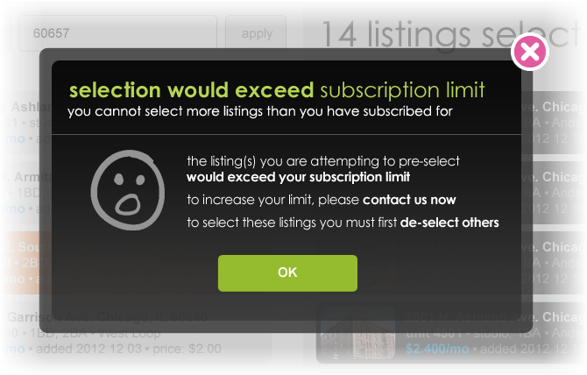
Closes modal.
A Photoshop comp for this screen element lives here >> https://www.dropbox.com/s/5y9b75ia8yn1aio/Exceeded%20Limit%20Modal%2002.psd

The Listing Filter Control

The Listing Filter Control exists on two screens:
- My Listings
- Select Listings to Advertise On
When deployed on the latter, it is slightly more complex, so it will be explained in this context and at the end, the exceptions for My Listings will be described.
The Listing Filter Control is intended to provide a means of narrowing and then further narrowing a group of displayed listings so that a Broker User can effectively target his/her advertising. This means that the filtering must be progressively reductive. That is to say it must be able to winnow out a smaller group from a larger and then, from that smaller group, an even smaller one. Think of Russian nesting dolls.

Here’s how it is intended to work, step-by-step:
Step 1
User views the Select Listings to Advertise On page.  User is shown the number of listings available to advertise on nationwide.  If the user is currently advertising on any of these, those listings are automatically subtracted from this nationwide list.  Brokers usually work regionally and it is in our interest not to have to load every single listing in the system, so the user is invited to narrow this list by location. | 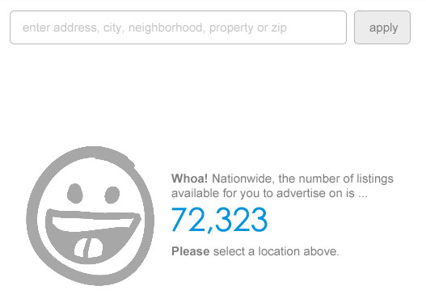  Note the difference here vs. initial PPT | All Listings Nationwide:  72.323K

The user picks a location in the exact same way an apartment seeker does on the home-page.  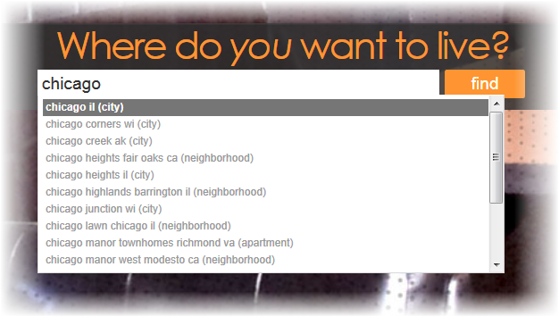 | 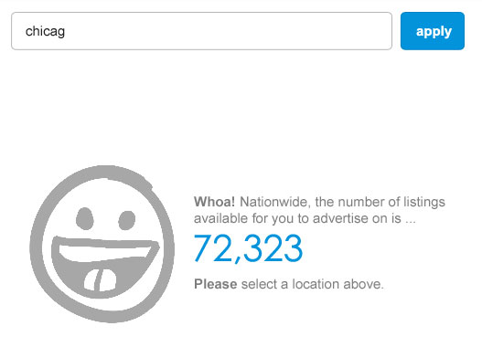 | Step 3  Step 2  All Listings Nationwide:  72.323K
‘Highlight All’ link shown
The screen is populated with all the listings in the specified area. Now the user is ready to start drilling in by the specifics of the rental offering (e.g. rent). Notice the location field has been completely replaced by a dropdown.  And three additional controls appear, too:  - A button showing the number of all listings available nationwide.  - A button showing the number of listings currently displayed in the location selected in the previous step. It additionally includes an X icon.  - A ‘+ Highlight All’ link. | 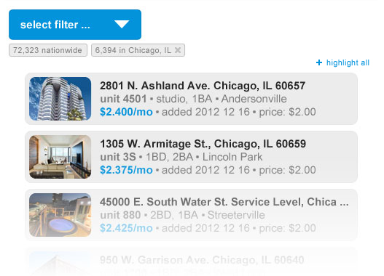  Clicking button takes you back to the beginning  beginning  Clicking button takes you back to the beginning  Lazy-load 6,394 listings | Chicago, IL: 6.394K  All Listings Nationwide:  72.323K
The User selects a filter from the dropdown … | 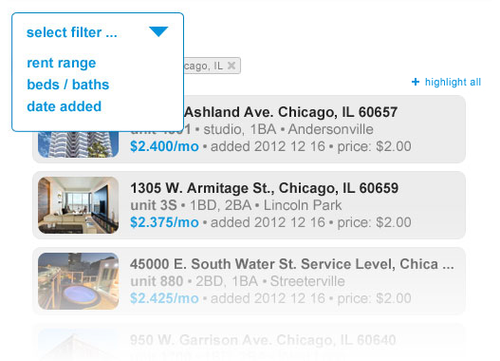 | Step 4  All Listings Nationwide:  72.323K  Chicago, IL: 6.394K
Step 5
The User has chosen to filter by rent range ... | 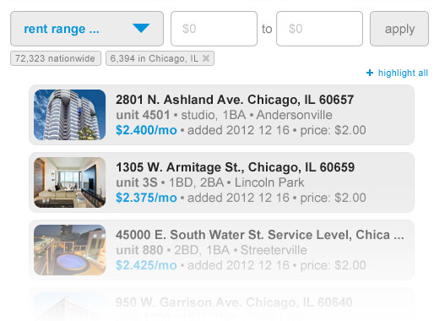 | All Listings Nationwide:  72.323K  Chicago, IL: 6.394K

The User enters a desired range.  The ‘Apply’ button colors up and becomes clickable.  When the User clicks ‘Apply’ … | 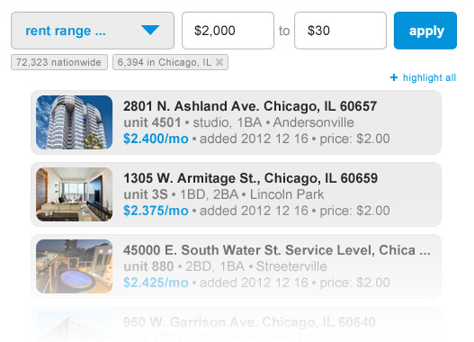 | Step 6  All Listings Nationwide:  72.323K  Chicago, IL: 6.394K
This button’s meaning has changed: Instead of taking the user back to the beginning, as before, it now takes you back to the state shown in steps 3-6. It has transformed from a ‘Last State’ into a ‘Past State.’

- … the fields disappear.  - The dropdown returns to the colored-up ‘Select a Filter …’ state.  - The selected rent range appears as a third button.  The button paradigm crystalizes: only the rightmost, most-recently-chosen filter-button contains an X icon that can be used to “peel away” the topmost layer of the “filtering onion.” The intent here is to make a distinction between two kinds of buttons: “Past State” vs. “Last State.” Past State buttons contain no X icon. Clicking them returns them to the filtering “state” denoted in the button’s label. Last State buttons do contain an X icon and clicking them removes the filter denoted in its label. | 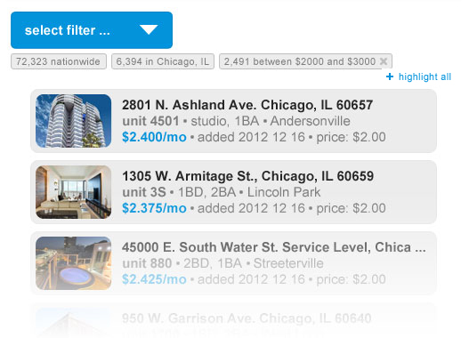  Lazy-load 2,491 listings  “Last State” Removes state denoted  “Past State” Clicks to state denoted | Step 7  Chicago, IL: 6.394K  Rent $2K to $3K: 2.491K  All Listings Nationwide:  72.323K

Now when the User goes to select a filter to further narrow his/her search, he/she sees the Rent Range filter is grayed.  This is to communicate to the User that this filter is currently in use for the results showing. | 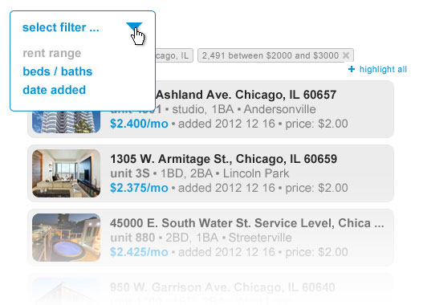 | Step 8  Rent $2K to $3K: 2.491K  Chicago, IL: 6.394K  All Listings Nationwide:  72.323K
Step 9
The User can still select it … | 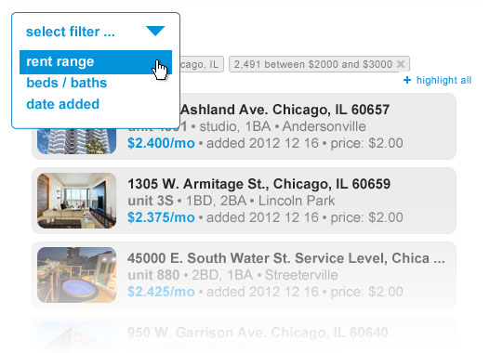 | Rent $2K to $3K: 2.491K  Chicago, IL: 6.394K  All Listings Nationwide:  72.323K

… and if he/she does, they see this. | 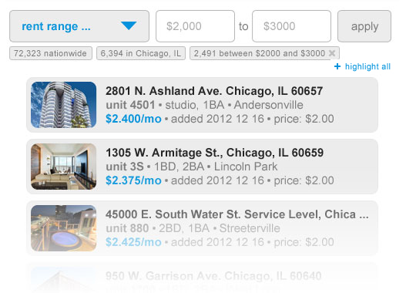 | Step 10  Rent $2K to $3K: 2.491K  Chicago, IL: 6.394K  All Listings Nationwide:  72.323K
Step 11
The User starts entering new numbers.  As before, the ‘Apply’ button colors up and becomes clickable. | 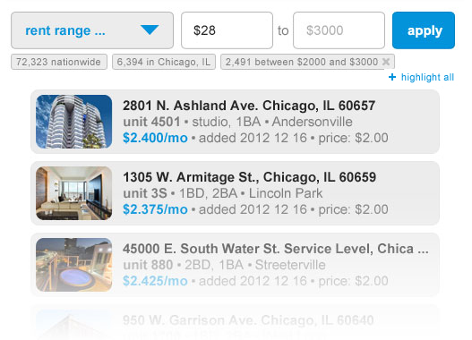 | Rent $2K to $3K: 2.491K  Chicago, IL: 6.394K  All Listings Nationwide:  72.323K

The User has successfully entered new numbers for the rent range filter, further narrowing their search. | 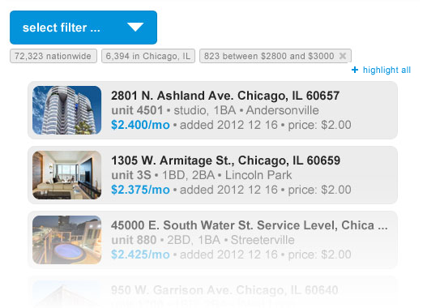  Note – when the user clicks the ‘Highlight All’ link, that link toggles to an ‘Un-highlight All’ link.  Note how this button updates  Lazy-load 823 listings | Step 12  Rent  $2.8K to $3K:  823  Chicago, IL: 6.394K  All Listings Nationwide:  72.323K
Step 13
Let’s say the User has decided to advertise on all these listings and so highlights all of them using the ‘Highlight All’ link.  Even though these listings are all highlighted now, the User can still filter the listings further … | 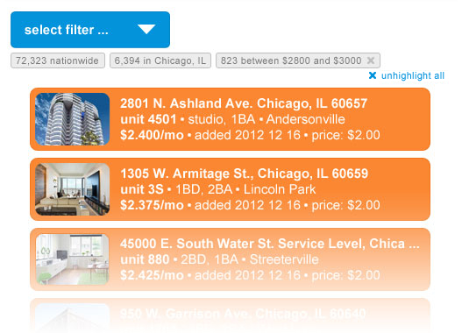 | Rent  $2.8K to $3K:  823  Chicago, IL: 6.394K  All Listings Nationwide:  72.323K

… for example by Date Added … | 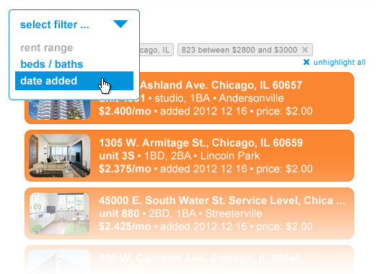 | Step 14  Rent  $2.8K to $3K:  823  Chicago, IL: 6.394K  All Listings Nationwide:  72.323K
Step 15
… User sees control for adding date … | 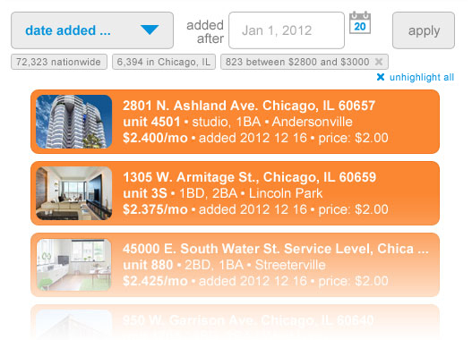  This icon is a place-holder. Please use whichever calendar icon is used elsewhere in site.  Clicking it displays whichever date-picker calendar is used elsewhere in site. | Rent  $2.8K to $3K:  823  Chicago, IL: 6.394K  All Listings Nationwide:  72.323K

The User selects a date.  As before, the ‘Apply’ button colors up and becomes clickable. | 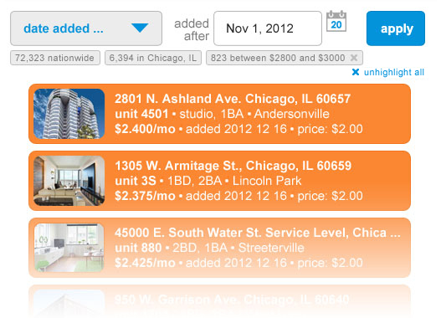 | Step 16  Rent  $2.8K to $3K:  823  Chicago, IL: 6.394K  All Listings Nationwide:  72.323K
Step 17
The modal shown here displays when both criteria (as in this example) have been met:  - One or more of the unselected listings has been clicked by the user.  - The User attempts to apply any additional filter  This “Second Chance Modal” is described in a later section of this document. Basically, the user is warned that listings they highlighted, but have not pre-selected will be lost and would they like to just add these to their order. | This modal is described in the section Second Chance Modal | Rent  $2.8K to $3K:  823  Chicago, IL: 6.394K  All Listings Nationwide:  72.323K

The number of listings is further reduced.  A filter button for ‘Date Added’ is appended on to the row of other filter buttons, which, because of their number, must now wrap to a second line. The wrapped row of filter buttons pushes the listings and the ‘Highlight All’ link down the page to accommodate.  As before, the filter resets to the ‘Select Filter’ state after the ‘Apply’ button has been pushed. | 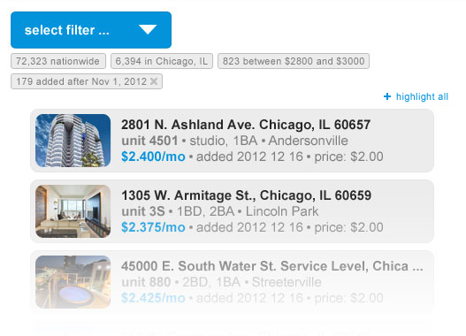  Lazy-load 179 listings | Step 19  Step 18  Added after  Nov 1, 2012: 179  Rent $2.8K  to $3K: 823  Chicago, IL: 6.394K  All Listings Nationwide:  72.323K
Blue on mouseover
Now let’s say the User has finished selecting a number of listings and wants to start a new search in Chicago. Let’s say the User knows that this time, he/she wants to target much lower rents. All the User needs to do is click the city button … | 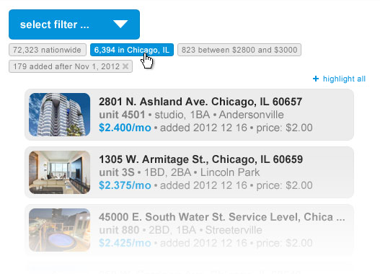 | Added after  Nov 1, 2012: 179  Rent $2.8K  to $3K: 823  Chicago, IL: 6.394K  All Listings Nationwide:  72.323K

… and now he/she can start re-filtering from the city level. | 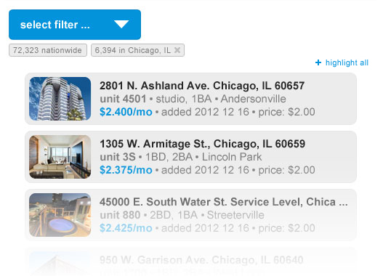 | Step 20  Chicago, IL: 6.394K  All Listings Nationwide:  72.323K
What if any of the unselected listings were highlighted when the user removes one or more layers of filtering (using either a Last or Past button)? Simple – they stay highlighted. When the User ADDS filters, we need to display a modal if any of the unselected listings were highlighted and that scenario is described in the “The Second Chance Modal” section later in this document. But whenever you take away layers of filtering, the highlighted listings stay highlighted and will appear interspersed with the un-highlighted listings brought in to the mix by the removal of the filter.

The “Second Chance Modal”

What happens when a User attempts to filter unselected listings they have clicked on
Inevitably, a User will invoke a filter that, when applied, will exclude one or more listings he/she has highlighted, but not pre-selected by dragging it over to the selection bucket. For an example of such a scenario, review steps 13-18 in the previous section. In such an instance, the question we want to pose to the User is this: we will proceed with the filtering operation you’ve requested, but which one of the following two things do you want us to do with the listings you’ve highlighted but not pre-selected?
- Forget them and filter?
- Or pre-select them and filter?
The user actually has a third choice, also, but it need not be described for them. They can close the modal, which cancels the filtering operation they initiated when clicking the ‘Apply’ button. This gives them a chance to perhaps add some of the highlighted listings, but not all, to their order.
The following modal only displays when both of the following two criteria have been met:
- One or more of the unselected listings has been highlighted by the user.
- The user attempts to apply any additional filter (removing any filter NEVER pops this modal).
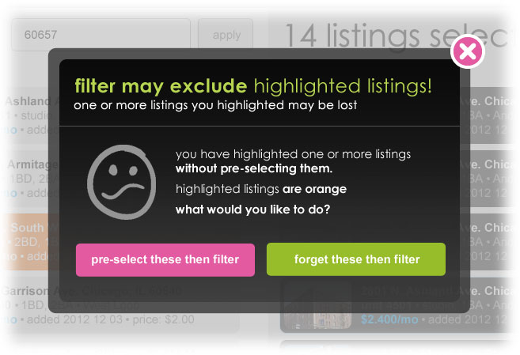
The modal closes and the onClick action of the ‘Apply’ button is canceled.
System adds all clicked/highlighted listings to the current order and then proceeds with the filtering operation.

System “forgets” all clicked/highlighted listings and proceeds with filtering operation.
A Photoshop comp for this modal lives here >> https://www.dropbox.com/s/uy6eatn09l9l73g/Second%20chance%20modal%2003.psd

Manage My Ads for Broker Subscription
The Broker User can use the “Manage My Ads” screen to do the following:
- Create a new ad
- Delete existing ads
- Designate a “Current Ad” from among the ads they have already created. If they have never created an ad, a default ad will be presented as their Current Ad. And obviously, if they have only created one ad, this one ad is the Current Ad, by default. There must always be a Current Ad.
- Edit existing ads

The two contexts under which a User will encounter the Manage My Ads screen
There are exactly two contexts under which a Broker User will ever see the Manage My Ads (MMA) screen:
- In the context of choosing listings to advertise on
- In any other context
My Listings
Future User Listings screens, TBD
Manage My Ads / Create New Ad
Select Listings to Advertise On
Navigating to MMA via SGN

Navigating to MMA via SGN
Context 2: Any other

Context 1: Choosing listings to advertise on

Context 1: choosing listings to advertise on
One of the contexts in which the User will encounter the Manage My Ads page is that of choosing listings to advertise on. This context exists when the following two criteria have been met:
- The user has selected one or more listings on which to advertise using the Select Listings to Advertise On page.
- Has pressed the ‘Select’ button on that same page.
This context becomes important in future versions of the User Listings build-out because the User must proceed in these future versions from the Manage My Ads (MMA) screen to a series of payment screens. And if the User attempts to navigate away from the MMA screen before moving on to these pay screens, the flow of the purchase is interrupted. For the Broker Subscription version of User Listings, however, the context of choosing listings to advertise on is important only insomuch as it explains the sudden instantiation of the Manage My Ads screen after the User pulls the trigger on his/her selection of listings. In short, the only point of instantiating the MMA screen at this juncture for now is to show the User which ad is appearing on all of the Listings they have just chosen and provide them an opportunity to change it. The MMA screen functions here exactly as it would if the User were visiting it randomly through the Supplemental Global Nav.

Context 2: all other contexts
The second context in which the User will view the Manage My Ads (MMA) page is any but that of choosing listings to advertise on. It is likely that a Broker User who has acquired some level of familiarity with User Listings would care to stop by the MMA page before selecting any listings to advertise on. The User would do this by navigating to it using the Supplemental Global Nav. Again, the distinction is made here only to point up the fact that for the Broker Subscription version of User Listings, the MMA screen is instantiated in two very different ways – one in which the User has requested it directly and the other in which he/she has not. Again, these differences in context become important in future iterations of the User Listings build-out in which on-line payment is involved. For the Broker Subscription iteration, the difference, as we’ve seen, is a matter only of when the Manage My Ads page appears, not what it does and/or how it behaves.

One-User-One-Ad
In future versions of User Listings, functionality will likely be proposed that would enable the Broker User to have multiple ads running at the same time on different listings. For any future iteration that includes the pay-as-you-go form of payment, the User will at least be able to vary the ad based on the group of listings purchased at any given time (For example, a User logs in on Monday and pays to advertise on 30 listings, they can apply ad A to this group. If they then log in again on Tuesday, they can purchase 20 more listings and apply ad B to this group – and so on). But for Broker Listings, and for the sake of lean methodology, the User can only ever have one ad running at a time. Say a User has 50 out of 100 possible ads running on 50 listings and logs in. If they go to Manage My Ads and change their Current Ad, it changes for the 50 listings they’re already advertising on and will appear on the 50 new listings they’re about to advertise on. In short, their subscription entitles them to create as many different ads as they like, but they can only ever run one at a time. Some thoughts about how this user schema relates to subscriptions are captured in Appendix 1.

Overview
The Manage My Ads screen is similar to some of the other screens in this Broker Subscription build of User Listings in that it’s layout is bifurcated. On the left the User is shown the User’s Current Ad along with options to edit it or create a new one. On the right, the User is shown every ad they have ever created, minus those they have chosen to delete. Here they can perform the following actions on these “Inactive Ads:” promote to current ad, edit, or delete. The only two kinds of ads that can ever appear on the MMA page are exactly one Current Ad and zero to N (TBD) Inactive Ads.
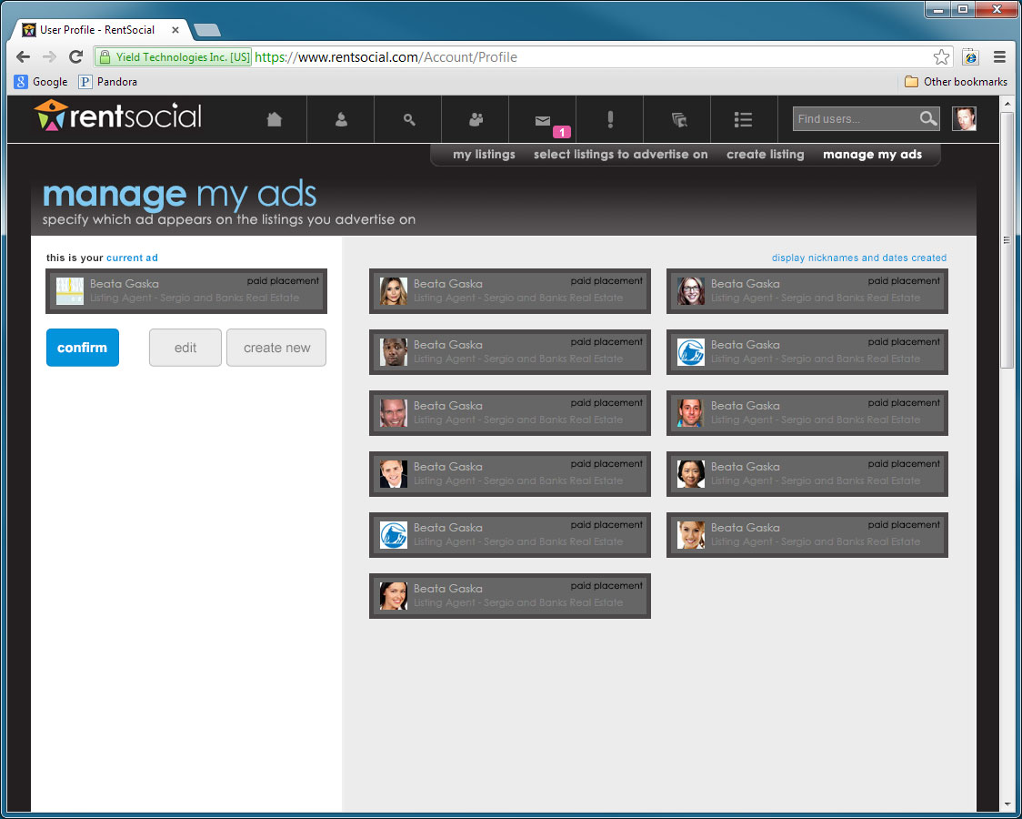
A Photoshop comp of this screen lives here >> https://www.dropbox.com/s/504eygrq5hxjyc1/FTC%20MMA%2008.psd
Please refer to the state labeled ‘Confirm’ in the ‘Layer Comps’ panel in Photoshop for this exact view.
For more on using the Layer comps panel, please refer to the instructions in Appendix III
The Current Ad
Inactive Ads

The Current Ad
The Current Ad is a crucial concept and must be understood before the Manage My Ads screen can be properly constructed. It comprises the most important means of conveying to the User our One-User-One-Ad paradigm for the Broker Subscription build of User Listings. Though the meaning of Current Ad will evolve in future versions of User Listings, for the Broker Subscription build it is extremely specific and deliberately simple. The Current Ad is that ad the User has designated to appear on those listings they have chosen to advertise on. If the User has not so designated a Current Ad, a “Default Current Ad” is used until the User creates one or chooses from among those he or she has created previously. In short, there is always a Current Ad. In no incarnation of the Broker Subscription build of User Listings can a Current Ad not exist. The Current Ad cannot vary for any sub-set of these listings. For example, it cannot vary based on when the User chose any of these listings. The User can choose ten listings on Monday, ten more on Tuesday and another ten on Wednesday. Whatever ad they last confirmed as their Current Ad is the ad that appears on all 30. In short, the Current Ad is the one ad in the One-User-One-Ad equation. The User’s ad is their ad is their ad is their ad (some thinking related to the concept of the Current Ad is described in Appendix II).
A Photoshop comp of this screen lives here >> https://www.dropbox.com/s/504eygrq5hxjyc1/FTC%20MMA%2008.psd
Please refer to the state labeled ‘Confirm with current descrip showing’ in the ‘Layer Comps’ panel in Photoshop for this exact view.
For more on using the Layer comps panel, please refer to the instructions in Appendix III
A reminder of this potentially elusive concept is never far from the User’s fingertips on the Manage My Ads page:
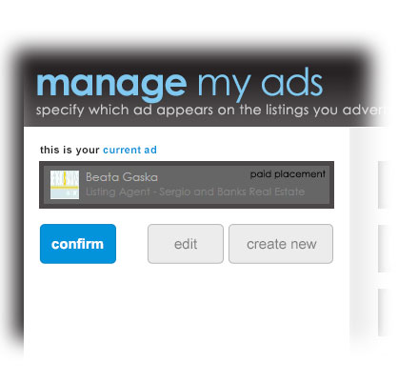
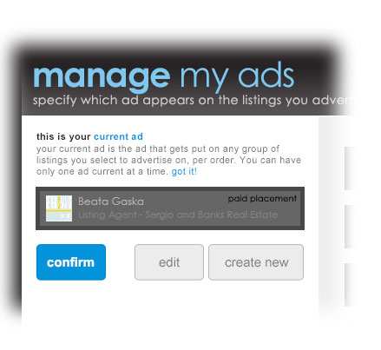
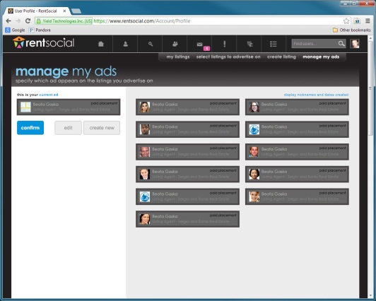
Collapses verbiage.
Link expands hidden verbiage …

… whatever content is beneath the verbiage gets pushed down.

Confirm
The only purpose of the Manage My Ads screen is for the User to be satisfied with whatever ad is appearing on the listings they have chosen to advertise on. The User registers this satisfaction by clicking the ‘Confirm’ button. They can click this button as the first thing they do upon encountering the MMA page or as the hundred-and-thirty-fourth thing they do. It makes no difference. But clicking it is always the last thing they do. That is because clicking it always takes them off the MMA page. Where they go next depends upon the context in which they have encountered it. More on this shortly. It should be noted first that the User can leave the MMA page in whatever way they desire: by clicking a different link in the Supplemental Global Nav. Or by clicking the browser’s ‘Back’ button. If they do leave the MMA page without clicking the Confirm button, they are assumed to be satisfied with whatever ad is shown to be their Current Ad and nothing changes.
Clicking the Confirm button, in any instance, is purely cosmetic functionality. But one that serves to:
- Remind the User of the control they have over what ad appears on their listings
- Habituate the User to an experience in which they will enjoy greater functionality in future versions of User Listings that will include assigning different ads to different groups of listings (for now, the User is trapped in a One-User-One-Ad paradigm). Further thoughts on this are discussed in Appendix I.
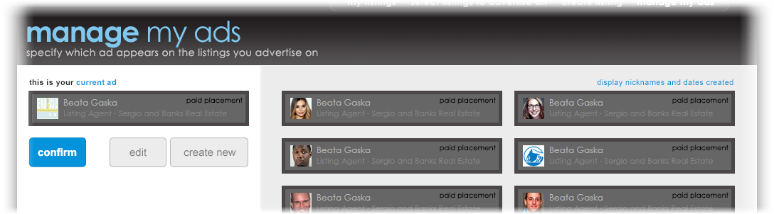
Always closes the Manage My Ads page

Context 2: User is then taken back to the originating page
Context 1: User is then taken to the My Listings page.

Create New / Edit
Clicking either the Edit or Create New buttons (instead of Confirm) fires a configuration of the Manage My Ads page in which six input fields, a Save button and a Cancel link are displayed. These fields enable the User to control the data displayed in the Current Ad. Any new ad being created automatically becomes the Current Ad.

Flow for Create New

User clicks the Create New button.
The button colors up on mouseover (blue with darker blue border and white bold font). Same for onClick.
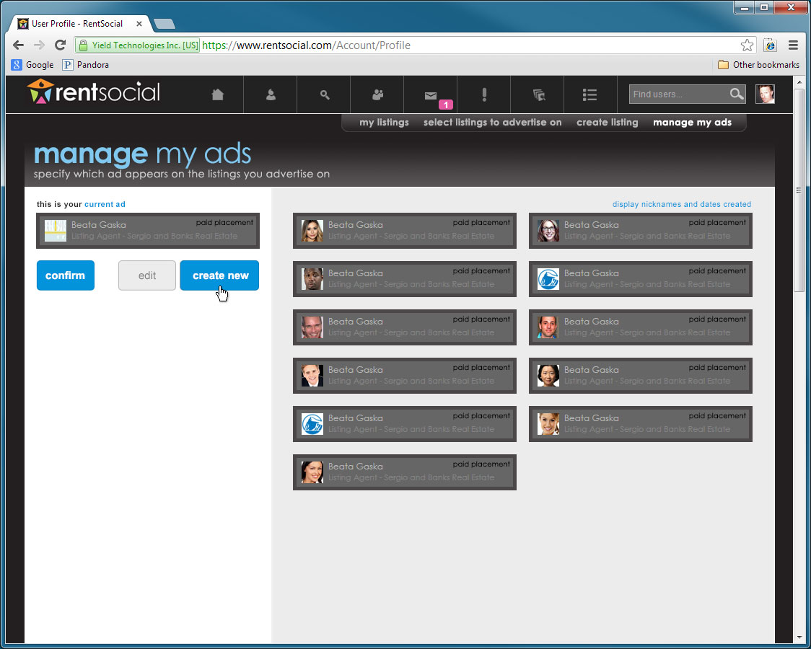
A Photoshop comp of this screen lives here >> https://www.dropbox.com/s/504eygrq5hxjyc1/FTC%20MMA%2008.psd
Please refer to the state labeled ‘Create New button colored-up’ in the ‘Layer Comps’ panel in Photoshop for this exact view.
For more on using the Layer comps panel, please refer to the instructions in Appendix III

The ad that was the Current Ad appears onClick in the inactive section of the page, top left.

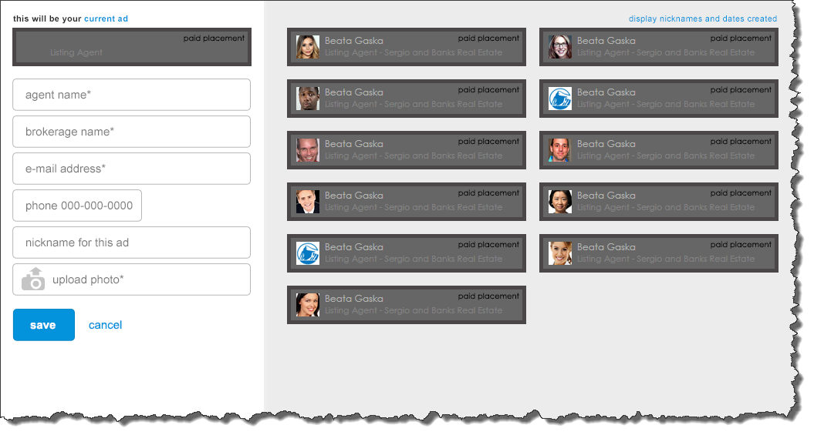
8th created
9th created
6th created
7th created
4thcreated
5th created
10th created
11th created
2nd created
3rd created
First created
Inactive Ads are arranged chronologically left-to-right and top-to-bottom with the most recently-created appearing top left and the first-created appearing at the bottom. This order maintains itself even when Inactive Ads are deleted.

The Current Ad is a blank slate that updates in real time as the User enters data into the fields.
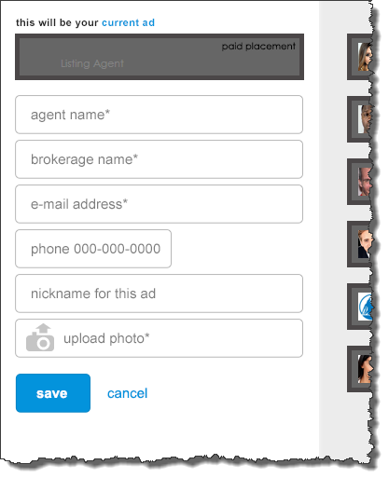
Some fields are required, some are not. Required items carry an asterisk. There is standard validation for required fields.
The User can either Save or Cancel:
- If the User Saves, the newly-created Ad becomes the Current Ad. The fields disappear and the Confirm, Create New and Edit buttons return.
- If the User Cancels, the ad that was the Current Ad prior to the User clicking Create New is removed from the list of Inactive Ads and again becomes the Current Ad. Whatever data was entered for the aborted new ad is discarded by the system. The fields disappear and the Confirm, Create New and Edit buttons return.

A Photoshop comp of this screen lives here >> https://www.dropbox.com/s/504eygrq5hxjyc1/FTC%20MMA%2008.psd
Please refer to the state labeled ‘Create New’ in the ‘Layer Comps’ panel in Photoshop for this exact view.
For more on using the Layer comps panel, please refer to the instructions in Appendix III

Flow for Edit

User clicks the Edit button
The button colors up on mouseover (blue with darker blue border and white bold font). Same for onClick.

Fields display pre-filled with grey Save button
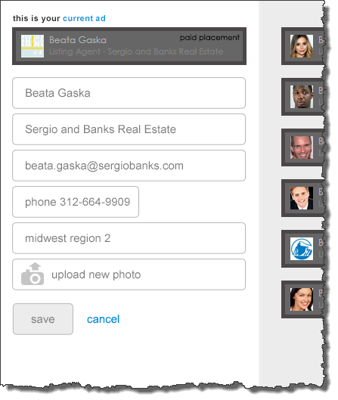
The same six fields (with Save button and Cancel link) that occur when the User clicks Create New occur but this time pre-filled with the data that was entered during the ad’s (the Current Ad’s) creation. The pre-filled data can be modified or left as it is – the Save button works regardless. However, the Save button does not color up until any field is modified in some way. If nothing is changed, the record can be saved, but in such an instance, the Save button only colors up on mouseover and onClick.
The User can either Save or Cancel:
- If the User saves, the newly-edited Ad remains the Current Ad. The fields disappear and the Confirm, Create New and Edit buttons return. Note! The one immutable characteristic of any ad is its creation date. This persists even if the User changes everything else about the ad. The User can never change it. The system keeps no record of deleted ads, however.
- If the User Cancels, the ad that was the Current Ad prior to the User clicking Create New is removed from the list of Inactive Ads and again becomes the Current Ad. Whatever data was entered for the aborted new ad is discarded by the system. The fields disappear and the Confirm, Create New and Edit buttons return.

A Photoshop comp of this screen lives here >> https://www.dropbox.com/s/504eygrq5hxjyc1/FTC%20MMA%2008.psd
Please refer to the state labeled ‘Edit’ in the ‘Layer Comps’ panel in Photoshop for this exact view.
For more on using the Layer comps panel, please refer to the instructions in Appendix III

Rollover functionality on Inactive Ads
When the User mouses over any Inactive Ad, that ad evinces a rollover state which provides the User with the ability to perform three actions upon it:
- Promote it to Current Ad
- Edit it
- Delete it
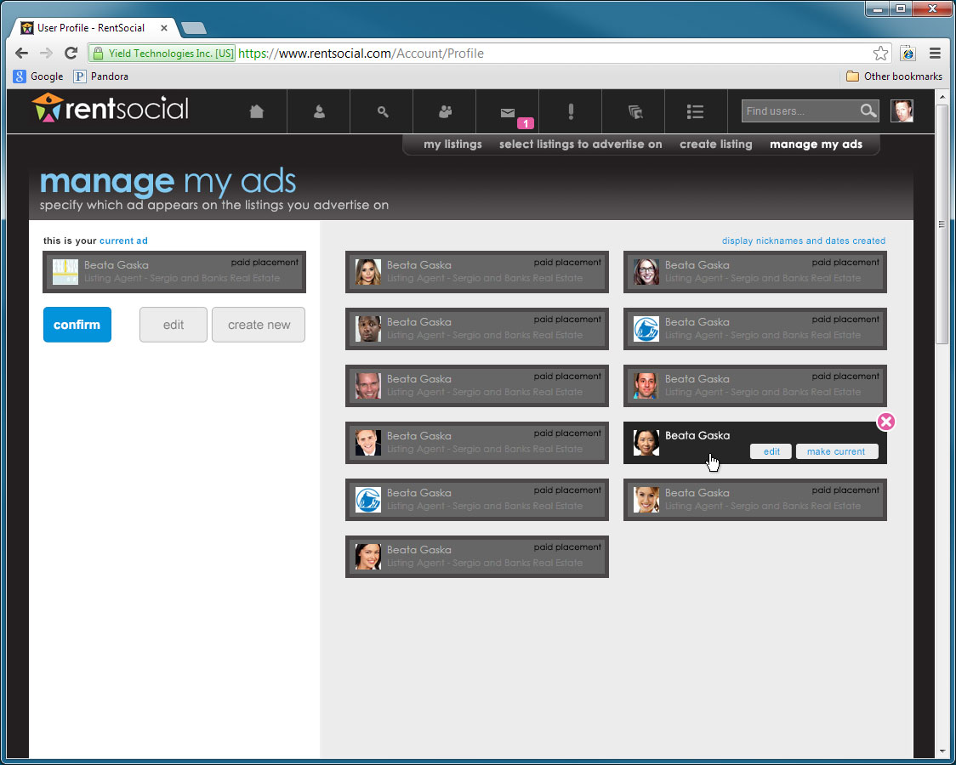
A Photoshop comp of this screen lives here >> https://www.dropbox.com/s/504eygrq5hxjyc1/FTC%20MMA%2008.psd
Please refer to the state labeled ‘Rollover’ in the ‘Layer Comps’ panel in Photoshop for this exact view.
For more on using the Layer comps panel, please refer to the instructions in Appendix III

Promoting an Inactive Ad to the Current Ad
A User may decide that an ad they created previously is a better fit for the listings they are currently advertising on than the Current Ad.
To do this, the User need only mouse over any of their Inactive Ads and they are presented with the option to do so, among others.
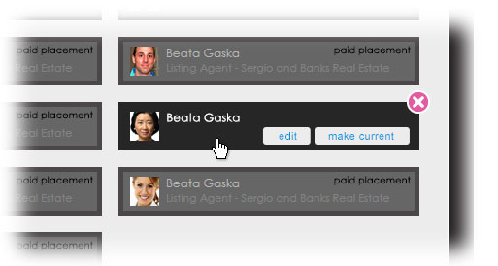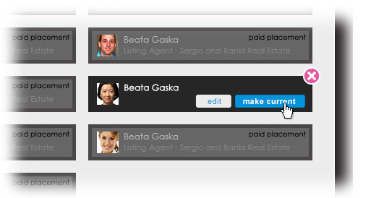
All they need do now is click the ‘Make Current’ button.
A Photoshop comp of this screen lives here >> https://www.dropbox.com/s/504eygrq5hxjyc1/FTC%20MMA%2008.psd
Please refer to the state labeled ‘Rollover - Moused Over’ in the ‘Layer Comps’ panel in Photoshop for this exact view.
For more on using the Layer comps panel, please refer to the instructions in Appendix III
That Inactive Ad becomes the Current Ad.
The Ad that was current appears on the Inactive Ad side, in order of its creation date, as described previously.

Editing an Inactive Ad
We’ve already seen how a User edits the Current Ad. But what if a User wishes to modify an Inactive Ad?
To do this, they can either promote it to Current Ad (as described in the section just previous) and then click the Edit button as described in the section on the Edit flow. Or they can just click the Edit button on mouseover.
When they do this, the Inactive Ad is instantly promoted to Current Ad and the Edit configuration described previously is automatically fired. Two steps in one. As before, the ad that was current prior to this operation joins the list of inactives.
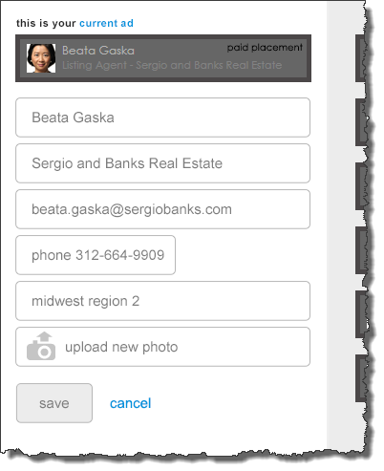

Deleting Ads
In some instances, especially those in which disused ads start to pile up, the User may wish to delete one or more of their inactive ads. Doing this is simple and straightforward.
- User mouses over Inactive Ad
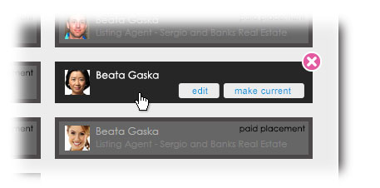
- User clicks close icon (X)
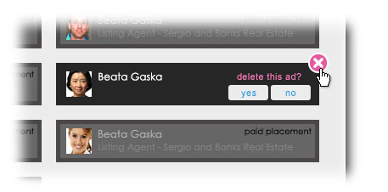
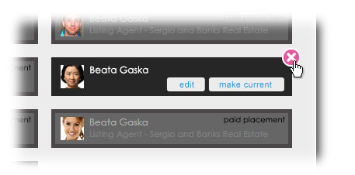
A Photoshop comp of this screen lives here >> https://www.dropbox.com/s/504eygrq5hxjyc1/FTC%20MMA%2008.psd
Please refer to the state labeled ‘Rollover - Confirm Delete Ad’ in the ‘Layer Comps’ panel in Photoshop for this exact view.
For more on using the Layer comps panel, please refer to the instructions in Appendix III
3. Confirm buttons appear. User makes selection.

The Default Ad
As we’ve seen, there must always be a Current Ad. Always. So what does the Broker User see when he/she first views the Broker Subscription pages? They haven’t had the chance to even create an ad. Or what happens if the User chooses to select listings to advertise on, but hasn’t yet created a Current Ad? The answer to both of these questions is the “Default Ad.”
In order for any User to become a Broker User, they must first become a regular User (some additional thoughts on this topic appear in Appendix II). To become a regular User, a person must minimally provide a first name, a last name and an e-mail address.
These are three of the four data elements we require to create a new ad (two others are optional) and so this is how they are used to create a Default Ad and to do so automatically. The fourth data element required when creating a new ad is a photo. If the User has yet to provide one for their standard User profile, the system uses the same default profile image used for any User who hasn’t provided a profile photo (this will obviously serve as some motivation for the User to start creating and/or editing ads). It should be noted here that this equivalency between a User’s profile photo and their ad photo is only true in the context of the User having never created an ad. The profile photo never equals the ad photo unless zero ad photos have been uploaded.

The two states of the Manage My Ads screen when no ad has been created
When the Manage My Ads screen is encountered by any given User, it can instantiate in only one of exactly two configurations:
- No Ad Created
- First-Timer

No Ad Created
The following configuration of the Manage My Ads screen instantiates if the following is true: logged-in User has never created an ad, but has viewed the Manage My Ads screen previously.
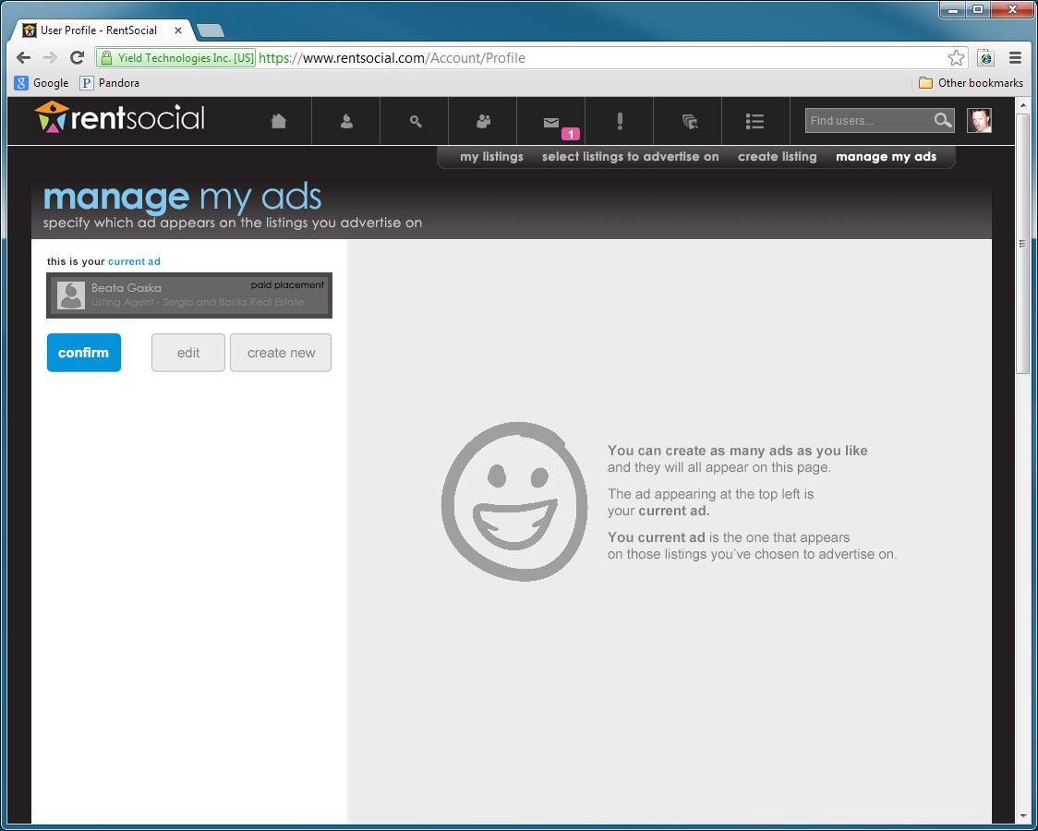
A Photoshop comp of this screen lives here >> https://www.dropbox.com/s/504eygrq5hxjyc1/FTC%20MMA%2008.psd
Please refer to the state labeled ‘Default - No Ad Created’ in the ‘Layer Comps’ panel in Photoshop for this exact view.
For more on using the Layer comps panel, please refer to the instructions in Appendix III

First-Timer
The following configuration of the Manage My Ads screen instantiates if the following is true: logged-in User has never created an ad, and has never viewed the Manage My Ads screen.
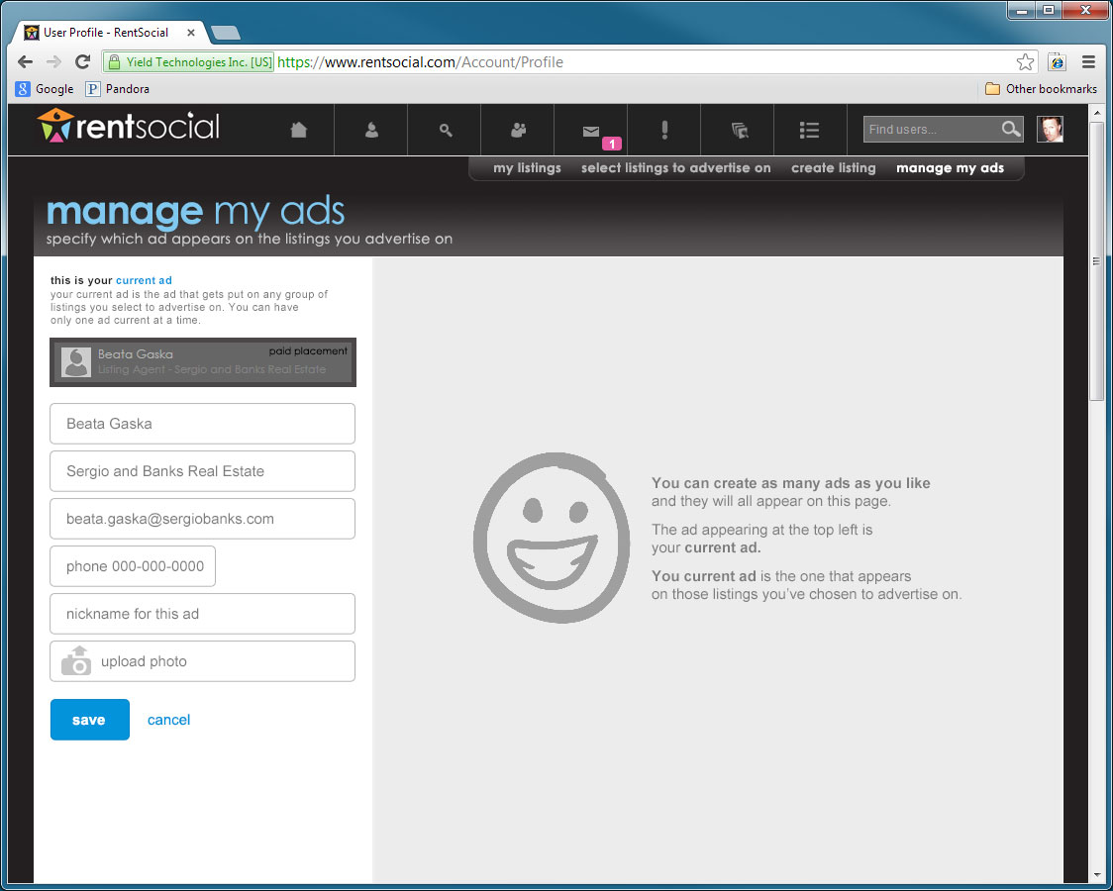
A Photoshop comp of this screen lives here >> https://www.dropbox.com/s/504eygrq5hxjyc1/FTC%20MMA%2008.psd
Please refer to the state labeled ‘Default - First-Timer’ in the ‘Layer Comps’ panel in Photoshop for this exact view.
For more on using the Layer comps panel, please refer to the instructions in Appendix III

Nicknames and Dates Created
In future versions of User Listings, ad management will become a more crucial part of its experience as Users assign more than one ad at a time to the listings they have elected to advertise on. This more advanced experience will require Users to search for, filter, and quickly select ads on the fly. Enabling them to do this will entail exposing various search criteria. The Broker Subscription build of User Listings gets the ball rolling in this regard by exposing two criteria: Nickname and Date Created.

Nickname
This is an optional field when Users create a new ad or edit one. The User may enter whatever nickname for the ad they wish up to 50 characters, but if they don’t, and this is important, a nickname is assigned to the ad automatically. This automatic nickname begins with ‘rs’ (for RentSocial) and the rest is generated based on the day and time of its creation (ensuring no two are alike). For example, an ad created on the 5th of July, 2013 at 3:56 in the afternoon would carry the nickname rs20130705-1556.

Date Created
Just a simple date stamp provided in Gregorian middle-endian format (as opposed to the military format evinced in the automatic nickname). For the ad created in the above example, the Date created would be July 5, 2013.

Showing Nicknames and Dates Created
Because of their limited utility, the nicknames and dates created for all Inactive Ads are hidden by default when the User first encounters the Manage My Ads screen in all instances. Indeed, in order to even see the nickname and date created for the Current Ad, the User must fire the Edit configuration by clicking the Edit button. To view them, however, the User need only click the link in the upper right-hand corner of the Inactive Ad region of the screen. This link toggles onClick and clicking it again hides the nicknames and dates again.
toggle
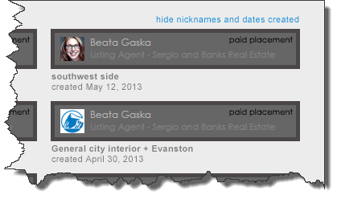
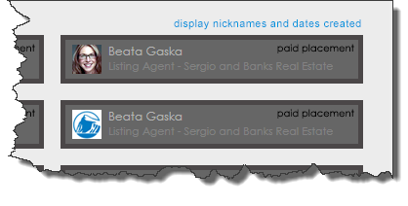
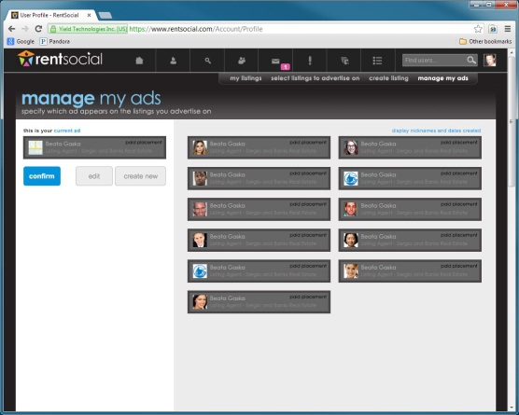
This is the Manage My Ads screen with the Nicknames and Dates Created showing:
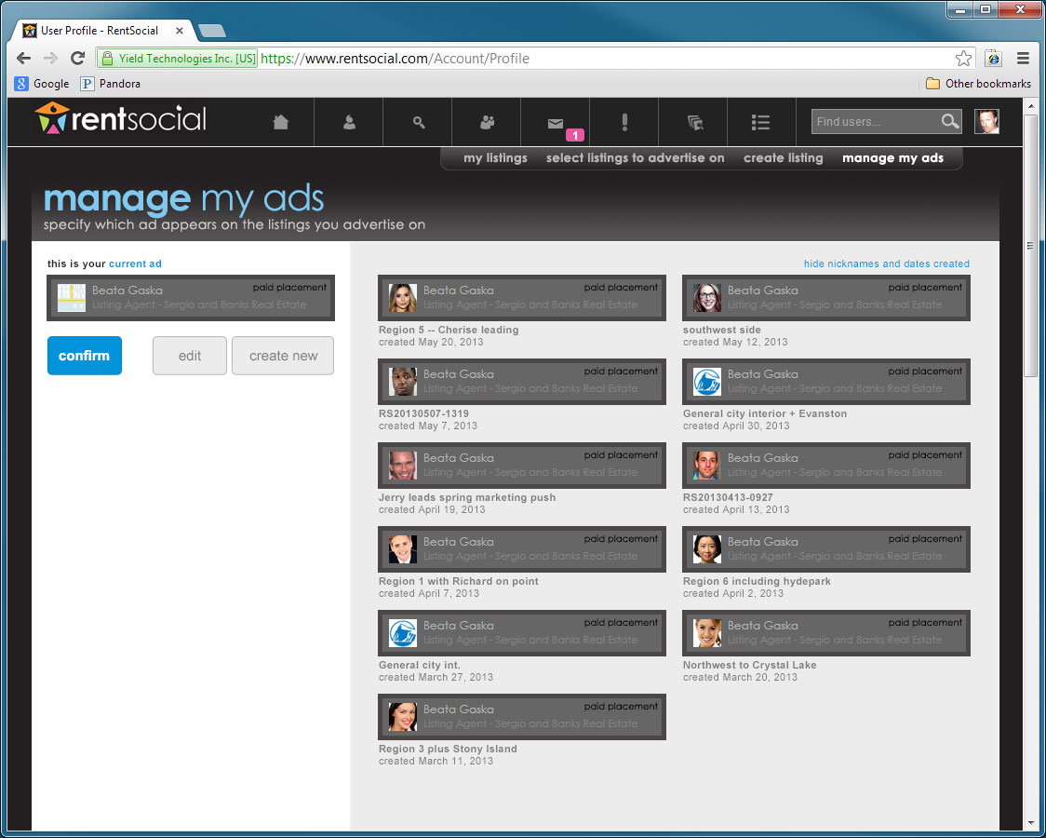
A Photoshop comp of this screen lives here >> https://www.dropbox.com/s/504eygrq5hxjyc1/FTC%20MMA%2008.psd
Please refer to the state labeled ‘Inactives with Nicknames and Dates Created’ in the ‘Layer Comps’ panel in Photoshop for this exact view.
For more on using the Layer comps panel, please refer to the instructions in Appendix III

Appendix I – Questions still outstanding as of version 1.0 of this document

The Supplemental Global Nav
Regarding the global nav add-on …
What is the gateway between the rest of the screens and the broker listings screens?

Can brokers advertise on only ListHub listings?
Has a business decision been made to offer brokers the opportunity to advertise only on ListHub listings and NOT listings from any other source? Like RentSentinel listings?

How would the One-User-One-Ad schema tie in to subscriptions?
Discussion on this so far has proceeded along these lines: Brokerage A wants ten of its brokers to be able to advertise on 100 RentSocial ListHub listings each. They sign a purchase order (PO) for a $1,000 a month subscription. Brokerage A then forwards to us the ten separate logins for these ten brokers and we flag each in the user record as Broker Users. Once they are flagged as Broker Users in the user record, each of these ten brokers can now create as many ads for themselves as they wish, but because of the one-user-one-ad framework, can only use one at a time. So each broker only gets one ad at a time, but Brokerage A effectively gets ten ads for one subscription/PO.

Appendix II – Assumptions

Broker Users must first be regular Users
This document assumes that any User for whom a Purchase Order exists requiring said User to be flagged in the user record as a Broker User will have already created a User account. In short, that any User who wants to be a Broker User must be a regular RentSocial User first. This assumption bears on the concept of the Default Ad, described in a section on the subject in this document.

Appendix III – Special Instructions

Viewing multiple comps in one Photoshop file
A recent innovation in Photoshop enables the user to view any Photoshop file in multiple states, making some layers visible and others not. This is useful for sharing comps because it no longer requires the designer to share out a different version of the same file for every view a develop needs to create. All the views exist in one file. To access these separate views, the user need only click the button in the “Layer Comps” panel of Photoshop. To view this panel, it’s Window > Layer Comps.
