Basic UI Mechanisms, Dimensions and Responsiveness Specifications – Lead2Lease 2.0 v.1.0
Table of Contents
The Purpose of this document 3
Assumptions 3
Viewable Area excludes browser chrome 4
The responsivenss of the Ribbon is a separate conversation 5
L2L UI Objects 6
An Object by any other name … 6
The Action Button Column (ABC) 8
Quick Search 9
Layout 9
User Experience 10
Five Screen Configurations 11
Ideal – widest possible to 1387px 12
Distinguishing characteristics: 12
Standard -- 1386px to 1055px 13
Distinguishing characteristics: 13
Compressed – 1054px to 992px 14
Distinguishing characteristics: 14
ABC Wraps – 991px to 831px 15
Distinguishing characteristics: 15
Half-Span Module Content Areas (HSMCA) Wrap – 830px to 1px 16
Distinguishing characteristics: 16
Abbreviated Right-Side Expandable Overlay Nav (ARSEON) 17
The characteristics of the ARSEON 17
Larger icons spaced appropriately 17
Third in Stack Order 17
Always translucent 17
Always spans the entire height of the page from top to bottom, whether contracted or expanded 18
Two distinct states 19
The Behaviors of the Abbreviated Right-Side Expandable Overlay Nav (ARSEON) 20
Icons and text-link labels on mouseOver 20
Expanding and Contracting the Abbreviated Right-Side Expandable Overlay Nav (ARSEON) 21
Appendix I - Viewing multiple comps in one Photoshop file 23

The Purpose of this document
The purpose of this document is to provide a framework of shared UI components Development can use to create a standard template for L2L 2.0 screens.

Assumptions
This document makes two key assumptions:
- Viewable Area excludes browser chrome
- The responsivenss of the Ribbon is a separate conversation

Viewable Area excludes browser chrome
Integral to the process of making any screen responsive is determining when the screen should, well, respond. This is achieved by establishing “Break-points.” A Break-point is that width at which a new responsive configuration of a screen’s UI objects gets triggered.
Because the width of browser chrome can vary slightly across browsers, we shall refer only to a screen’s “Viewable Area” when specifying screen widths for L2L 2.0. Viewable Area is what Google Chrome means when it refers to that portion of a browser session that appears in the browser’s “Viewport.”
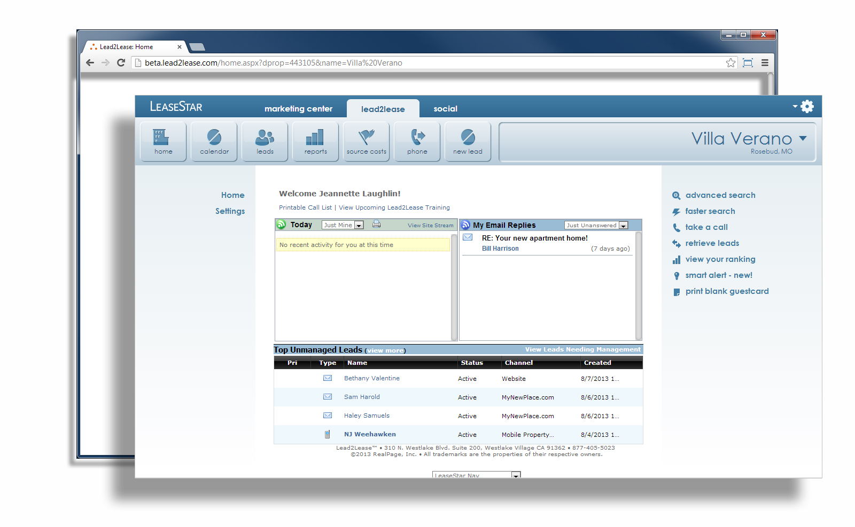

The responsivenss of the Ribbon is a separate conversation
Because further elaboration on the responsiveness of the Ribbon is a consideration universal to LeaseStar and not just L2L, it is not scoped for this document.
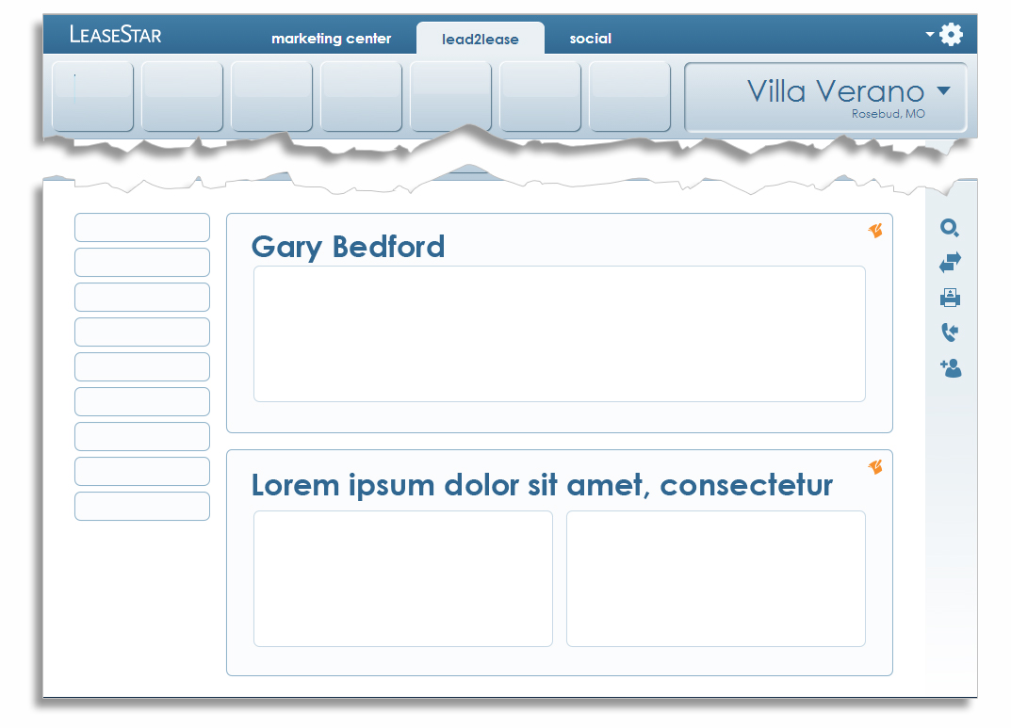

L2L UI Objects

An Object by any other name …
The first step in describing the behaviors and responsiveness of the UI components and mechanisms populating any given set of screens is naming the objects that comprise them.
Quick Search
7.1
Right-Side Nav Faded Background
(RSNFBG)

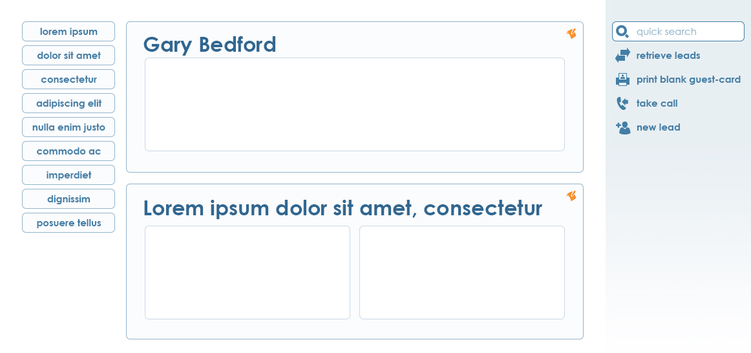
1.1
ABC Button
7
9
8
4
Smart Alert Feed (SAF)
Global Action Options Area (GAOA)
(TBD)
2
Module
Control
Half-Span Module Content Area (HSMCA)
Action Button Column (ABC)
Full-Span Module Content Area (FSMCA)
Standard Module
6
1
Module
Header
5
3
more …

… continued from previous page …
10
Abbreviated Right-Side Expandable Overlay Nav (ARSEON)

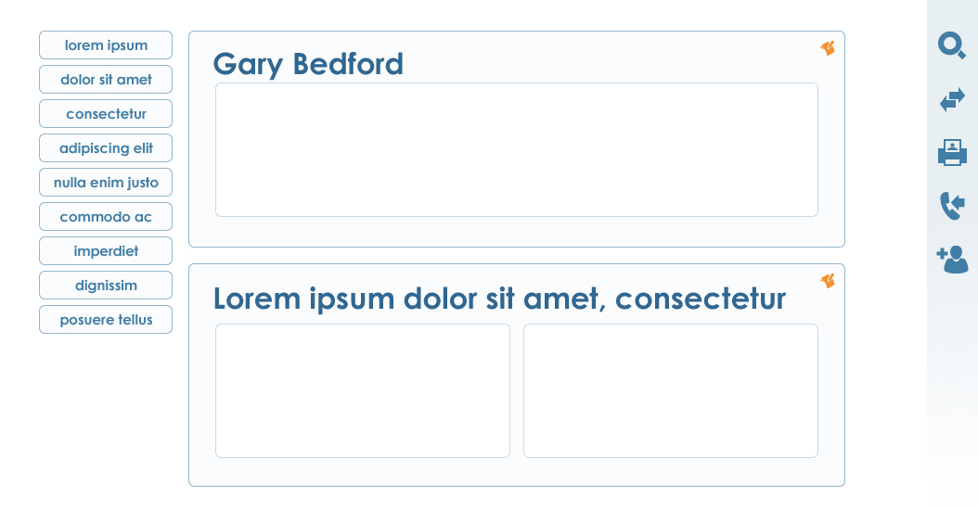
Obviously, those objects itemized here represent just the most basic and elemental of L2L 2.0’s new UI. Many, many more will be described in future versions of this and other related documentation.

The Action Button Column (ABC)
The Action Button Column (ABC) will be standard equipment on many L2L 2.0 screens. This is where every major operation to be performed on the data shown on a given L2L 2.0 screen lives. Those operations available will, of course, differ by screen and will generally be listed in order with the most crucial and/or popular operations at the top and the less crucial and/or popular operations toward the bottom.
Generally, the ABC will contain uncomplicated buttons that fire their respective operations. The only manner in which they will vary collectively is by width – see the following two sections on their responsiveness:
- ABC Wraps – 991px to 831px
- Half-Span Module Content Areas (HSMCA) Wrap – 830px to 1px
Individually, an ABC Button will vary in only two respects:
In vertical height when the text it contains must wrap to two lines: |  | In color on mouseOver – the colors virtually invert:
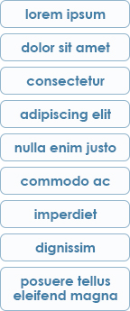 |  | 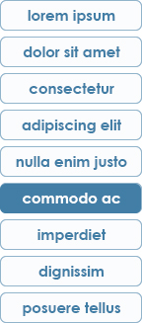  A Photoshop comp for the design discussed here is available.  - The file name is: ABC 02.psd  - The comp lives on the Wiki here under ‘2.0 UI UX’: http://wiki.realpage.com/x/vxFa.  - The Layer Comp states relevant to the discussion on this page are as follows:  - Default  - mouseOver  - Multi-line button  - For more on what Layer Comp states are, please refer to Appendix I.

Quick Search
The Quick Search field occurs in both the Right-Side Nav and the Abbreviated Right-Side Expandable Overlay Nav (ARSEON) and looks nearly identical in both.
Nearly.

Layout
Because of the subtle differences in spacing and alignment required when invoking the larger icons native to the ARSEON, the Quick search field must vary slightly in both spacing and alignment in order to retain its aesthetic appeal between these two instantiations. The following grid lays out their similarities and their very subtle differences:
 | RSN version | ARSEON version
Width | 205px | 205px
Distance from left edge of RSN or ARSEON background | 10px | 10px
Distance from right edge of RSN or ARSEON background | 10px | 10px
Square size of Search icon | 20px | 20px
Distance between leftmost edge of search field and leftmost edge of Search icon | 5px | 9px
Distance between leftmost edge of search field and beginning of text ‘quick search’ (and any text entered by the User thereafter). | 38px | 44px
A Photoshop comp for the design discussed here is available.
- The file name is: QuickSearch01.psd
- The comp lives on the Wiki here under ‘2.0 UI UX’: http://wiki.realpage.com/x/vxFa.
- The Layer Comp states relevant to the discussion on this page are as follows:
  - RSN version – Default
  - ARSEON layout
- For more on what Layer Comp states are, please refer to Appendix I.

User Experience
The User’s experience of Quick Search must be robust, responsive and elegant as it will be one of the most regularly used of the UI mechanisms appearing in L2L 2.0.
Unlike the small matters of spacing and alignment described in the previous section, the following descriptions are true for both the Right-Side Nav (RSN) and Abbreviated Right-Side Expandable Overlay Nav (ARSEON) instantiations of Quick Search in every case:
Default |  | Icon is not clickable
User clicks inside field but does not type anything |  | - Icon is not clickable  - Text label disappears
User clicks inside field and begins typing |  | - Icon changes color  - Icon is clickable  - Text label is replaced by User-entered text
User either clicks icon or hits ‘Enter’ on their keyboard to initiate search |  | - Icon returns to default state and is no longer clickable  - Text label returns to default state

A Photoshop comp for the design discussed here is available.
- The file name is: QuickSearch01.psd
- The comp lives on the Wiki here under ‘2.0 UI UX’: http://wiki.realpage.com/x/vxFa.
- The Layer Comp states relevant to the discussion on this page are as follows:
  - RSN version – Default
  - RSN version - User enters text
- For more on what Layer Comp states are, please refer to Appendix I.

Five Screen Configurations
All Lead2Lease 2.0 (L2L 2.0) screens will exist in one of five states of responsiveness that depend on the User’s browser width (or, to be more specific, the width of the User’s browser’s view-port). Each of these states represent a unique “Configuration” of those objects which facilitate User workflow on any given L2L 2.0 screen. Depending upon which Configuration the User is seeing, these objects may widen, narrow, wrap or disappear entirely.
Here is a list of each Configuration along with its Break-point (that width at which the Configuration gets triggered). They are listed here in order of screen width – widest to narrowest.
# | Configuration | Gets triggered at this width (Break-point) | Exists in this range
1 | Ideal | 1387px | 1387px to ∞
2 | Standard | 1386px | 1386px to 1055px
3 | Compressed | 1161px | 1054px to 992px
4 | ABC Wraps | 991px | 991px to 831px
5 | HSMCA’s Wrap | 830px | 830px to 1px

Now let’s explore each Configuration in detail.

Ideal – widest possible to 1387px
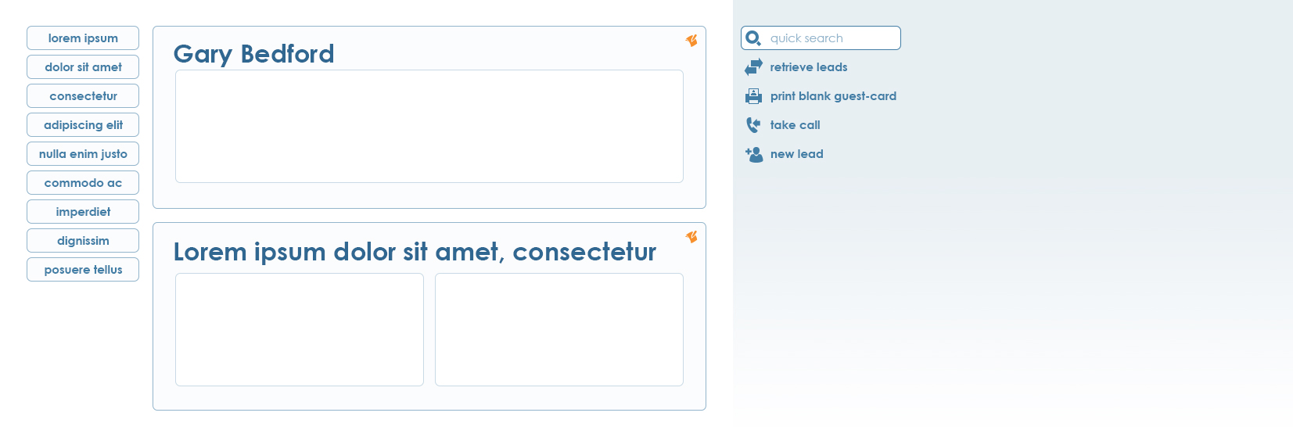
Smart Alert Feed (SAF)
(TBD)
(shown: 1653px)
A Photoshop comp for the design discussed here is available.
- The file name is: L2L Responsive Layout IDEAL01.psd
- The comp lives on the Wiki here under ‘2.0 UI UX’: http://wiki.realpage.com/x/vxFa

Distinguishing characteristics:
- Smart Alert Feed (SAF) appears
- No object wraps
- Right-Side Nav (RSN) appears
- Abbreviated Right-Side Expandable Overlay Nav (ARSEON) does not appear

Standard -- 1386px to 1055px
Smart Alert Feed (SAF)
(TBD)
(shown: 1162px)
A Photoshop comp for the design discussed here is available.
- The file name is: L2L Responsive Layout STANDARD 01.psd
- The comp lives on the Wiki here under ‘2.0 UI UX’: http://wiki.realpage.com/x/vxFa

Distinguishing characteristics:
- Smart Alert Feed (SAF) appears
- The Smart Alert Feed (SAF) wraps under the Right-Side Nav (RSN)
- No other object wraps
- Right-Side Nav (RSN) appears
- Abbreviated Right-Side Expandable Overlay Nav (ARSEON) does not appear

Compressed – 1054px to 992px
(shown: 1054px)

Distinguishing characteristics:
A Photoshop comp for the design discussed here is available.
- The file name is: L2L Responsive Layout COMPRESSED 04.psd
- The comp lives on the Wiki here under ‘2.0 UI UX’: http://wiki.realpage.com/x/vxFa .

- Smart Alert Feed (SAF) does not appear
- Right-Side Nav (RSN) does not appear
- Abbreviated Right-Side Expandable Overlay Nav (ARSEON) appears
- No object wraps

ABC Wraps – 991px to 831px
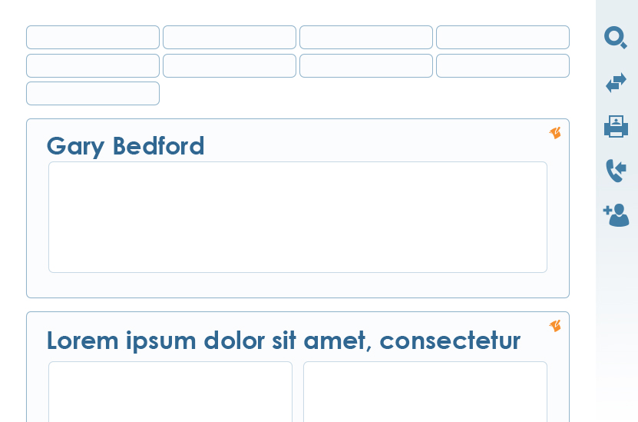
A Photoshop comp for the design discussed here is available.
- The file name is: L2L Responsive Layout ABC WRAPS 01.psd
- The comp lives on the Wiki here under ‘2.0 UI UX’: http://wiki.realpage.com/x/vxFa .

(shown: 831px)

Distinguishing characteristics:
- Smart Alert Feed (SAF) does not appear
- Right-Side Nav (RSN) does not appear
- Abbreviated Right-Side Expandable Overlay Nav (ARSEON) appears
- The Action Button Column (ABC) buttons expand in width from 144 to 174
- The ABC wraps into groups of four buttons across with a 4-pixel margin separating them horizontally and a 6-pixel margin separating them vertically
- No other object wraps

Half-Span Module Content Areas (HSMCA) Wrap – 830px to 1px
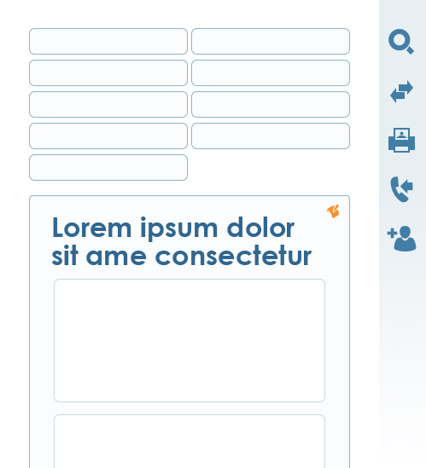

A Photoshop comp for the design discussed here is available.
- The file name is: L2L Responsive Layout HSMCAs WRAP 01.psd
- The comp lives on the Wiki here under ‘2.0 UI UX’: http://wiki.realpage.com/x/vxFa .

(shown: 499px)
This configuration cannot occur if any Full-Span Module Content Areas (FSMCA) appear on the page.

Distinguishing characteristics:
- Smart Alert Feed (SAF) does not appear
- Right-Side Nav (RSN) does not appear
- Abbreviated Right-Side Expandable Overlay Nav (ARSEON) appears
- The Action Button Column (ABC) buttons expand in width to 186px
- The ABC wraps into groups of two buttons across with a 4-pixel margin separating them horizontally and a 6-pixel margin separating them vertically
- All Half-Span Module Content Areas (HSMCA) wrap under one another within the Standard Modules containing them. Unless otherwise specified, the rightmost HSMCA wraps under the leftmost.
- Any Standard Modules that appear (and contain HSMCA’s) contract from 708px to 375px

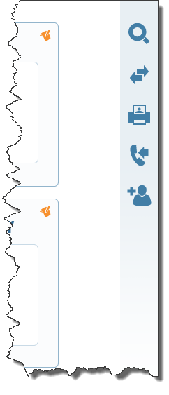
Abbreviated Right-Side Expandable Overlay Nav (ARSEON)
As described in a previous section, at a screen width of 1054px, the Right-Side Nav disappears and is replaced by the Abbreviated Right-Side Expandable Overlay Nav (ARSEON). This interface mechanism is intended to help accommodate Users viewing L2L 2.0 screens on iPads and monitors with resolutions of 1024x768 or less. Its description will come in two parts:
A Photoshop comp for the design discussed here is available.
- The file name is: L2L Responsive Layout COMPRESSED 04.psd
- The comp lives on the Wiki here under ‘2.0 UI UX’: http://wiki.realpage.com/x/vxFa..

- Its characteristics
- Its behavior

The characteristics of the ARSEON

Larger icons spaced appropriately
The icons in the RSN are 20px in height. The icons in the ARSEON are 30px in height. Please refer to the Photoshop comps for exact vertical spacing. It should be noted here that when expanded, the ‘Search’ icon in the ARSEON reverts to the same size as that used in the RSN – 20px – so that it fits within the ‘Search’ field. Please refer to the section on Quick Search in this document. Please also refer to the appropriate Photoshop comps.

Third in Stack Order
The ARSEON overlays everything else on any L2L 2.0 screen except:
- The Property Dropdown (PDD)
- The Single Sign-On Fly-Out (SSOFO)

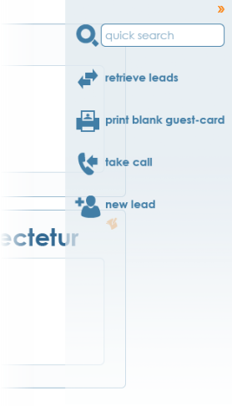
Always translucent
In every state in which it occurs, contracted or expanded, moused over and moused out, onFocus or onClick, the ARSEON appears translucent when overlaying screen objects below it in the stack order of any L2L 2.0 screen.
A Photoshop comp for the design discussed here is available.
- The file name is: ARSEON 06.psd
- The comp lives on the Wiki here under ‘2.0 UI UX’: http://wiki.realpage.com/x/vxFa..

Note translucency. Please refer to Photoshop comps for specifics of opacity/transparency

Always spans the entire height of the page from top to bottom, whether contracted or expanded
Though the gradient comprising its background fades and blends into the white background of the page (when it doesn’t overlay some other object), the Abbreviated Right-Side Expandable Overlay Nav (ARSEON) occupies the entire right edge of any L2L 2.0 page upon which it is invoked, whether expanded or contracted.
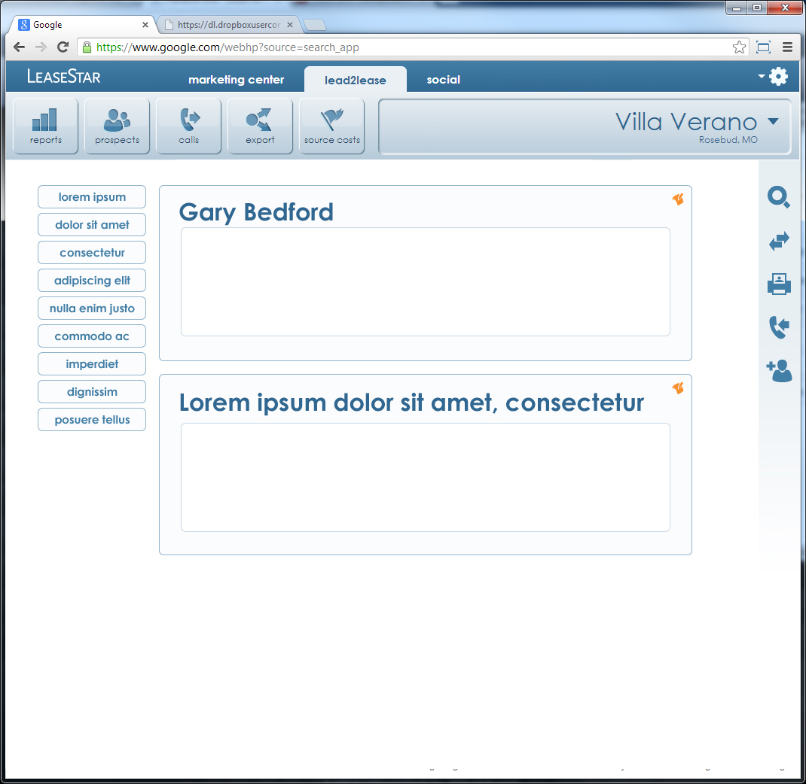
You may not see it, but, it’s there. The ARSEON appears to fade away, but it doesn’t.

Two distinct states
The Abbreviated Right-Side Expandable Overlay Nav (ARSEON) has two distinct states:
- Contracted
- Expanded
Contracted | Expanded
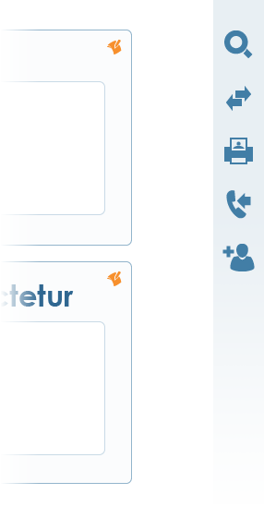 | 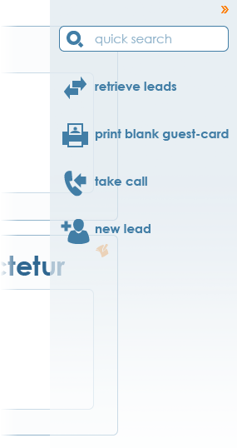  A Photoshop comp for the design discussed here is available.  - The file name is: ARSEON 06.psd  - The comp lives on the Wiki here under ‘2.0 UI UX’: http://wiki.realpage.com/x/vxFa.  - The Layer Comp states relevant to the discussion on this page are as follows:  - mouseOut  - For more on what Layer Comp states are, please refer to Appendix I.
Width = 55px | Width = 225px
Only icons show | - Icons show  - Text link labels show  - In the case of ‘Search,’ an input field shows  - A ‘Retract ’ panel control icon shows

The Behaviors of the Abbreviated Right-Side Expandable Overlay Nav (ARSEON)
All behaviors asscociated with the ARSEON were designed to be responsive, unobtrusive and there for the User when they need it.

Icons and text-link labels on mouseOver

Highlighting
- While the ARSEON is contracted or expanded, all icons turn orange on mouseOver.
- If the ARSEON is expanded, the text-link label turns orange as well.
- If the User mouses over the icon, the text-link label turns orange simultaneously and vice versa.
A Photoshop comp for the design discussed here is available.
- The file name is: ARSEON 06.psd
- The comp lives on the Wiki here under ‘2.0 UI UX’: http://wiki.realpage.com/x/vxFa.
- The Layer Comp states relevant to the discussion on this page are as follows:
  - mouseOut
  - mouseOver
- For more on what Layer Comp states are, please refer to Appendix I.

mouseOut | mouseOver

Tool-Tip
A tool-tip shows up on mouseOver when the ARSEON is contracted, but not when it is expanded:
Contracted | Expanded
new lead

Expanding and Contracting the Abbreviated Right-Side Expandable Overlay Nav (ARSEON)
The default state of the ARSEON is contracted.

Expanding the ARSEON
The ARSEON expands when either of two things happens:
- The User mouses over specific regions of the contracted ARSEON without clicking.
- The User clicks the Quick search icon in the contracted ARSEON.
Regions which will cause the ARSEON to expand when moused over: | Icons which will cause the ARSEON to expand when clicked:

Contracting the Abbreviated Right-Side Expandable Overlay Nav (ARSEON)
The ARSEON contracts when any one of the following five things happen:
- The User mouses out of the ARSEON.
- The User enters search criteria into the Search field and hits either the ‘Search’ icon or ‘Enter’ on their keyboard.
- The User clicks any of the other icons or their associated text-link labels.
- The User clicks the ‘Retract ’ panel control icon.
- The User clicks anywhere else on the screen (not shown below)
User actions sufficient for the ARSEON to contract from an expanded state …
The User mouses out of the ARSEON | The User enters search criteria in the Search field and hits either the ‘Search’ icon or ‘Enter’ on their keyboard | The User clicks any of the other icons or their associated text-link labels | The User clicks the ‘Retract ’ panel control icon
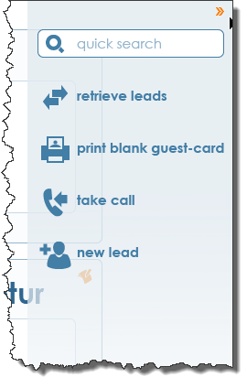 | 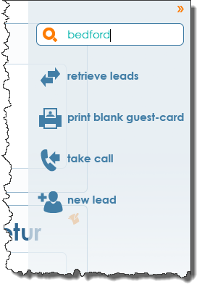 | 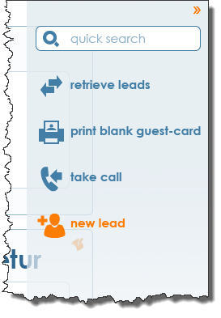

Appendix I - Viewing multiple comps in one Photoshop file
A recent innovation in Photoshop enables the user to view any Photoshop file in multiple states, making some layers visible and others not. This is useful for sharing comps because it no longer requires the designer to share out a different version of the same file for every view a developer needs to create. All the views exist in one file. To access these separate views, the user need only click the button in the “Layer Comps” panel of Photoshop for the desired comp state. To view this panel, in Photoshop go to Window > Layer Comps.
