Marketing Center 1.5: Unified User Interface – version 1.5.6
Table of Contents
The Purpose of this Document 4
Overview 4
Scope 4
Time-frame 4
Preview of changes 5
Marketing Center 5
Lead2Lease 6
LeaseStar Social 7
Complete Re-Style 8
New Navigation Schema – The “Ribbon” 9
Logo-Dropdown 10
Logo-Dropdown UX 10
Primary Navigation 13
Single Sign-On Fly-Out Thumbnail / Button (SSOFOTB) 14
SSOFOTB UX 14
The Single Sign-On Fly-Out (SSOFO) 15
Features shared by all three versions 16
The Marketing Center version of the Single Sign-On Fly-Out (SSOFO) 17
The Lead2Lease version of the Single-Sign-On Fly-Out (SSOFO) 21
The LeaseStar Social version of the Single sign-On Fly-Out (SSOFO) 23
Property Dropdown 25
Property Dropdown UX 26
Property Dropdown UI 29
The Button Array 33
Button States 33
Overall Layout 34
Fixed vs. Flexible UI elements 34
The Difference Between Fixed and Flexible 35
The Fixed UI Elelements – Solid as Rocks 35
The Flexible UI Elements – Going with the Flow 40
The Page Content Area and its Impact on Overall Layout 44
PCA Screen Alignment and LSN / RSN Instantiation 45
The Curious Case of Lead2Lease 46
Both side navs used 46
What’s going in to the Right-Side Nav? 47
Behaviors of the Right-Side Nav(RSN) links 48
A More Prominent and User-Friendly Quick Search 49
More prominent 49
More User-Friendly 50
States of the Quick-Search field 51
Search Results 51
New Main Nav Item Introduced – Add Lead 52
Multiple and Aggregate Left-Side Nav Location Indicators for Filtering 53
Single Sign-On (SSO) 55
Where we are and where we want to go 55
Where we are 56
Where we want to go 59
The internal experience 60
Logging Out 61
Footer 61
Appendix I - Viewing multiple comps in one Photoshop file 62

The Purpose of this Document
To provide the development team assigned to this project with those descriptions and assets required to facilitate the approved design for said project.

Overview
The goal of this project is to unify the look-and-feel of three distinct LeaseStar products:
- Marketing Center (MC)
- Lead2Lease (L2L)
- LeaseStar Social (LSS)
What constitutes this unification will be very clearly described in this document. The ultimate goal is to have one product, Marketing Center, which encompasses the functionality, but not the branding, of both Lead2Lease and LeaseStar Social (formerly RentMineOnline). However, the immediate goal is to retain all of the functional distinctions between products as well as some of the branding distinctions.
With the exception of the “Lead2Lease Senior” initiative, next to no new functionality will be introduced as part of this unification effort. L2L Senior will be developed in parallel with the unification effort.

Scope
Essentially, we will be giving all three products “a haircut” by replacing their primary, secondary, and in some instances, tertiary navigation with a new navigation schema they will share in common. We will additionally be improving upon and otherwise unifying the “Single Sign-On” experience for users of all three products. A common footer is the third item scoped.

Time-frame
The aim is to have a working beta version for clients to interact with during the 2013 RealWorld conference beginning July 14. This will be a separate branch and not production code.

Preview of changes
Here is a quick preview of the changes required by this project:

Marketing Center
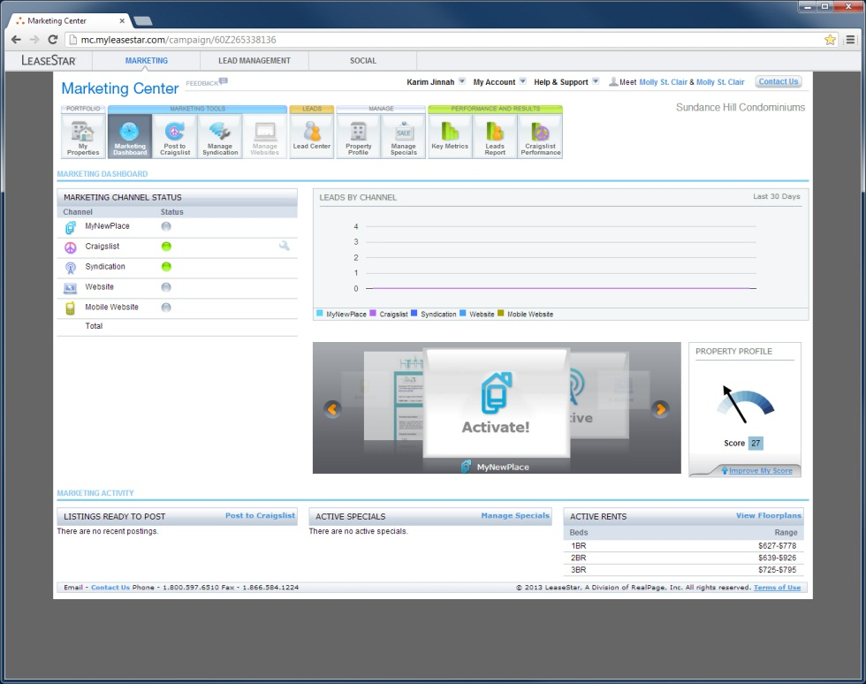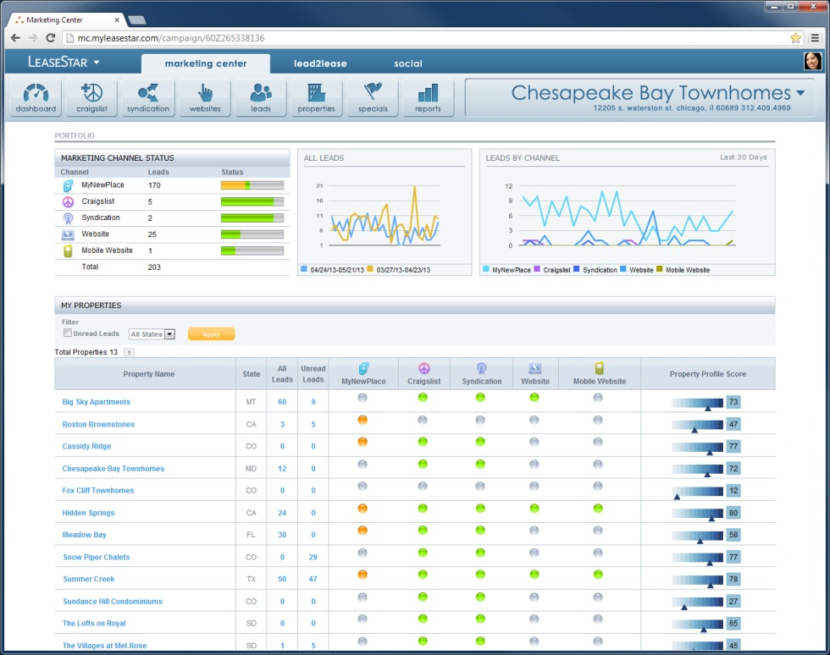
A Photoshop mockup for the design discussed here is available.
- The file name is: BC19 - MC L2L LSS 03.psd
- The mockup lives on the Wiki here under ‘Mockups and Documentation: http://wiki.realpage.com/display/LSUI/LeaseStar+Unified+UI+Home
- A separate copy for Chicago developers who cannot access the Wiki has been placed here: \\rxpeitfs001\UIDevelopment\Creative\Erik\Marketing Center\
- The Layer Comp states relevant to the discussion on this page are as follows:
  - MC After
- For more on what Layer Comp states are, please refer to Appendix I.

Lead2Lease
(This view includes the design components associated with the “Lead2Lease Senior” initiative mentioned previously)
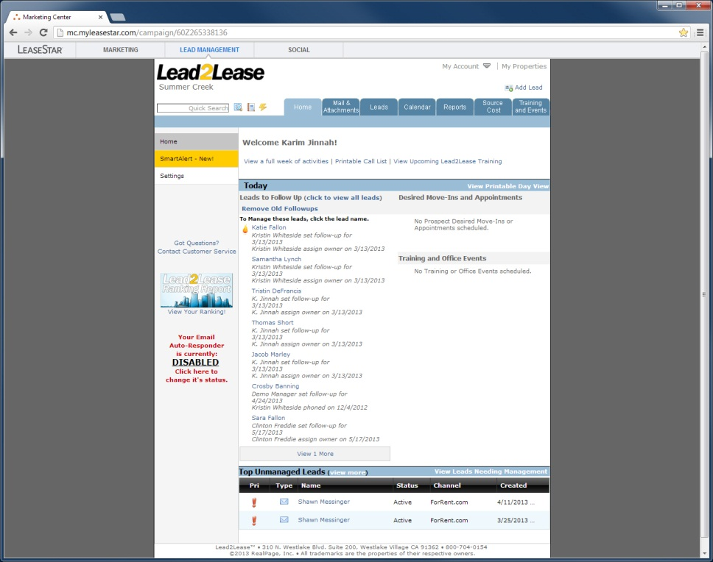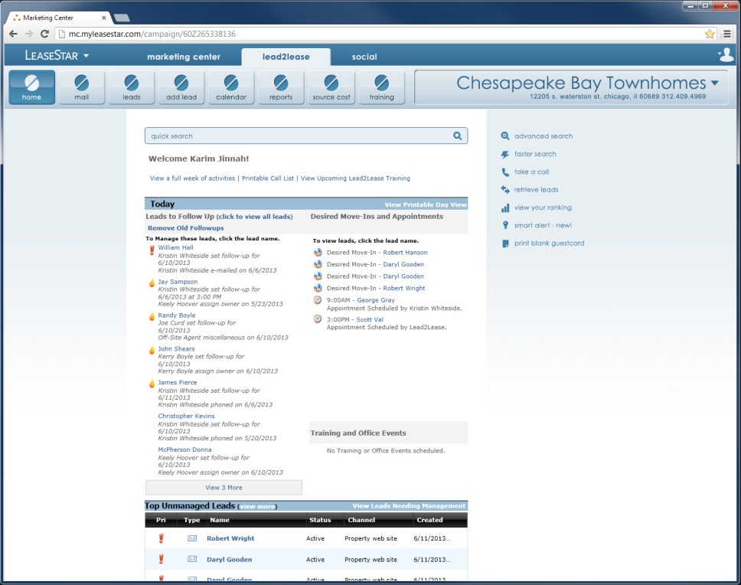
A Photoshop mockup for the design discussed here is available.
- The file name is: BC26 - L2L 17.psd
- The mockup lives on the Wiki here under ‘Mockups and Documentation: http://wiki.realpage.com/display/LSUI/LeaseStar+Unified+UI+Home
- A separate copy for Chicago developers who cannot access the Wiki has been placed here: \\rxpeitfs001\UIDevelopment\Creative\Erik\Marketing Center\
- The Layer Comp states relevant to the discussion on this page are as follows:
  - Property Home
- For more on what Layer Comp states are, please refer to Appendix I.

LeaseStar Social
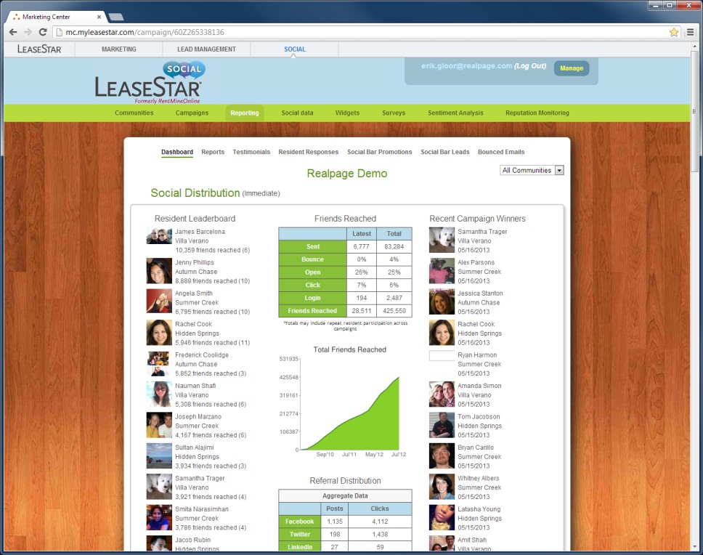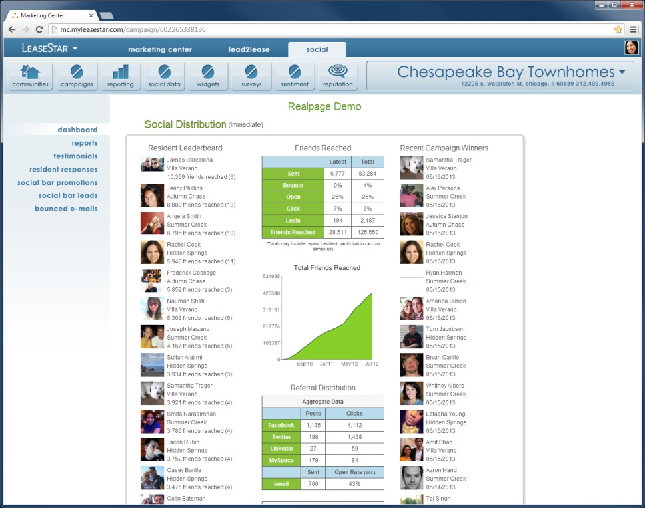
A Photoshop mockup for the design discussed here is available.
- The file name is: BC19 - MC L2L LSS 03.psd
- The mockup lives on the Wiki here under ‘Mockups and Documentation: http://wiki.realpage.com/display/LSUI/LeaseStar+Unified+UI+Home
- A separate copy for Chicago developers who cannot access the Wiki has been placed here: \\rxpeitfs001\UIDevelopment\Creative\Erik\Marketing Center\
- The Layer Comp states relevant to the discussion on this page are as follows:
  - LSS After
- For more on what Layer Comp states are, please refer to Appendix I.

A Photoshop comp of this screen lives at the following location: \\rxpeitfs001\UIDevelopment\Creative\Erik\Marketing Center\BC19 - MC L2L LSS 03.psd NOTE! Please refer to Appendix I describing the use of the “Layer Comps” panel in Photoshop and using it to show the view described here. The view described here can be configured in the Photoshop file by clicking the layer state ‘LSS After’

Complete Re-Style
Though not scoped for the July 14 deadline, the ultimate aim is to re-style the entire UI of Marketing Center, Lead2Lease and LeaseStar Social – not just the navigation, Single Sign-On and footer. Here is a preview of what a typical screen might look like after this complete re-styling (page content TBD):
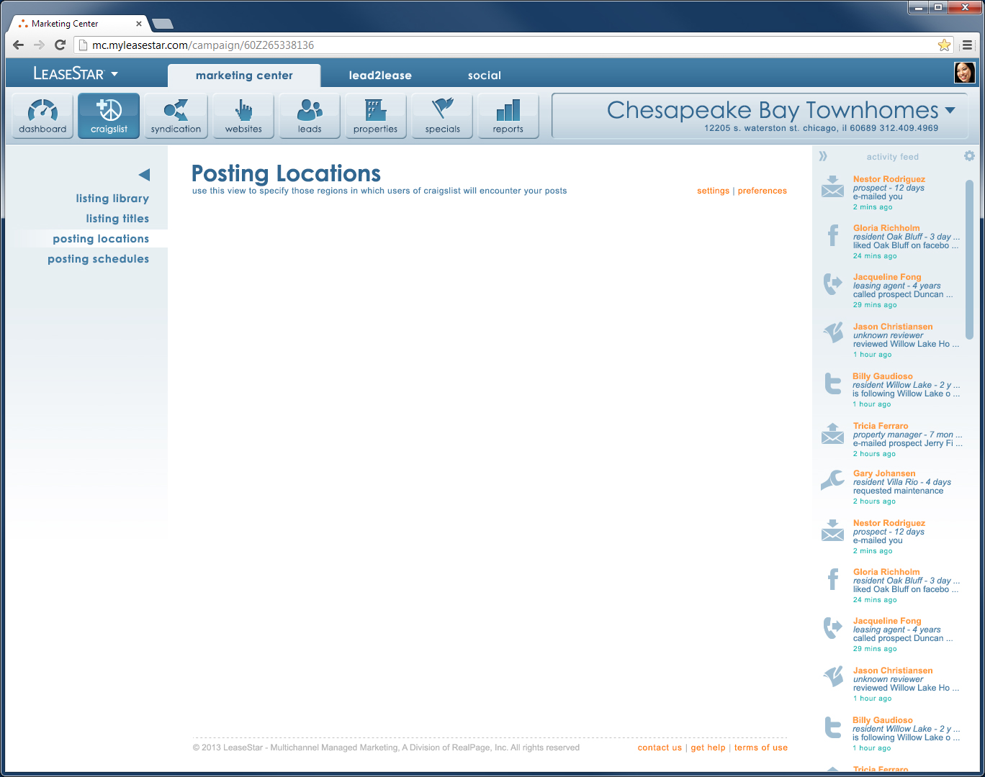
Content TBD

New Navigation Schema – The “Ribbon”
Ninety percent of the changes comprised by this effort take place in the top fifth of the screen for all three products in what shall hereafter be referred to in this document as The Ribbon (so-named because of its similarity to the UI element of the same name used in Windows Office applications since the ’07 versions).
Let’s take a look at each of the Ribbon’s components individually and one at a time.

Logo-Dropdown
- Facilitate branding across all three applications (Marketing Center, Lead2Lease and LeaseStar Social)
- Clicking it will fire a dropdown that enables the User to navigate to OneSite. In later versions, YieldStar will be a third option.

Logo-Dropdown UX

Bifurcated Clickability
The Logo-Dropdown (LDD) is straightforward in all respects except one: It’s clickability is divided in two:
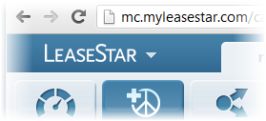
Clicking the downward-pointing arrow, or clicking anywhere in the general vicinity (as shown here) fires the dropdown.
Clicking the logo proper will take the User to a TBD “home-page” that will probably end up being the dashboard page. More on this in later versions of this document.
This distinction shall evince itself for the User in the mouseover states:
Mousing over logo proper | Mousing over downward-pointing arrow
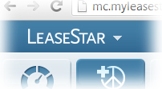  No change | 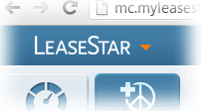  Downward-pointing arrow turns orange

States
The Logo Dropdown (LDD) can evince three distinct states: MouseOut, MouseOver, and OnClick. Please note that some of the UI components for the LDD have changed subtly and that this Photoshop comp -- \\rxpeitfs001\UIDevelopment\Creative\Erik\Marketing Center\BC22 - STATES - LOGO DROPDOWN - 03.psd -- should be considered the definitive resource for all of its associated elements. Specifically, a subtle change was made to the size of the logo (this was an incidental and unavoidable result of fleshing out the design for the LDD). Additionally, the downward-pointing arrow has changed slightly in size, form and color.

MouseOut
Please note slight change in size, form and color of the downward-pointing arrow.
A Photoshop mockup for the design discussed here is available.
- The file name is: BC22 - STATES - LOGO DROPDOWN - 03.psd
- The mockup lives on the Wiki here under ‘Mockups and Documentation: http://wiki.realpage.com/display/LSUI/LeaseStar+Unified+UI+Home
- A separate copy for Chicago developers who cannot access the Wiki has been placed here: \\rxpeitfs001\UIDevelopment\Creative\Erik\Marketing Center\
- The Layer Comp states relevant to the discussion on this page are as follows:
  - MouseOut
  - MouseOver
- For more on what Layer Comp states are, please refer to Appendix I.

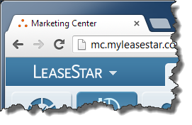

MouseOver
As described previously, this mouseover state exists only when the User is mousing over the downward-pointing arrow, not the logo proper.
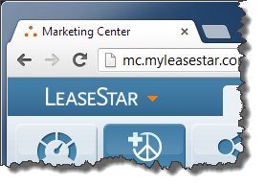

OnClick
Again, this state exists only when the User has clicked the downward-pointing arrow, not the logo proper.

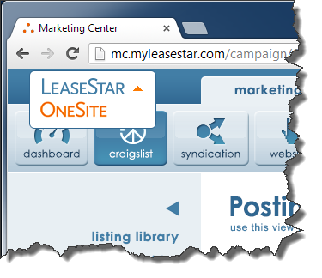
Appearance
The downward-pointing arrow …
- Stays orange
- Inverts – it now points upward

Behavior
- The LDD stays open until:
  - The User makes a selection
  - Clicks anywhere else on the screen
- To make a selection in the LDD, the User clicks the desired option
- To close the LDD without making a selection, the User may:
  - Click the upward-pointing arrow
  - Click the currently-selected logo
  - Click anywhere else on the screen besides one of the options listed
A Photoshop mockup for the design discussed here is available.
- The file name is: BC22 - STATES - LOGO DROPDOWN - 03.psd
- The mockup lives on the Wiki here under ‘Mockups and Documentation: http://wiki.realpage.com/display/LSUI/LeaseStar+Unified+UI+Home
- A separate copy for Chicago developers who cannot access the Wiki has been placed here: \\rxpeitfs001\UIDevelopment\Creative\Erik\Marketing Center\
- The Layer Comp states relevant to the discussion on this page are as follows:
  - OnClick
- For more on what Layer Comp states are, please refer to Appendix I.

Primary Navigation
Enables the User to navigate between Marketing Center, Lead2Lease and LeaseStar Social.

Single Sign-On Fly-Out Thumbnail / Button (SSOFOTB)
The Single Sign-On Fly-Out Thumbnail / Button (SSOFOTB) serves in the capacity both of display and trigger:
- It displays the profile photo associated with the User currently logged in to Marketing Center.
- When clicked, it fires a flyout in which the User can perform various account-related activities, including logging out.

SSOFOTB UX

Default image for now
Because photos are not currently associated with the User profile records of Marketing Center, Lead2Lease or LeaseStar Social and because no such mechanism will exist to capture such photos before this project is expected to be complete, a default image will be used until such a time as said mechanism is implemented. This default image will continue serving in this capacity even after said mechanism is implemented for those instances in which a User has not yet uploaded/specified an image.

States of the SSOFOTB
MouseOut | MouseOver
The SSOFOTB can have just two states: MouseOut and MouseOver (an OnClick state is more a part of the “Single-Sign-On Fly-Out” UX, described in the next section). Both of these states will differ depending upon whether the User has uploaded a photo to their profile. And because, as described earlier, such a mechanism will not be implemented before this project is complete, the only incarnations of these states of the SSOFOTB that will be described in this document are those which apply to the default image.
A Photoshop mockup for the design discussed here is available.
- The file name is: BC 23 - SSO 07.psd
- The mockup lives on the Wiki here under ‘Mockups and Documentation: http://wiki.realpage.com/display/LSUI/LeaseStar+Unified+UI+Home
- A separate copy for Chicago developers who cannot access the Wiki has been placed here: \\rxpeitfs001\UIDevelopment\Creative\Erik\Marketing Center\
- The Layer Comp states relevant to the discussion on this page are as follows:
  - SSOFOTB – MouseOut
  - SSOFOTB - MouseOver
- For more on what Layer Comp states are, please refer to Appendix I.

The Single Sign-On Fly-Out (SSOFO)
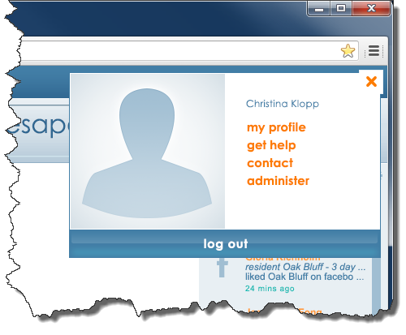
The SSOFO is fired when the User clicks the Single Sign-On Fly-Out Thumbnail / Button (SSOFOTB) described in the previous section. It facilitates that functionality specific to the User currently logged in. Broadly, these include a means of modifying one’s profile, getting help, contacting RealPage or performing administrative operations.
Now because Marketing Center, Lead2Lease and LeaseStar Social each handle User-specific functionality differently, the SSOFO was designed to unify this experience for the User, at least to the extent to which this can be done without introducing new screens and/or new functionality. To wit, every item occurring within the flyout maps to existing functionality currently in production for all three products.
However, there is only so much unification that can happen with such significant differences in functionality existing between these products. For example, there is no means of modifying one’s profile in Lead2Lease (indeed there isn’t even a profile, per se). These differences mean that the flyout must inevitably differ slightly depending upon which product the User is in when he/she fires it.
Which means there must be a slightly-different version of the SSOFO for each product:
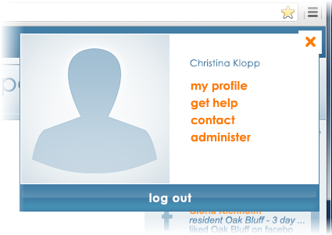
(LSS version of SSOFO)
(L2L version of SSOFO)
(MC version of SSOFO)

Features shared by all three versions
So because there will be a slightly different version of the Single Sign-On Fly-Out (SSOFO) for each product, let’s get their shared features out of the way first:

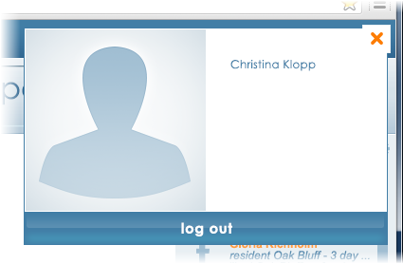
Behavior
- As already described, the SSOFO is fired when the User clicks the SSOFOTB
- To close the SSOFO without using any of its functions, the User must:
  - Click the X in the upper right-hand corner of the SSOFO
  - Click anywhere on the screen outside the SSOFO
- The area below the User’s name will populate with orange links. If the User navigates to any screen using these links, those conditions under which the flyout closes change slightly: If, after firing the SSOFO, the User clicks any of these orange links, the SSOFO will stay open, but will now close when the User mouses out of the SSOFO. This is in addition to those circumstances already described under which the SSOFO will close (see above bulleted item).
- Mousing over the ‘Logout’ button causes that button to evince a mouseover state in which the button turns orange
- Clicking the ‘Logout’ button fires an ‘Are you sure?’ popup, the design of which is TBD. Clicking the ‘Yes’ button in that popup logs the User out and sends them to the shared Landing page.

Appearance
The User’s name or whatever constitutes their login name (for example, their e-mail address) appears as shown near the top edge of the SSOFO.
Obviously, in later iterations, the User’s profile photo will appear in place of this default profile image.
A Photoshop mockup for the design discussed here is available.
- The file name is: BC 23 - SSO 07.psd
- The mockup lives on the Wiki here under ‘Mockups and Documentation: http://wiki.realpage.com/display/LSUI/LeaseStar+Unified+UI+Home
- A separate copy for Chicago developers who cannot access the Wiki has been placed here: \\rxpeitfs001\UIDevelopment\Creative\Erik\Marketing Center\
- The Layer Comp states relevant to the discussion on this page are as follows:
  - SSOFO – Standard
  - SSOFO – Logout button MouseOver
- For more on what Layer Comp states are, please refer to Appendix I.

The Marketing Center version of the Single Sign-On Fly-Out (SSOFO)
As is now plain, the distinctions between versions of the SSOFO are encompassed entirely by the orange links that occur in each. Varying link labels and, as we shall see, accordion-like states for some of these links are the occasion for these distinctions. The Marketing Center version of the SSOFO is the most complex, so let’s get it out of the way first.
By way of habituating the User to a standard array of options in this attempt to standardize the Single Sign-On experience, only the following four links shall occur (or not occur) within the SSOFO by default for each product: ‘My Profile,’ ‘Get Help,’ ‘Contact’ and ‘Administer.’ Let’s take them one at a time.

My Profile
OnClick, this link takes the User to the ‘My Profile’ page currently in production and currently-accessed by the User dropdown
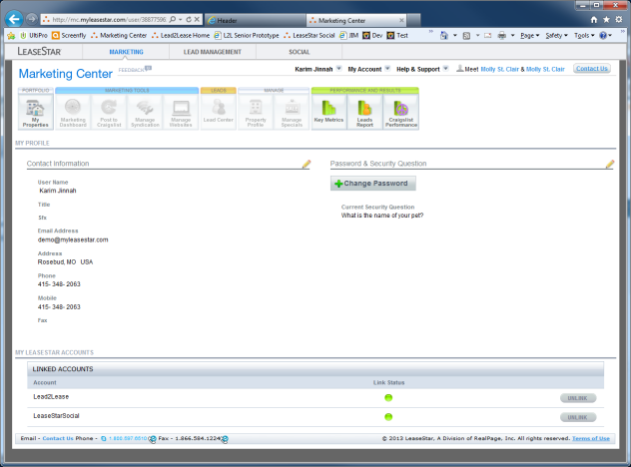
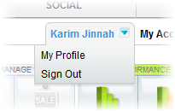
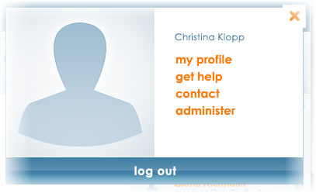
A Photoshop mockup for the design discussed here is available.
- The file name is: BC 23 - SSO 07.psd
- The mockup lives on the Wiki here under ‘Mockups and Documentation: http://wiki.realpage.com/display/LSUI/LeaseStar+Unified+UI+Home
- A separate copy for Chicago developers who cannot access the Wiki has been placed here: \\rxpeitfs001\UIDevelopment\Creative\Erik\Marketing Center\
- The Layer Comp states relevant to the discussion on this page and th rest of this section are as follows:
  - SSOFO – MC
  - SSOFO - MC - Contact accordioned
  - SSOFO - MC - Administer accordioned
  - SSOFO - L2L
  - SSOFO - L2L - Administer accordioned
  - SSOFO – LSS
  - SSOFO - LSS - Get Help accordioned
- For more on what Layer Comp states are, please refer to Appendix I.

The old way

The ‘My Profile’ page

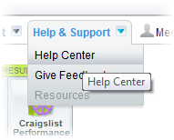
Get Help
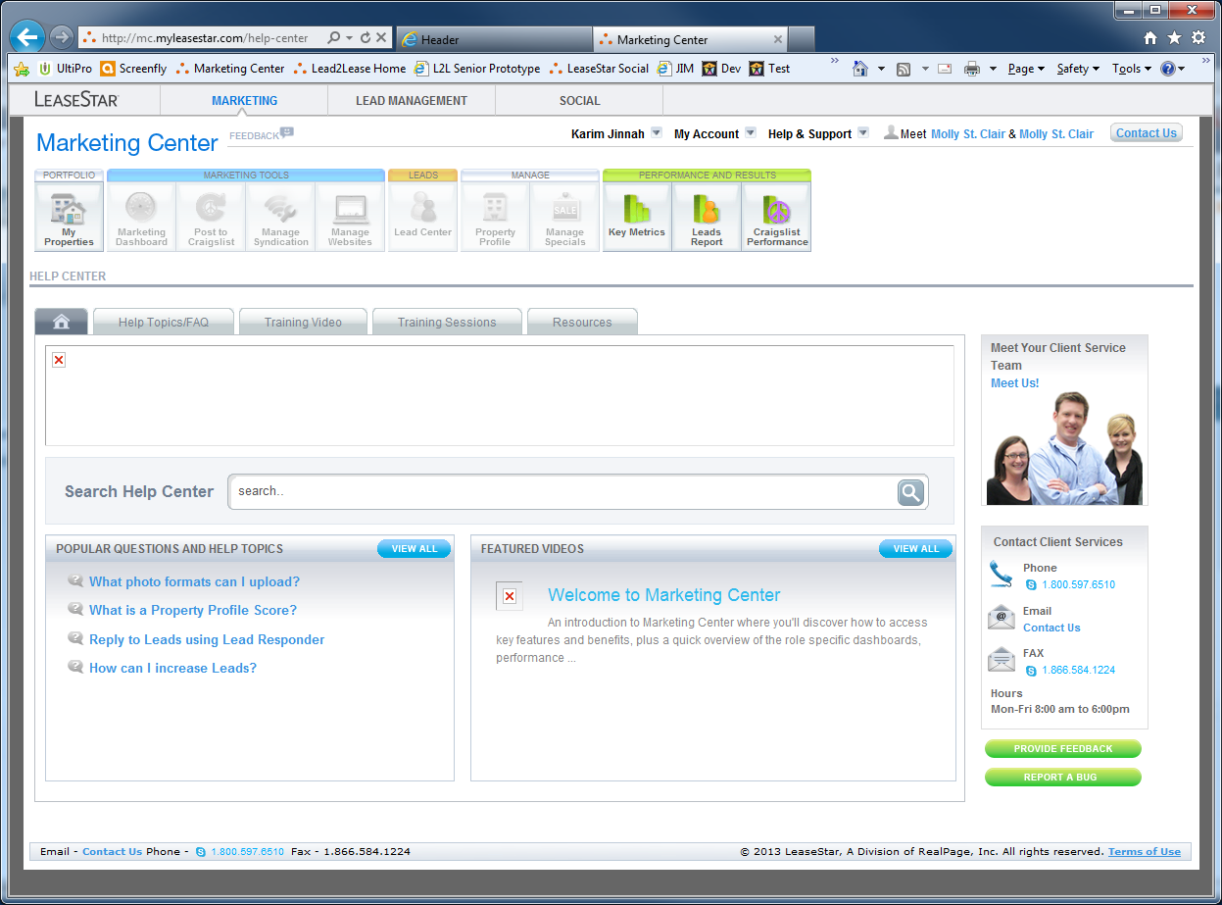
The old way
OnClick, this link takes the User to the ‘Help Center’ page currently in production and currently-accessed by the ‘Help & Support’ dropdown

The ‘Help Center’ page

Contact
Closing the SSOFO cancels any accordion-like behavior and returns the SSOFO to the default state
Okay, here’s where things get tricky and where we start seeing some of that accordion-like behavior mentioned at the start of this section.
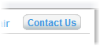
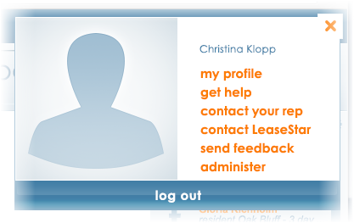
Clicking any of the other links (‘My Profile,’ ‘Get Help,’ or ‘Administer’) “retracts” the accordion and these three new links are once again replaced by a single ‘contact’ link
Three distinct new links appear where just the ‘Contact’ link was before
OnClick, this link “expands,” in an accordion-like fashion, in to three distinct links
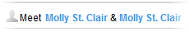
The old way
The old way
The old way

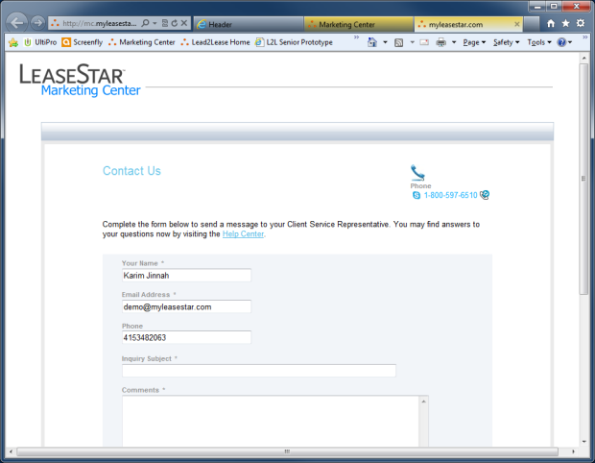
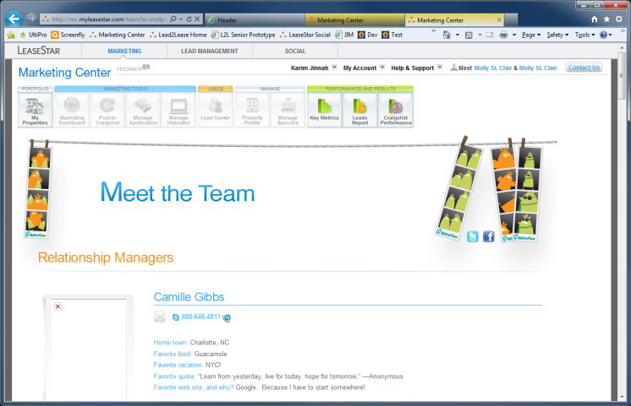
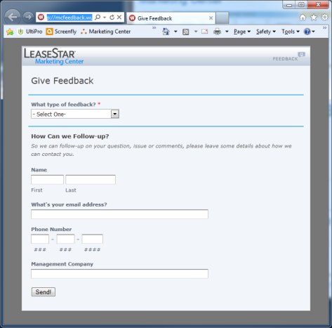

The ‘Give Feedback’ page
The ‘Contact Us’ page
The ‘Meet the Team’ page

Administer
Closing the SSOFO cancels any accordion-like behavior and returns the SSOFO to the default state
Same mechanism for Administer.
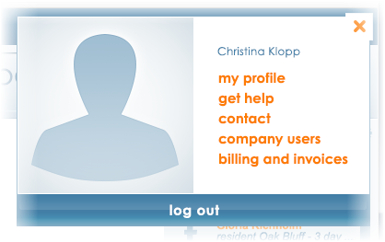
Clicking any of the other links (‘My Profile,’ ‘Get Help,’ or ‘Contact’) “retracts” the accordion and these two new links are once again replaced by a single ‘Administer’ link
Two distinct new links appear where just the ‘Administer’ link was before

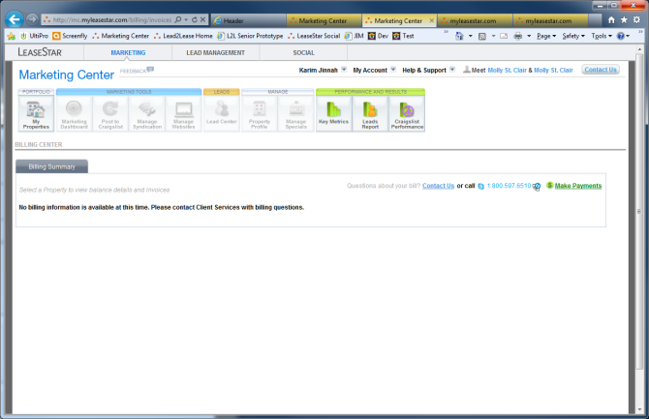
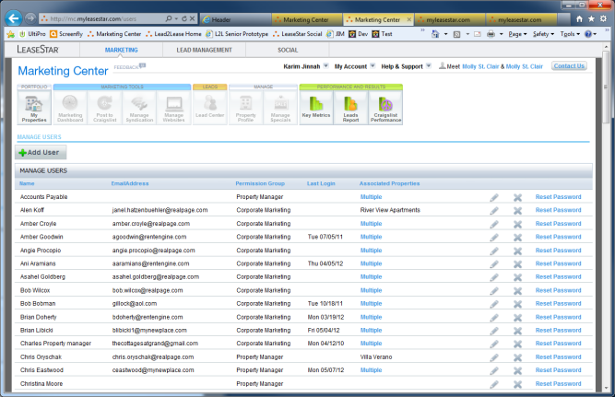

The old way

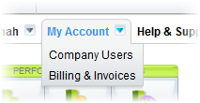
The old way
The ‘Manage Users’ page
The ‘Billing Center’ page

The Lead2Lease version of the Single-Sign-On Fly-Out (SSOFO)
If the Marketing Center version of the SSOFO is the most complex, the Lead2Lease version is the least - with only two links of the standard four we’re establishing:

Get Help
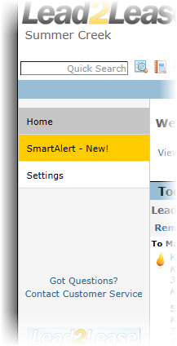
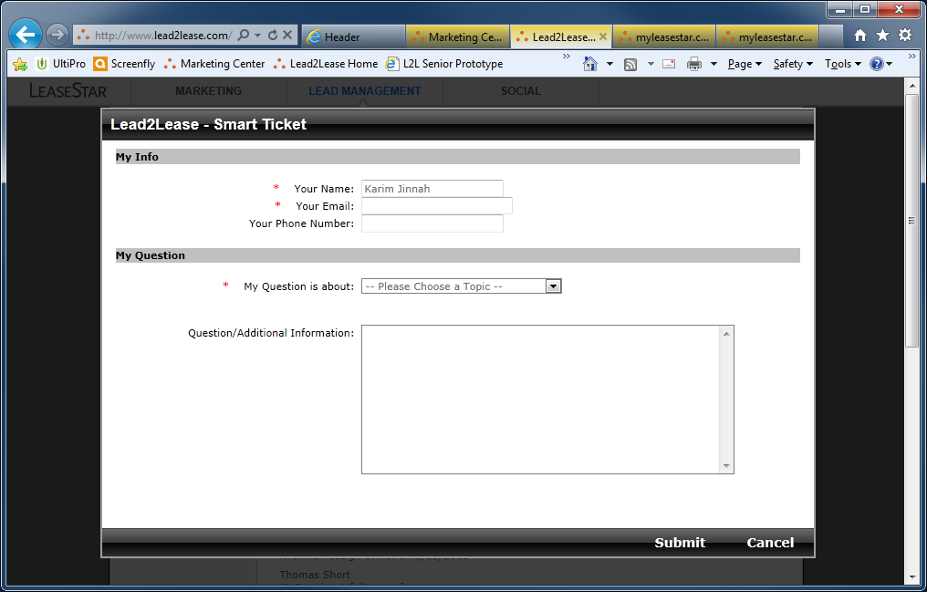

The old way

The ‘Lead2Lease Smart Ticket’ modal

Administer
Clicking ‘Get Help’ “retracts” the accordion and the two new links are once again replaced by a single ‘administer’ link
Closing the SSOFO cancels any accordion-like behavior and returns the SSOFO to the default state
Administer for Lead2Lease (L2L) accordions out to Settings and Preferences for Mail.
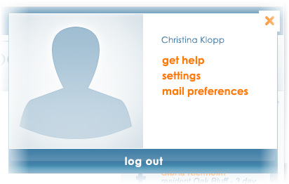
Two distinct new links appear where just the ‘Administer’ link was before
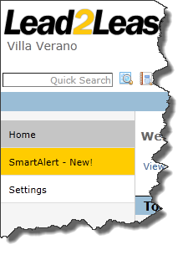
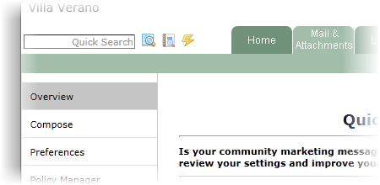
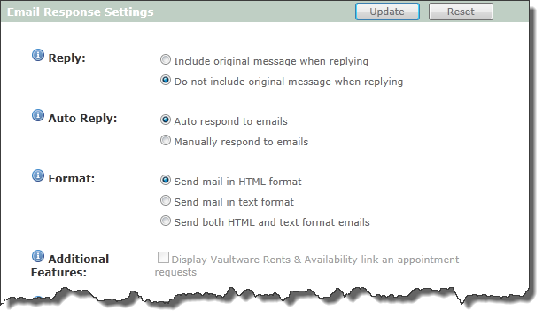
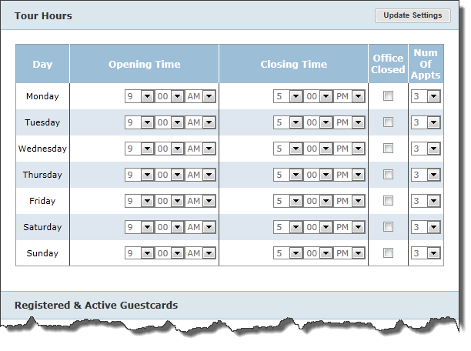
The old way
The Mail Preferences page
The old way
The Settings page

The LeaseStar Social version of the Single sign-On Fly-Out (SSOFO)
The LeaseStar Social (LSS) version of the SSOFO uses three of the standard four links we’re establishing. Two are simple, the other “accordions out” like the ‘Contact’ link in the Marketing Center version of the SSOFO. Let’s take the simple ones first:
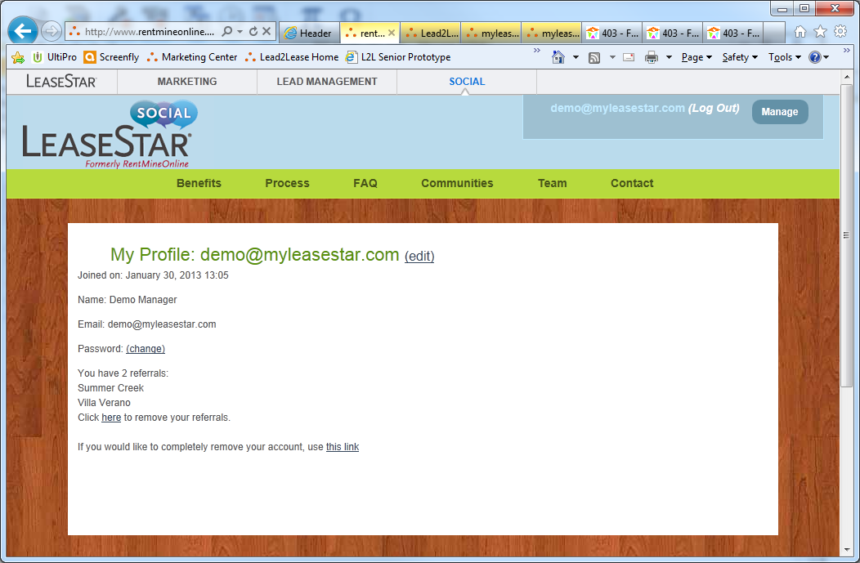
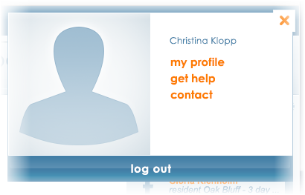
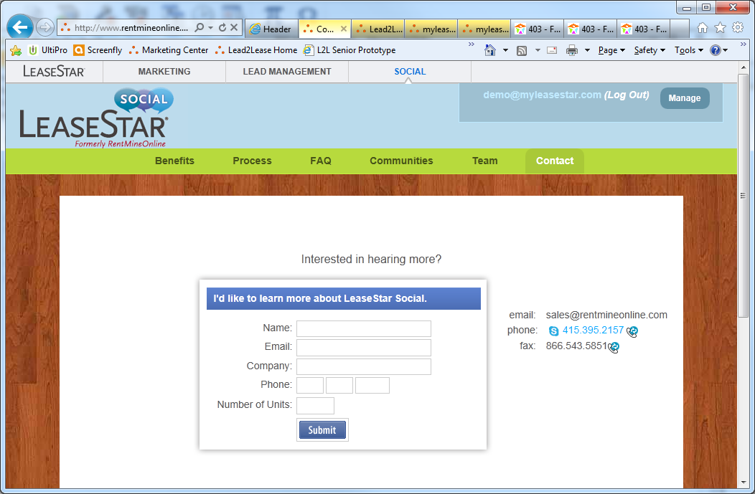
The ‘My Profile’ page
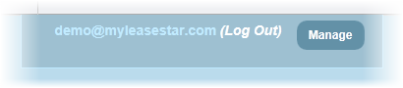
The old way

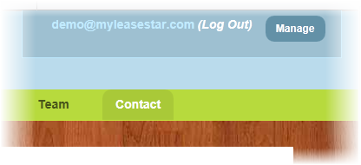
The old way

The ‘Contact’ page

Get Help
Closing the SSOFO cancels any accordion-like behavior and returns the SSOFO to the default state
The LeaseStar Social (LSS) version of the Single Sign-On Fly-Out (SSOFO) has one link that “accordions out,” just like the ‘Contact’ link or ‘Administer’ link does in the Marketing Center version. This is its ‘Get Help’ link. LSS provides a number of useful resources for the User, but these all live on different screens.
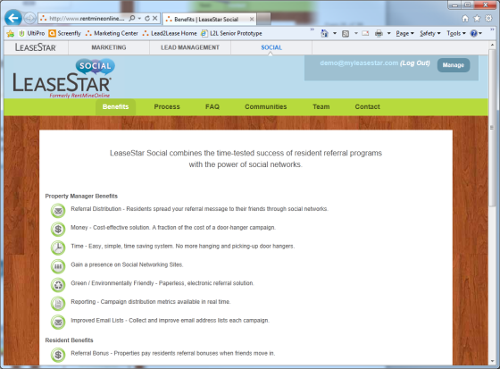
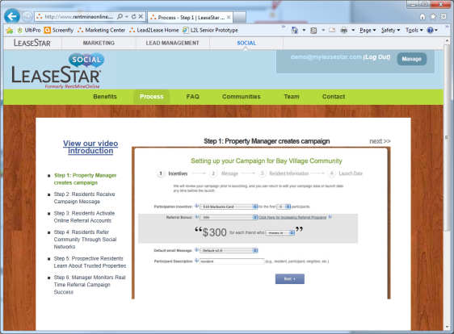
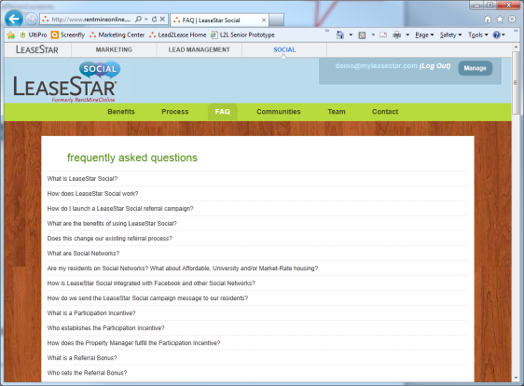
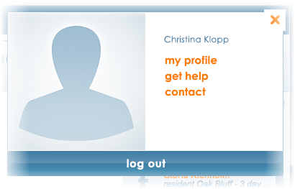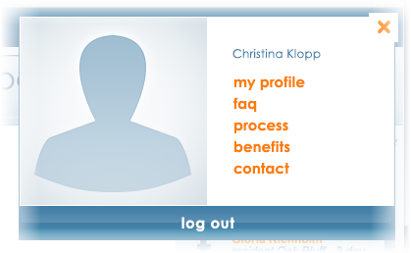
The ‘Process’ page
The ‘Benefits’ page
Clicking any of the other links (‘My Profile,’ or ‘Contact’) “retracts” the accordion and these three new links are once again replaced by a single ‘Get Help’ link
Three distinct new links appear where just the ‘Get Help’ link was before
dsdc

The old way
The old way
The ‘FAQ’ page
The old way

Property Dropdown
This dropdown is large because it is intended to help keep the property a User is working in front of mind.
It can show any one of the properties being managed or ‘All Properties.’ Region may also be an option.
Obviously, a nexus of functionality exists between the Property Dropdown and the last UI element in the Ribbon – the “Button Array.” Those individual buttons included in any given instantiation of the Button Array depend on what selection has been made in the Property Dropdown.
Nexus of functionality
For example, if Property A has not availed themselves of Website services but Property B has, the ‘Websites’ button will not occur when Property A is selected in the Property Dropdown, but will when Property B is (this may be handled by always including all buttons and disabling the irrelevant ones. More about this later). This logic already exists in the version of Marketing Center in production as of this document and it is a key assumption of this project that porting this functionality over to the Ribbon is a matter merely of wiring existing back-end functionality up to new front-end code.

Property Dropdown UX
Like all the other UI elements described in this document, the Property Dropdown (PDD) is intended to be responsive and intuitive. Basically, it will behave like most dropdowns except with a couple twists that may make it feel more like a fly-out or modal.

States of the PDD

Mouseout
No surprises here. It’s what we’ve seen so far:
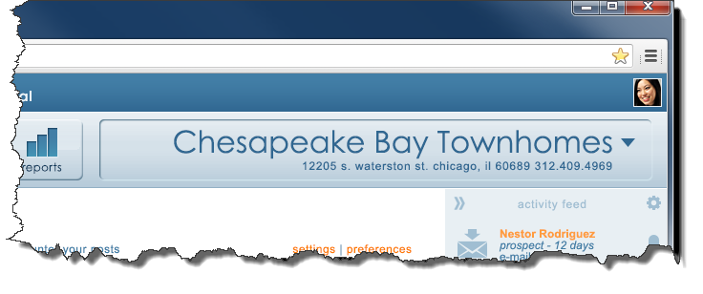
A Photoshop mockup for the design discussed here is available.
- The file name is: BC21 - STATES 01.psd
- The mockup lives on the Wiki here under ‘Mockups and Documentation: http://wiki.realpage.com/display/LSUI/LeaseStar+Unified+UI+Home
- A separate copy for Chicago developers who cannot access the Wiki has been placed here: \\rxpeitfs001\UIDevelopment\Creative\Erik\Marketing Center\
- The Layer Comp states relevant to the discussion on this page are as follows:
  - PDD - MouseOut
- For more on what Layer Comp states are, please refer to Appendix I.

Mouseover
Two changes:
- The background turns white but the recessed edging stays the same.
- The downward-pointing arrow turns orange.
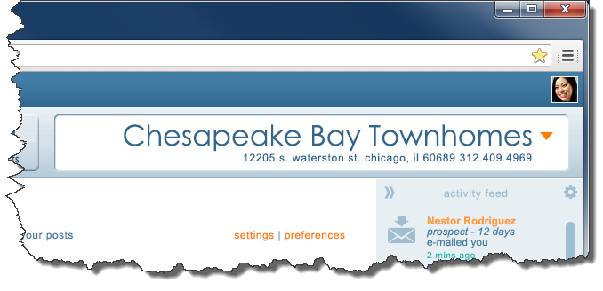
A Photoshop mockup for the design discussed here is available.
- The file name is: BC21 - STATES 01.psd
- The mockup lives on the Wiki here under ‘Mockups and Documentation: http://wiki.realpage.com/display/LSUI/LeaseStar+Unified+UI+Home
- A separate copy for Chicago developers who cannot access the Wiki has been placed here: \\rxpeitfs001\UIDevelopment\Creative\Erik\Marketing Center\
- The Layer Comp states relevant to the discussion on this page are as follows:
  - PDD - Mouseover
- For more on what Layer Comp states are, please refer to Appendix I.

OnClick

Appearance
When the User clicks the downward-pointing arrow OR the currently-selected property, the following tow changes occur:
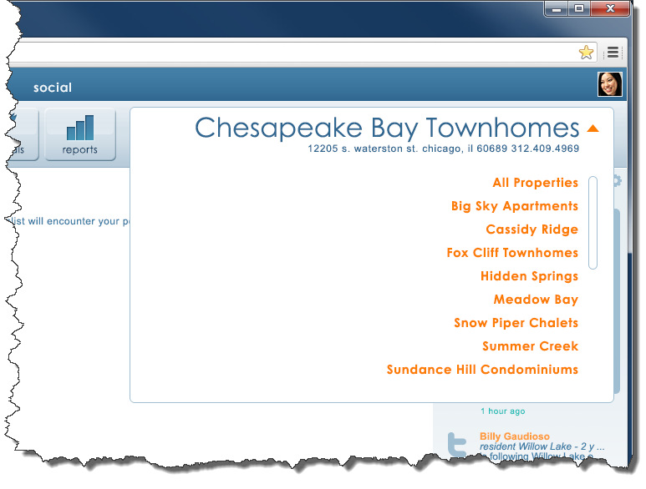
- The orange, formerly downward-pointing arrow, inverts. It now points up.
- A large field appears that is the same width as whatever width the Property Dropdown (PDD) area was at the time of the click (it is variable – more on this to come). The height of this PDD Field is roughly equal to half the page (but never more than 35 pixels past the baseline of the last link occurring within it). A scrollbar facilitates access to those property links below the viewable area. Obviously, the scrollbar does not appear if there are too few properties to warrant it.

Behavior
- If the User scrolls via the mouse scroll-wheel anywhere within this PDD Field, the property links scroll – but the currently-selected property (e.g. Chesapeake Bay Townhomes), remains stationary, unaffected by the scrolling. When moused outside the PDD Field, the page scrolls when the User scrolls via their mouse’s scroll-wheel.
- The ‘All Properties’ link is always at the top of the list of available links.
- The currently-selected property is always excluded from the lineup of links in the PDD Field (notice how in this example it does not appear after ‘Cassidy Ridge’ as it ordinarily would in an alphabetical list.
A Photoshop mockup for the design discussed here is available.
- The file name is: BC21 - STATES 01.psd
- The mockup lives on the Wiki here under ‘Mockups and Documentation: http://wiki.realpage.com/display/LSUI/LeaseStar+Unified+UI+Home
- A separate copy for Chicago developers who cannot access the Wiki has been placed here: \\rxpeitfs001\UIDevelopment\Creative\Erik\Marketing Center\
- The Layer Comp states relevant to the discussion on this page are as follows:
  - PDD - OnClick
- For more on what Layer Comp states are, please refer to Appendix I.

- Clicking anywhere outside the PDD Field closes the PDD Field and returns it to the mouseout state with no changein selection.
- Clicking the upward-pointing orange arrow or the currently-selected property closes the PDD Field and returns the PDD to the mouseout state with no changein selection.
- Selecting any of the properties from the lineup of links in the PDD field immediately selects that property (making it appear in the large blue text with its address occurring underneath) and then closes the PDD field, returning the PDD field to the mouseout state.

Property Dropdown UI
The Property Dropdown (PDD) has a couple of peculiarities that bear mentioning. As described earlier in this document, a nexus of functionality exists between the Button Array and the PDD. This nexus of functionality must therefore always be kept, if subtly, at the forefront of the User’s mind. How will this be done? By keeping them connected visually.

Together forever and never to part
Rick Astley had it right in this case. Observe how the PDD sectioning always hugs the right edge of the rightmost button in any given instantiation of the Button Array:
The exact distance from the right edge of the rightmost button and the left edge of the PDD should always be 17 pixels.
So the width of the PDD must at all times be dynamic. If the User stretches their browser window, the left edge of the PDD must chase the rightmost edge of the rightmost button in the Button Array.
While we’re on the subject, it should be noted that the distance from the rightmost edge of the PDD to the right edge of the browser window should always be 15 pixels. Contrast this against the distance of the leftmost edge of the leftmost button (in any given instantiation of the Button Array) from the left edge of the browser window, a mere 8 pixels.

Truncation
There may at some point be more buttons in the Button Array than can be accommodated without truncating a particularly long property name. Either because the User has sized their browser window too narrowly, or their monitor is of an unusually low resolution. When this happens, the Property name should truncate from the right.
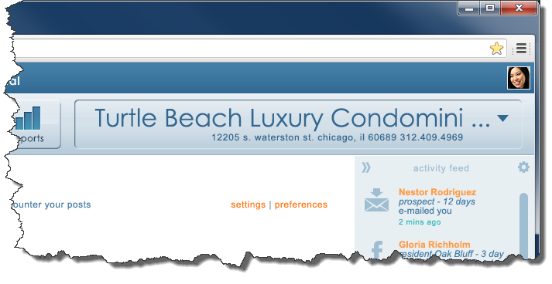
Notice that the truncation takes the standard form of an “ellipsis” (the “three dots”) and, in accordance with standard AP (Associated Press) style, is preceded by one space. Please note this is how truncation will be effected throughout the site.
In case of truncation, there should be no less than 25 pixels of padding between the first letter in the current property name and the leftmost edge of the PDD.
Please also notice how in the instance of truncation, the address below the current property aligns with the last letter before the truncation and not the last dot in the ellipsis.

Extreme Truncation
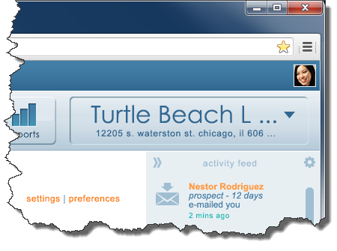
A number of stipulations:
- The goal of truncation is reducing the User’s need to scroll horizontally. Obviously, at some point, if we’ve done our jobs right, the User will have no one to blame for scrolling horizontally other than themselves – by either sizing their browser too narrowly or using their grandfather’s monitor from the ‘90s.
- The PDD should never be less than 320 pixels wide.
- If there isn’t enough space for the address below the selected property name, it should truncate, too. When it does, it should do so from the right, just like the property name.
- Whenever both the Property name and address are truncated, they align on the right according to their ellipses (as opposed to aligning by the last letter on the right, decribed in the previous section in those cases in which only the property name is truncated).
- The PDD Field, described above, NEVER truncates. When this field is fired, it manifests in its entirety and if the User must horizontally scroll to view it, them’s the breaks. Truncation and Extreme Truncation will be the only instances in which there is a disconnect between the respective widths of the PDD and the PDD Field. In all other cases, the widths of these distinct, but couldn’t-be-more-closely-related UI elements, are exactly the same:
 | No truncation | Truncation | Extreme Truncation
PDD | Width = PDD Field | Width < PDD Field | Width < PDD Field
PDD Field | Width = PDD | Width > PDD | Width > PDD

What happens when the context is multiple properties?
On a number of screens, across the suite, the context is not one property, but all properties. What should the Property Dropdown (PDD) show in such instances?
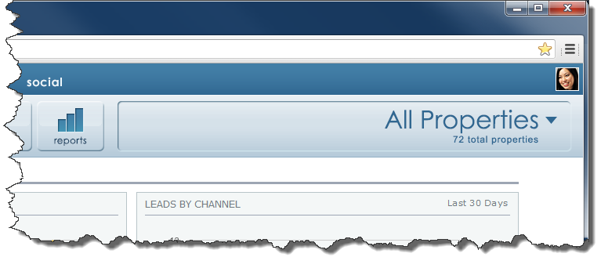
Instead of a single, selected property, the PDD should read ‘All Properties’ and in place of the address that goes underneath, a count of all properties.
‘All Properties’ should be an option in the list of properties in the PDD, but when clicked must take them to a ‘My Properties’-type page. If no such page exists in the app, the ‘All Properties’ option should not exist in the PDD.
The PDD should automatically flip to ‘All Properties’ whenever the User navigates to a screen for which a single property is not relevant – for example the Marketing Center’s ‘My Properties’ page. So the flow would go like this in such an instance:
- User goes in to Marketing Center’s ‘My Properties’ page – the PDD shows ‘All Properties’
- User selects a Property from the PDD and is taken to the Dashboard page for the selected Property – same action as would occur if the User clicked any of the Properties on said ‘My Properties’ page.
- The User drills in, performs various operations and/or consumes various data for the property they selected and then selects ‘All Properties’ from the PDD.
- The User is taken to the ‘My Properties’ page.
The same flow should be extrapolated for development in both Lead2Lease and LeaseStar Social.

What about screens when no property is in context?
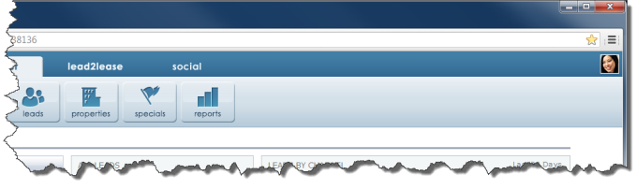
It is possible there may be a small fraction of screens for which no one property is in context and neither are all properties. In such instances, the PDD should simply not occur:

The Button Array
If the tabs at the top of the Ribbon facilitate primary navigation, the buttons in the Button Array facilitate secondary navigation. Because this Unified UI project is essentially a re-skin of existing products and the functionality native to each, the buttons will only navigate a User within whichever product they are currently working in – Marketing Center, Lead2Lease or LeaseStar Social.

Button States
The Button Array works like radio buttons: only one can be selected at a time. As can be seen here, a button in the Button Array can exist in at least two distinct states: selected and unselected. The selected state is the one in which the colors have been basically inverted: blue button and light-colored icon/label. A third state may be introduced in later versions of this documentation: disabled. This state exists in the current version of Marketing Center and is presumably intended to show the User desirable functionality they may wish to purchase. A decision to not show buttons describing unavailable functionality was still pending as of this document.

Overall Layout
Always with an emphasis on simplicity and elegance, the overall layout of the Unified UI should cue the User that these three rather different apps are now each part of a single suite. Accomplishing this will require a little fancy foot-work in the background but will occur to the User as so subtle as to be practically invisible. Which is as it should be. The User should never be focused on layout any more than a passenger on an airliner should be focused on the wingspan of their aircraft. It should just do the job.

Fixed vs. Flexible UI elements
The above-mentioned fancy footwork comes in the form of a subtle dance between UI elements with fixed widths and those with flexible widths. Let’s call these all out now.
Property Dropdown (PDD):
Flexible
Right-Side Nav:
Flexible
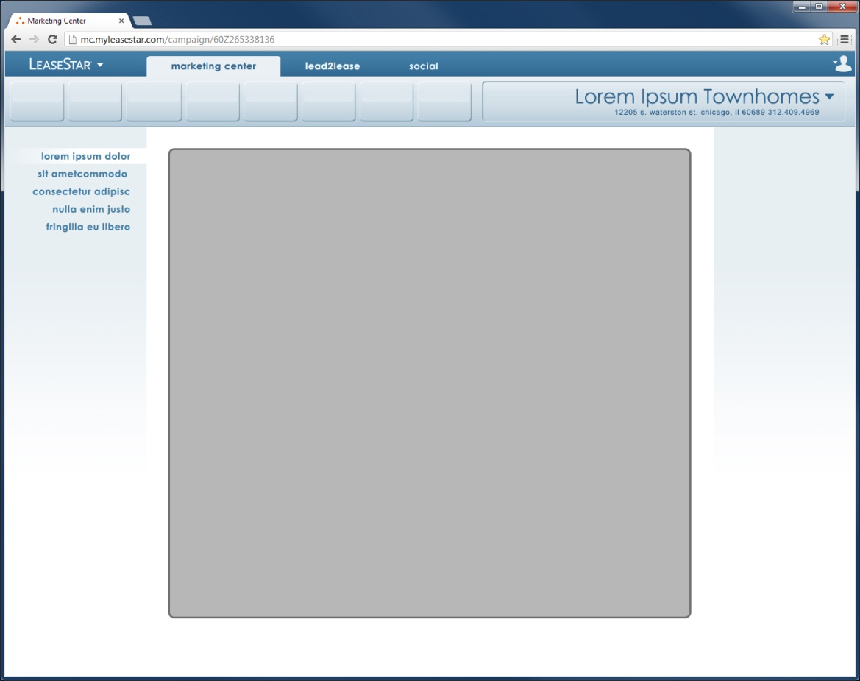
Page Content Area:
Fixed
Right margin:
Fixed
Button Array:
Fixed
Left-Side Nav:
Fixed
Left margin:
Fixed

The Difference Between Fixed and Flexible
Because some UI elements with fixed widths may at times appear to be flexible and vice versa, it is important that we establish the distinction before delving in to each individual UI element:
- The widths of Fixed UI elements are NOT affected by the width of the browser window.
- The widths of Flexible UI elements ARE affected by the width of the browser window.

The Fixed UI Elelements – Solid as Rocks

The Button Array
Taken in composite, the Button Array is a single, fixed-width UI element that only ever varies in width based on whichever product is currenly selected (Marketing Center, Lead2Lease, or LeaseStar Social) because of the different number of buttons that occur in each. For example, as of this writing only four buttons are planned to occur in LeaseStar Social (LSS) where Marketing Center (MC) will likely have eight. So if the width of the Button Array is determined by the number of buttons, how wide are each button?

The Button Array Button
All standard Button Array Buttons should be of equal width, except for those which carry a longer label – these are non-standard. In the comps provided in conjunction with this document, the width of a standard Button Array Button is 86 pixels.

Standard
86 px

Non-Standard
Non-Standard Buttons are those which carry a longer label. Because there must be at least 10 pixels of horizontal padding on either end of any label, the Button must expand gently to accommodate longer labels. In the below example, the Source Cost Button for L2L ended up being 88 pixels wide. But the width of a Non-Standard Button Array Button could vary widely, depending upon the length of its label. These labels should never wrap. These labels should never exceed 20 chracters total, including spaces.
??? px
88 px

10 px
10 px
or …
lorem ipsum dolor

Spacing
The width of any one of the 3 possible incarnations of the Button Array (one for each product) is not only defined by the width of each individual button, but the spacing between them:
… and 6 pixels of space occur between each button
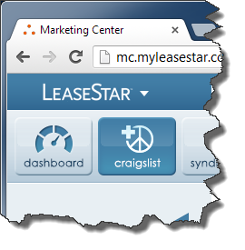
The Button Array begins 8 pixels away from the leftmost edge of the browser window …
So, for example, if we knew we were going to have 5 buttons for Lead2Lease, all of which were Standard, except one which was 92 pixels wide, we can easily calculate the fixed width of this Button Array: (8 px left-side spacing) + (4 x 86 px Standard Buttons) + (92 px Non-Standard Button) + (4 x 6px Spacing) = 468 px.

The Left-Side Nav
The Left-Side Nav (LSN) is possibly the easiest piece of this puzzle. It is always exactly 225 px wide. Never more. Never less.
225 px
ALWAYS

Left and Right Margins
The next of our fixed UI elements are the Left and Right Margins. Unseen, but stalwart and ever-present, these two margins never change their width either. They are always 34 pixels wide.
34 px
34 px

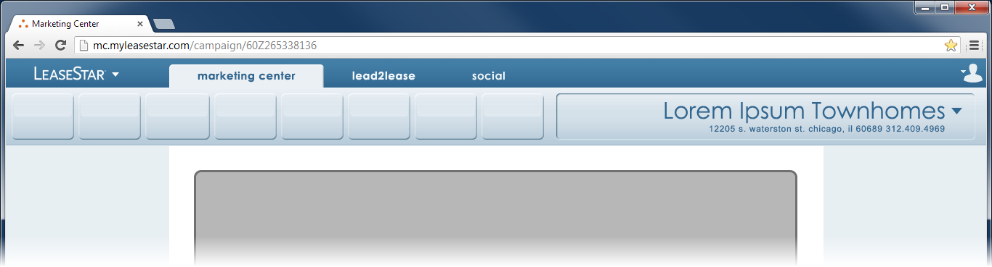

It should be noted …
Because this section is focused on the interplay between fixed and non-fixed-width UI elements and how their interplay affects overall layout, vertical dimensionalities will be discussed in later versions of this document. It should be noted here, however, that the top margin is 34 pixels tall, same as the widths of both the left and right margins.

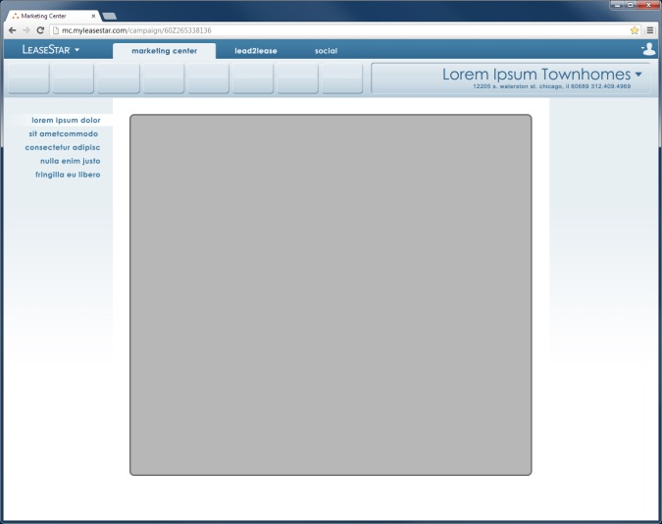
Page Content Area
Like the Button Array, the Page Content Area UI element is fixed (in that it is unaffected by the width of the browser window), but will vary across products.
Page Content Area
UNLIKE the Button Array, and unfortunately, it may also vary occasionally within each product. Especially Lead2Lease (L2L).

Generally, the widths of these Fixed UI Elements are as follows:
Marketing Center: 1188 px | LeaseStar Social: 869 px | Lead2Lease: 760 px
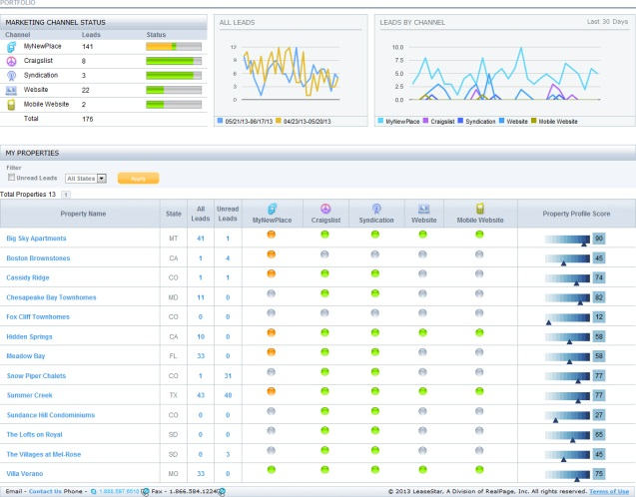 | 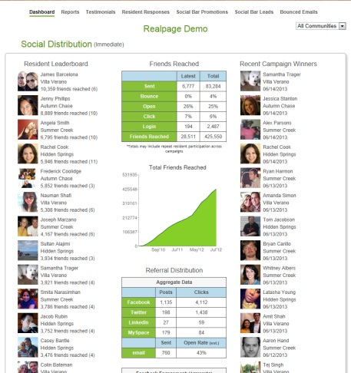 | 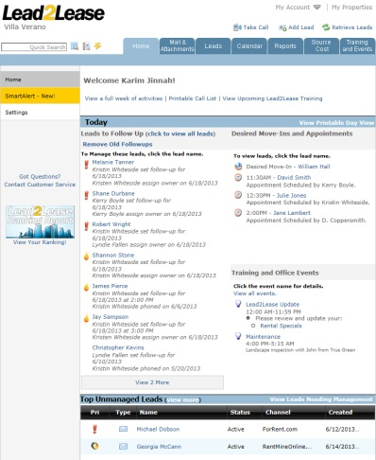

More on the relationship between these starkly different Page Content Area widths and the overall layout shortly.

The Flexible UI Elements – Going with the Flow

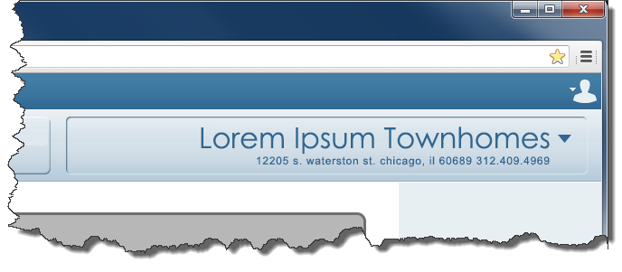
The Property Dropdown
The Property Dropdown (PDD) is one of only two Flexible UI elements. Its behavior is described in detail in an earlier section of this document.

The Right-Side Nav
The Right-Side Nav(RSN), unlike the Left-Side Nav(LSN) is flexible and comparatively complex. That is because the RSN has two jobs to do, where the LSN has only one. Like the LSN, the RSN must provide a home for navigational content, but unlike the LSN, the RSN is additionally responsible for framing the Page Content Area (PCA) UI element. It does this by chasing the rightmost edge of the PCA Area with its left edge, in a fashion similar to the way in which the leftmost edge of the PDD chases the rightmost edge of the rightmost Button in the Button Array. Let’s look a little more closely.

Life on the Edge
The RSN likes to live life on the edge. On the edge of the PCA UI element, that is. It will chase its rightmost edge wherever it goes:
Notice how the Page Content Area is perfectly framed by a 34px margin, no matter how narrow it is or how wide. Nor how narrow the browser window or how wide.

Providing a Home for Navigational Content
So by chasing the rightmost edge of the Page Content Area (PCA), the Right-Side Nav (RSN) accomplishes its job of keeping the PCA framed at all times. But what about its other job? It must also provide a home for navigational content. To effectively do this it must adhere to a mimimum width, even as it chases the rightmost edge of the PCA. That minimum width is the same as the Left-Side Nav’s constant width: 225px.
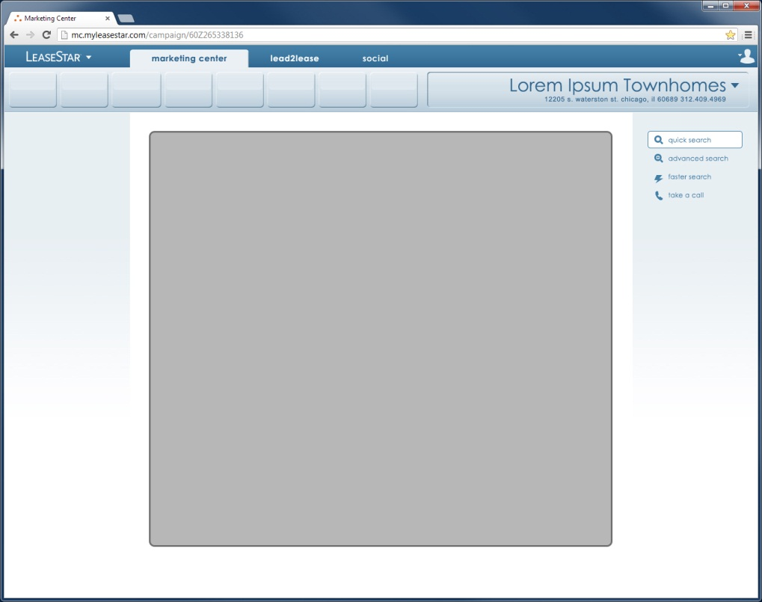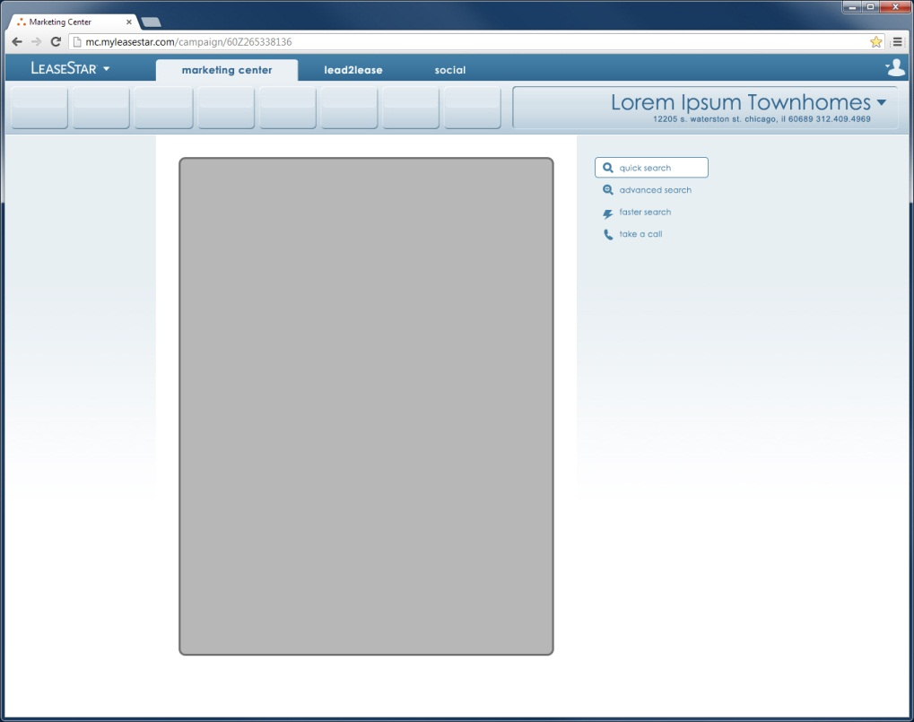

Minimum width: 225px
This Navigational Content area does not stretch along with the RSN. It stays 225px wide, even though its borders are unseen.

Flexible to a Point
So, as we’ve seen, the two Flexible UI elements, the Property Dropdown (PDD) and the Right-Side Nav (RSN) may be flexible, but only to a point. Each has their limit. Indeed, each becomes fixed when the browser window is too narrow. As was discussed in the section on the PDD, the PDD has a mimimum width of 320px. And similarly, the RSN has a minimum width of 225px. And it is only when these two Flexible UI elements reach their minimum widths and become fixed, should the browser window begin to scroll horizontally.

It is possible for the User to set their browser’s width so narrow that not even our flexible UI elements can save them from horizontal scrolling

The Page Content Area and its Impact on Overall Layout
As we’ve seen, the width of the Page Content Area (PCA) varies widely in width across all three products:
- Marketing Center: 1188px
- LeaseStar Social: 869px
- Lead2Lease: 760px
That’s a difference of 36%, or more than a third of total screen width from widest to narrowest.
And, as alluded to earlier in this document, the difference will be even more stark for some of the Lead2Lease screens. These screens will be modified as part of the UI Unification effort and their resulting width will be a mere 597px. Marketing Center is twice this size!
So if the goal is to make these screens all look like they belong to the same suite, clearly some even fancier footwork than has already been described is in order. And this fancy foot-work will all revolve around the PCA, Left-Side Nav(LSN) and Right-Side Nav(RSN).
Feet don’t fail us now:

PCA Screen Alignment and LSN / RSN Instantiation
To solve for discrepancies in width of the Page Content Area (PCA) across the products and especially Lead2Lease(L2L), we shall use selective instantiation of the Left and Right-Side Navs. And we will align the PCA to the browser window based on the product.
 | Marketing Center | Lead2Lease | LeaseStar Social
 | PCA | PCA  L  S  N  R  S  N | PCA  L  S  N
Screen Alignment of PCA | Center | Left | Left
Left-Side Nav Instantiated? | No | Yes | Yes
Right-Side Nav Instantiated? | No | Yes | No

The Curious Case of Lead2Lease
For LeaseStar Social and especially Marketing Center (MC), implementation of the Unified UI is a relatively straightforward proposition. But implementing it for Lead2Lease (L2L) presented enough challenges to warrant a section of this document devoted strictly to its special peculiarities. Let’s go through these one at a time.

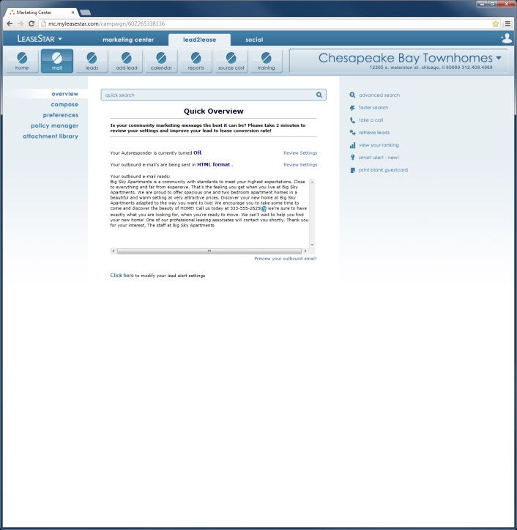
Both side navs used
As mentioned in the section previous, L2L is distinct among the three products comprising MC by virtue of its instantiation of both the Left-Side Nav (LSN) and the Right-Side Nav (RSN).
Both Side Navs instantiated

What’s going in to the Right-Side Nav?
Certainly nothing new. The term Right-Side Nav is a general term and somewhat a misleading one in this instance. Indeed, the items placed in this area were grouped here because they WERE NOT at all related to navigating the various screens of Lead2Lease (L2L). Perhaps “toolbox” or “quick links” would be a better term for this area in the case of L2L because these terms more accurately describe its contents.
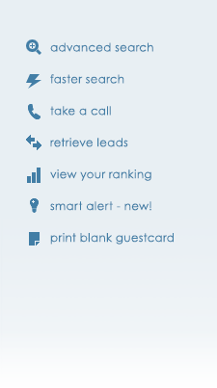
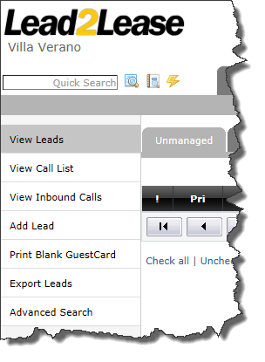
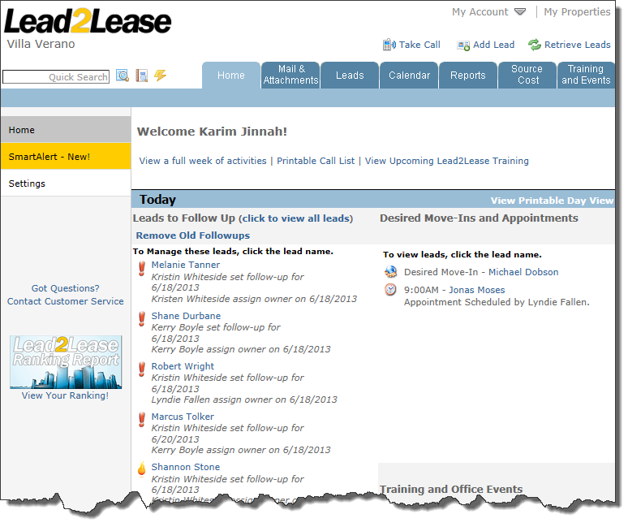

Behaviors of the Right-Side Nav(RSN) links

Mouseover and OnClick
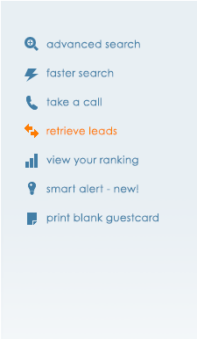
When the User mouses over or clicks any of the links in the RSN, they turn orange, including the icon. This is the standard orange for all text-links and rollover states described elsewhere in this document: #fd7c03.

A More Prominent and User-Friendly Quick Search
The Quick Search Field (QSF) is one of the most often-used and most relied-upon UI elements in Lead2Lease(L2L). Which is why it is being given a new, more prominent home on all L2L screens as part of the Unified UI effort. A key improvement in its usability has been specified as well.

More prominent
The new QSF shall appear at the top of the Page Content Area (PCA) of every L2L screen and span its width entirely from right to left. And because the widths of the PCA in L2L may vary, so too will the width of the QSF.
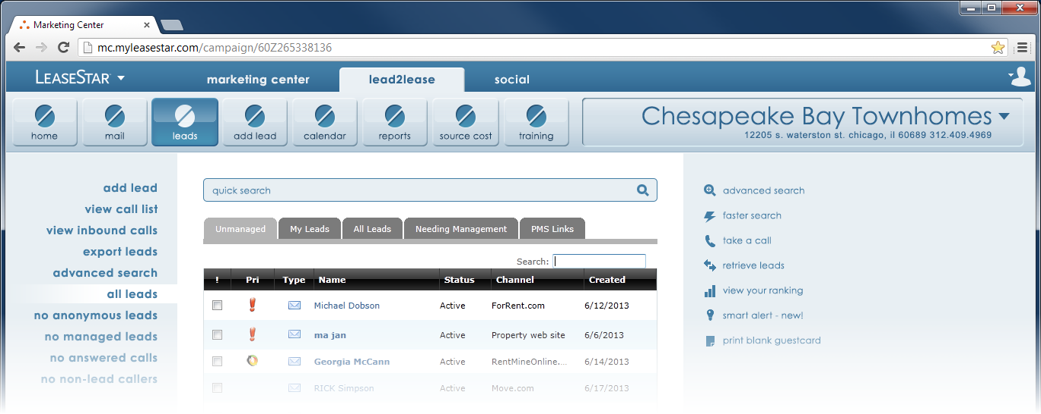

A Photoshop mockup for the design discussed here is available.
- The file name is: BC26 - L2L 17.psd
- The mockup lives on the Wiki here under ‘Mockups and Documentation: http://wiki.realpage.com/display/LSUI/LeaseStar+Unified+UI+Home
- A separate copy for Chicago developers who cannot access the Wiki has been placed here: \\rxpeitfs001\UIDevelopment\Creative\Erik\Marketing Center\
- The Layer Comp states relevant to the discussion in this section are as follows:
  - (All)
- For more on what Layer Comp states are, please refer to Appendix I.

More User-Friendly

No more button click to initiate search
In the version of Lead2Lease (L2L) in Production as of this document, Quick Search operated as follows:
Button B
Field A

- User enters search term in field A
- User must click button B
This is a little confusing for two reasons:
- First, the User MUST click the ‘Search’ button because hitting the ‘Enter’ button on their keyboard doesn’t submit the search.
- Second, it’s confusing because it equates by size and proximity a trigger button (the ‘Search’ button) with option buttons that have nothing to do with the current search: ‘Advanced Search’ and ‘Faster Search.’
For the revised version of Quick Search, we are resolving this confusion in the following two ways:
- The User may click the (redesigned) ‘Search’ button/icon after entering their search term or they may merely hit the ‘Enter’ key on their keyboard.
- By separating the ‘Search’ button from the ‘Advanced Search’ and ‘Faster Search’ buttons significantly.
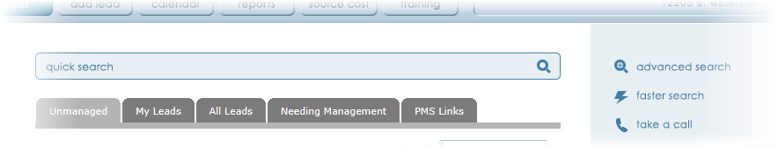
User may click this button to Submit search or merely hit the ‘Enter’ key on their keyboard.

States of the Quick-Search field
MouseOut or OnFocus of any other UI element
or OnClick of any other UI element
MouseOver
OnClick
OnSubmit

Search Results
The results of a Quick search appear exactly as they have in the past. If the screen needs to widen to accommodate this UI element, the means for doing so have already been described in an earlier section of this document.
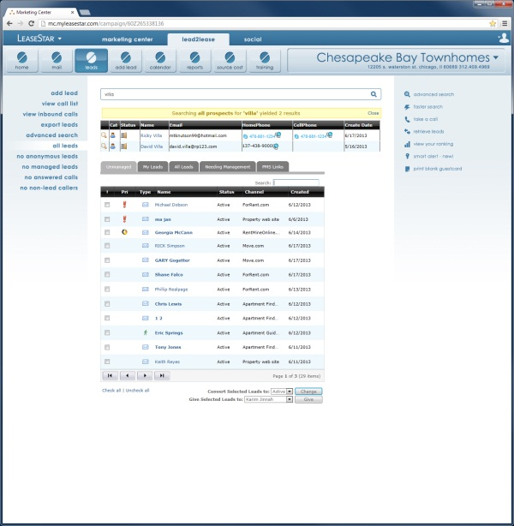
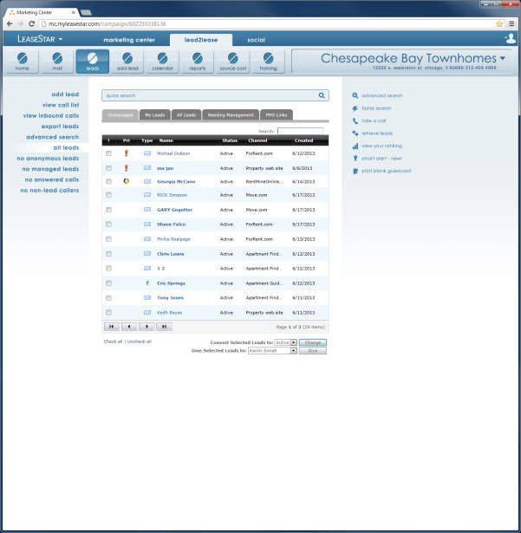
A Photoshop mockup for the design discussed here is available.
- The file name is: BC26 - L2L 17.psd
- The mockup lives on the Wiki here under ‘Mockups and Documentation: http://wiki.realpage.com/display/LSUI/LeaseStar+Unified+UI+Home
- A separate copy for Chicago developers who cannot access the Wiki has been placed here: \\rxpeitfs001\UIDevelopment\Creative\Erik\Marketing Center\
- The Layer Comp states relevant to the discussion on this page are as follows:
  - Leads
  - Search Results
- For more on what Layer Comp states are, please refer to Appendix I.

New Main Nav Item Introduced – Add Lead
In the Production version of Lead2Lease (L2L) that was current as of this document, there were seven options in the main nav:
For the Unified UI version, there are eight. The new addition is ‘Add Lead,’ a function so fundamental to the Lead2Lease User’s workflow, they should never have to go looking for it. It takes the User directly to the new guest card screen.

In deference to the undoubtedly habituated connection between Leads and Adding Leads from the Left-Side Nav in the minds of our users, there are redundant links in the Left-Side Nav on both pages that link each respective page back to the other.
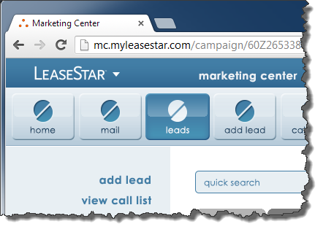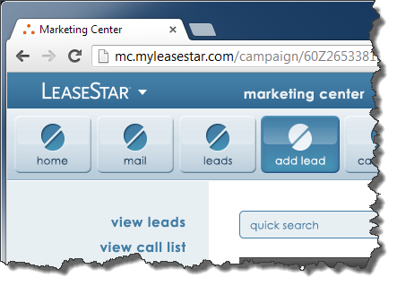

Multiple and Aggregate Left-Side Nav Location Indicators for Filtering
Whoa. That’s a mouthful. Let’s start at the beginning. What is a Location Indicator? A Location Indicator is what we’ll call the state of any navigation option indicative to the User of their location in the app. Working together, these Location Indicators can, in an instant, tell the User exactly where they are in the app at any given time. For example, by referring to the three Location Indicators shown below, we can see that we are in …
- Lead2Lease (not Marketing Center or LeaseStar Social)
- Source Cost
- Edit Annual Costs
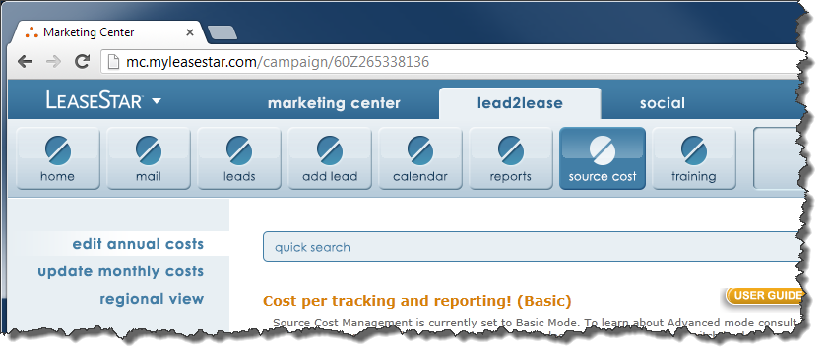
3
22
1
So what are Left-Side Nav Location Indicators (LSNLIs)? You guessed it. Those Location Indicators appearing in the Left-Side Nav.

So, if you want to know the ONE place you’re at would you ever want to have more than one Location Indicator in any given navigational area? What if, for example, Calendar, Reports and Source Cost were all lit up at the same time? We wouldn’t know where we were, would we?
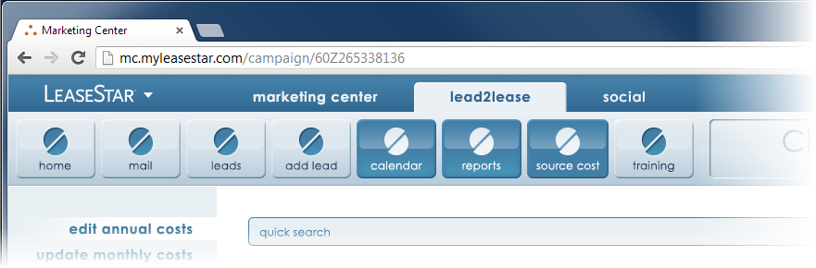
Okay, I’m where now?
Needless to say that when it comes to Location Indicators, one selection only must be the golden rule.
However, in order to replicate the filtering functionality that occurrs in the Left-Side Nav of the version of Lead2Lease (L2L) in Production as of this document, we’re going to make an exception to that rule. The old version used checkboxes. The new version will use Left-Side Nav Location Indicators (LSNLIs) in multiple and in aggregate:
Checkmarks mimicked by LSNLI’s occurring in multiple | Checkmarks mimicked by LSNLI’s occurring in aggregate
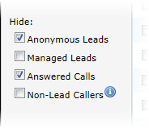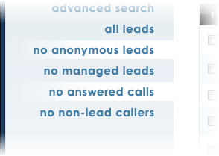 | 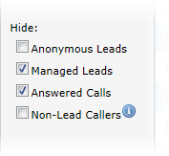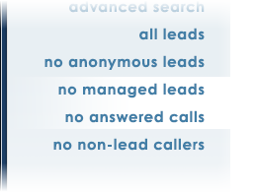
A Photoshop mockup for the design discussed here is available.
- The file name is: BC26 - L2L 17.psd
- The mockup lives on the Wiki here under ‘Mockups and Documentation: http://wiki.realpage.com/display/LSUI/LeaseStar+Unified+UI+Home
- A separate copy for Chicago developers who cannot access the Wiki has been placed here: \\rxpeitfs001\UIDevelopment\Creative\Erik\Marketing Center\
- The Layer Comp states relevant to the discussion on this page are as follows:
  - Filtered Leads - Multiple
  - Filtered Leads - Aggregate
- For more on what Layer Comp states are, please refer to Appendix I.

Single Sign-On (SSO)
Single Sign-On (SSO) exists in production as of this document. It is the aim of the current effort to build on that logic and improve upon it in the two following ways:
- Put the LeaseStar brand, as well as the Marketing Center product, front and center
- Make the User’s experience of SSO simpler, more elegant and more functional

Where we are and where we want to go
Newcomers are the key to expanding our market share and so the importance of their experience with our products cannot be overstated. And because of the hard work already put in on SSO, it is easy to lose track of the use case experienced by newcomers. So the first step in ensuring newcomers have an ideal experience, is reviewing the existing experience.

Where we are
For a newcomer to our products, there is a distinct external home-page for each:
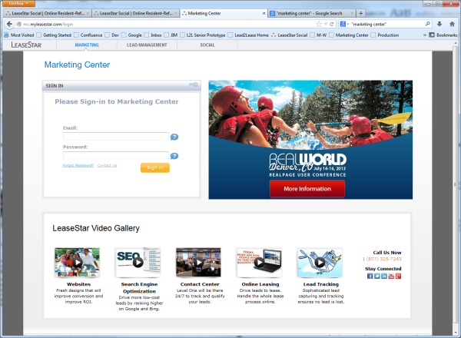
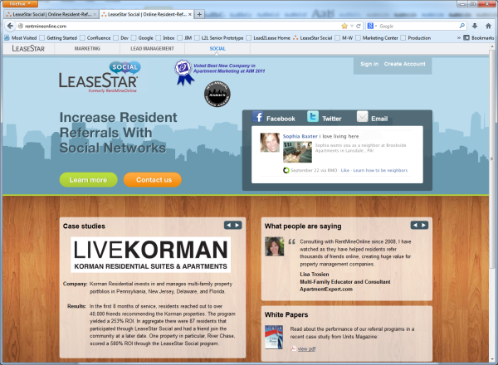
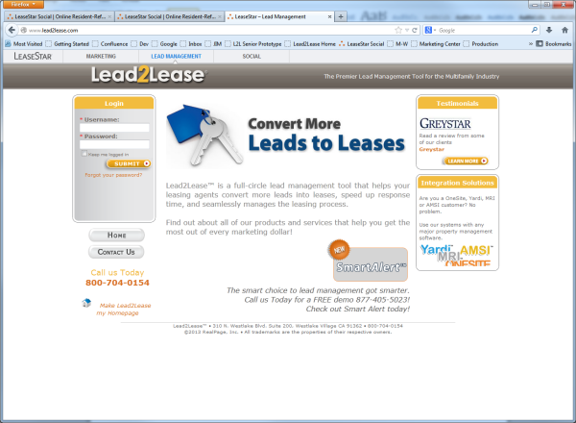

www.lead2lease.com
mc.myleasestar.com
or
www.myleasestar.com

www.leasestarsocial.com
or
www.rentmineonline.com

Newcomer

This was appropriate to start as a means of brand retention and of keeping existing Users in a familiar environment.
The first steps toward unifying the brand and experience exist in the form of a subtle header all three share in common. It establishes the LeaseStar brand and facilitates navigation between all three products:

Logically, when the User logs in to any one product, they are logging in to all three – assuming they’ve paid for all three.
But the logging in is a different experience for each product:
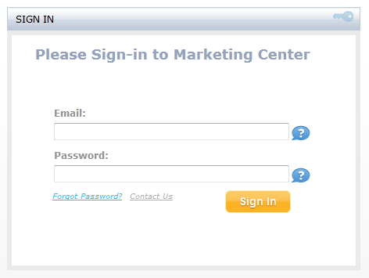 | 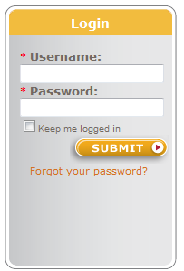 | 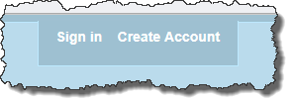  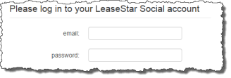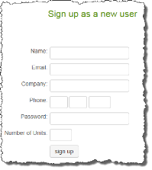
Onscreen fields. What about creating  a new account? | Onscreen fields. What about creating  a new account? | Links to two distinct pages.
Newcomer
???
If you were a new User, would you assume you had logged in to all three products in any of these instances? They seem very much tied to the product the User is in.

Where we want to go
User hits one landing page when attempting to hit Marketing Center, Lead2Lease or LeaseStar Social (or just plain LeaseStar) externally using any of the URL’s depicted.
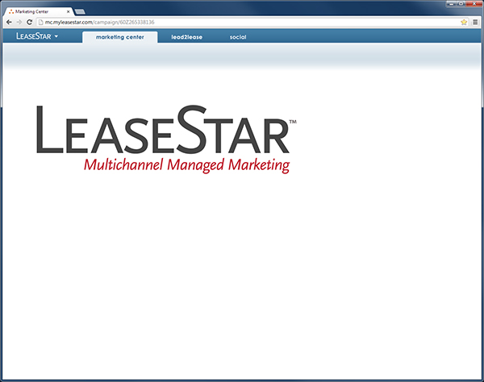
(This is the roughest imagining of what this screen might look like and should not be considered in any way a design direction under consideration)
Sign Up
Sign in
www.leasestar.com
mc.myleasestar.com
www.myleasestar.com
www.lead2lease.com
www.leasestarsocial.com
www.rentmineonline.com

Newcomer

The internal experience
For customers of all three products, the SSO experience will not change drastically. Once their login tracking cookie is active, they will bypass the above-described landing page and drill in to whichever product they’ve typed in to their address bar or navigated to from favorites, pre-logged-in. Ideally, we’ll want to add more logical URLs for each. See these highlighted in yellow below:
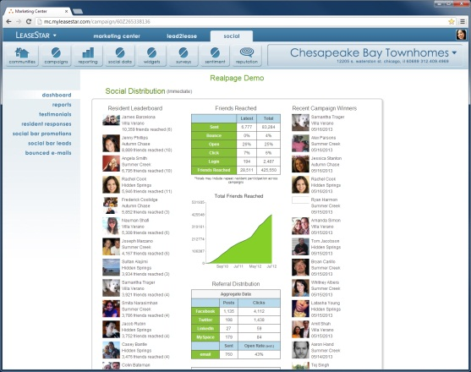
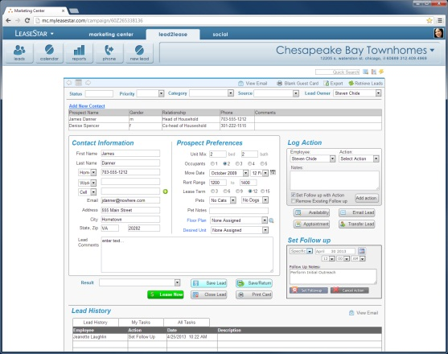
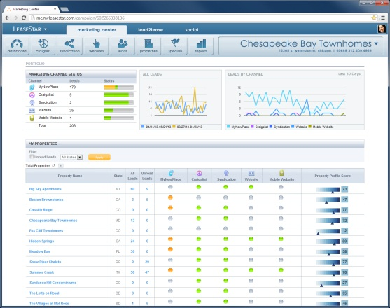

www.leasestar.com/lead2lease
www.leasestar.com/l2l
www.lead2lease.com
www.leasestar.com/marketing center
www.leasestar.com/mc
mc.myleasestar.com
www.myleasestar.com
www.leasestar.com/social
www.leasestar.com/lss
www.leasestarsocial.com
www.rentmineonline.com

Returning User

Logging Out
Logging out is facilitated by means of the Single Sign-On Fly-Out (SSOFO), described in a preceding section on the subject.

Footer
This is described in the Photoshop comp mentioned earlier in this document (\\rxpeitfs001\UIDevelopment\Creative\Erik\Marketing Center\BC19 - MC L2L LSS 03.psd – Layer comp state ‘Full Redesign sample screen (content TBD).’ The design for it will likely evolve, but probably not before the deadline of the effort comprised by this document.

Appendix I - Viewing multiple comps in one Photoshop file
A recent innovation in Photoshop enables the user to view any Photoshop file in multiple states, making some layers visible and others not. This is useful for sharing comps because it no longer requires the designer to share out a different version of the same file for every view a developer needs to create. All the views exist in one file. To access these separate views, the user need only click the button in the “Layer Comps” panel of Photoshop for the desired comp state. To view this panel, in Photoshop go to Window > Layer Comps.
